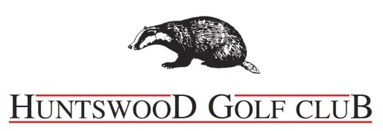

WINE LIST

WHITE WINE

Semillon Sauvignon Blanc
Whistling Duck | Australia
A fresh & lively palate with tropical flavours and a hint of lime zest
Bottle 16.95 | Glass 250ml 5.75 / 175ml 4.50

Chardonnay
Whistling Duck | Australia
A balanced, crisp wine with exotic fruit aromas
Bottle 16.95 | Glass 250ml 5.75 / 175ml 4.50

Pinot Grigio
Monte Di Cellio | Italy
Rich & fragrant with a refreshing & elegant flavour
Bottle 16.95 | Glass 250ml 5.75 / 175ml 4.50

Sauvignon Blanc
La Palma | Chile
Fresh & Lively with a delicious white peach and nectarine aromas
Bottle 17.95 | Glass 250ml 5.95 / 175ml 4.75

Picpoul De Pinet
Domaine Delsol | France
Exciting & refreshing, a must try wine
Bottle 18.25

RED WINE

Cabernet Merlot
Whistling Duck | Australia
Soft, plummy with a lovely fruit aroma & great finish.
Bottle 16.95 | Glass 250ml 5.75 / 175ml 4.50

Shiraz
Whistling Duck | Australia
A good bouquet & rich flavours, a great easy way to drink red.
Bottle 16.95 | Glass 250ml 5.60 / 175ml 4.50

125ml glass available on request

RED WINE Cont…

Merlot
La Palma| Chile
Soft blackberry aroma on the nose. Rich concentrated fruit on the palate
Bottle 17.50 | Glass 250ml 5.95 / 175ml 4.75

Rioja
Rio del Ray Tempranillo | Spain
Berry fruit aromas, smooth & easy to drink Bottle 17.95

Malbec
San Felipe Reserve | Argentina
Layers of soft rich dark red berry fruits, plums & raisins that are harmoniously blended.
Bottle 18.95 Glass 250ml 6.25 | 175ml 4.95

ROSÉ WINE

Rosé Zinfandel
Wildwood | California
Summer flavours of sun ripened strawberries & cherries. Medium, not overly sweet
Great served with ice.
Bottle 16.95 | Glass 250ml 5.75 / 175ml 4.50

Pinot Grigio Blush
Monte di Cello | Italy
Extremely small production, very appealing pink colour, dry with a great tangy fresh fruitiness that makes it perfect for any time of the year.
Bottle 17.95 | Glass 250ml 5.95 / 175ml 4.75

CHAMPAGNE & SPARKLING

Prosecco - Di Maria
Citrus aromas, vibrant with a soft gentle fizz
Bottle 19.95 | Small Bottle 200ml £5.95

Champagne - Laurent Perrier Brut
Apricot & lemon notes with a creamy toasty finish | Bottle 37.95

Moet & Chandon
Light & fresh tasting with fresh orchard fruit & toasted aromas | Bottle 37.95

