Cadet for sale only £900

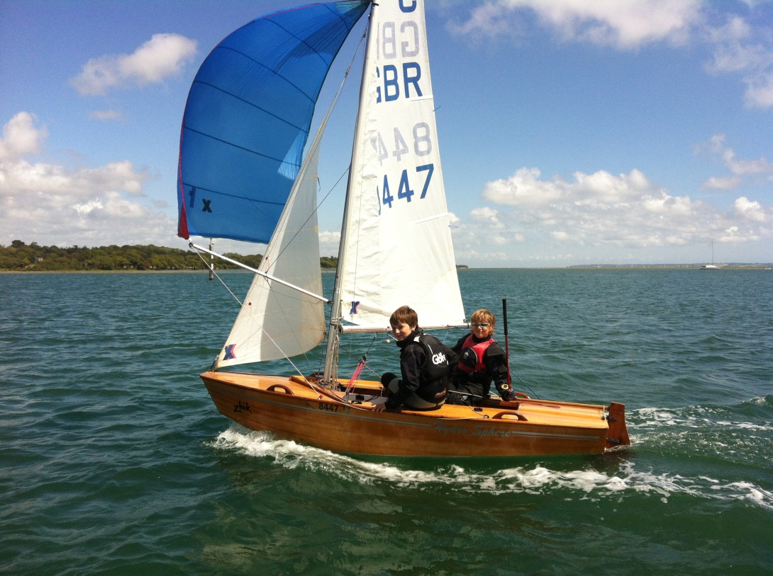

· World team boat (Hydrosphere); championship ready to launch and race (inc rigging etc)

· Very high quality race and training sails

· Mast and shrouds

· Boom and spinnaker pole

· Rudder and centreboard

· Top, bottom and cocoon cover

· Launching trolley

Contacts:

· Ross Wilkinson (Surrey)

· 07733 300091

· Rosco.wilkinson@btopenworld.com

