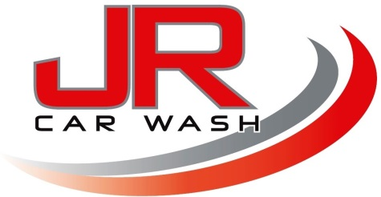

JR Car Wash Terms & Conditions

LIABILITY

We will perform the services selected by you from our service menu with all reasonable skill and care. Whilst the company shall take all reasonable steps to ensure that its servants or agents shall take reasonable care of the vehicle whilst in its custody (including with limitation where the vehicle is washed and cleaned), the company shall not be liable for:

Damage to, loss of the vehicle or any part of it, any of its accessories or any of its content.

Damage to any other property, arising from, or in connection with the company’s custody of the vehicle.

Where such liability is proved to arise, and only to the extent it is proven to arise, as a result of negligence, a criminal act or breach of statutory duty on the part of the company or its servants or agents.

In addition, the company accepts no responsibility or liability for any damage, however caused, resulting from or in connection with the seizure of the vehicle by police, H.M Customs & Excise or any persons lawfully authorised to do so.

The servants or agents of the company have no authority to accept any valuables or other articles for safe custody and the company will not be liable for any loss of or damage to any such articles which a customer purports to leave in the safe custody of keeping of the company, its servants or agents.

You must disclose to us all defects, damage or weakness in your vehicle, known or suspected by you, which may be affected by the services prior to our commencing with the cleaning process.

We do not undertake to insure the vehicle against loss while it is in our possession.

Insurance of your vehicle is, at all times, your responsibility.

Any complaints about our work cannot be considered unless reported prior to departing the car park.

You will be liable to us for any death, injury or damage suffered by us or our staff attributable to any defect in your vehicle or any harmful contents.

It should be noted that polish and other cleaning products can be slippery and extreme caution should be exercised when collecting your vehicle.

We accept no liability whatsoever for loss or damage caused as a consequence of failing to heed this warning.

Old or non-original paintwork can be damaged in the cleaning process. All such defects shall be indicated to our staff prior to commencement of the cleaning process.

Child seats and booster seats must be refitted by you. We will not be able to refit seats under any circumstances.

Older cars may have weaker plastics and we agree to provide the services at your risk in respect of vehicles over three years old.

CAR SIZE

Our determination of the size category of your vehicle with regard to the price list shall be final and binding.

PRIVACY

Any payment or booking information provided to us, will only be used by us and will not be distributed or given to any other organisation.

MEMBERSHIP

MONTHLY DUES

The member agrees to pay the monthly dues for the membership, which is subject to increase at the director’s discretion.

Monthly dues will continue to be collected each month regardless of the member’s usage of the affiliated car wash until we are notified via email or phone that you wish to cancel this agreement. Regardless of such a cancellation, any outstanding balance of the membership fee will remain due and payable in accordance with this agreement. You may pay the monthly dues in advance for a full or partial year as annual or prepaid dues. If you fail to pay the monthly dues payment within 30 days after the date such payment is due, your membership privileges may be cancelled and you may have to reapply for membership under new terms.

BY REQUESTING JR CAR WASH TO WASH/VALET MY VEHICLE, I AGREE TO THE TERMS AND CONDITIONS AS STATED ABOVE.

Signed: ___________________________________________________________

Date: _____________________________

