Everyone can access support from our Outreach worker. For example:
Do you struggle to make it to our regular sessions but feel you would benefit from the support services the children’s centre can offer?
Do you feel isolated or lonely and would like help to make new friends in the local area?
Are you struggling to make ends meet and need immediate financial support?
Are you having problems with your housing?
Are you struggling to manage your child’s difficult behaviour?
Have you experienced/are experiencing hardships?
Are you a young parent that needs a bit of extra support?
If any of these or other issues are impacting on your family life Sadif can help!
If you are currently being supported by your local Health or Children’s Services teams please ask them to refer you to your local children’s centre.

You can contact Sadif Monday – Thursday 9-1pm to make an appointment.
How can Sadif help?
We have a separate entrance to the Grange School on Queen Mary’s Drive, behind the playing fields.
Please press the buzzer to enter.
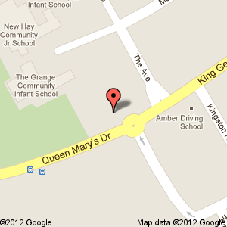
or….

Email her at: outreach.poplarscc@grange.surrey.sch.uk
Call her on
Mobile 07341 866432

How to contact Sadif

The Poplars Children's Centre
In New Haw

Outreach Worker
‘Offering one to one support for local families ’

Your named outreach worker is:
Sadif Khan

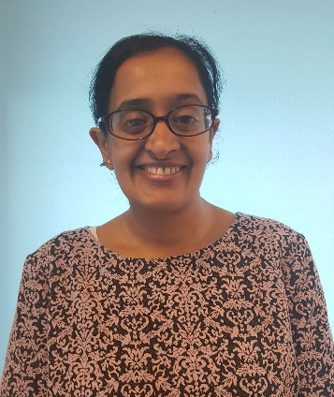
07341 866432
What is an Outreach Worker?
Outreach workers support local families with children under the age of 5. They do this on a one to one basis to ensure families access the help and support they need. Also sometimes known as ‘family support workers’.

What services does an Outreach Worker offer?

Supporting Families
Sadif will work closely with you to identify what support you may need, how she can help and also support you to access relevant services.
She can do this either at the centre or arrange to come to your home where she will introduce herself and discuss the many ways in which she can support you and your family.
She can also help you to work with other agencies including housing, social care and health teams if required.
Her aim is to ensure you and your family get the best support available locally.
Sadif speaks 3 languages: Urdu, Punjabi & English.

Advice and Information
Providing relevant advice and information on all family related matters; including:

- Parenting and family support
- Health and child development
- Benefits, Employment and training
- Childcare options
- Help you to apply for FEET (Free Early Education for Two year olds)
- Grants/Benefits Applications

Work with other agencies

- Health Visitors
- Social Workers
- Childcare settings
- Citizens Advice Bureau
- Housing
- Foodbank

Parenting
Sadif is qualified to deliver our Parenting Puzzle Course, these are normally run once a year at the centre. Her substantial training to deliver this course means that she can offer expert advice on all aspects of parenting.

Breastfeeding Support
Sadif is qualified to support breastfeeding mothers, you can call and make an appointment or to have a chat if you are having difficulties or have any questions.
Applications/Letters
Sadif’s experience as an outreach worker means she has expertise in completing applications and writing formal letters to ensure you get all the support you are entitled to.

