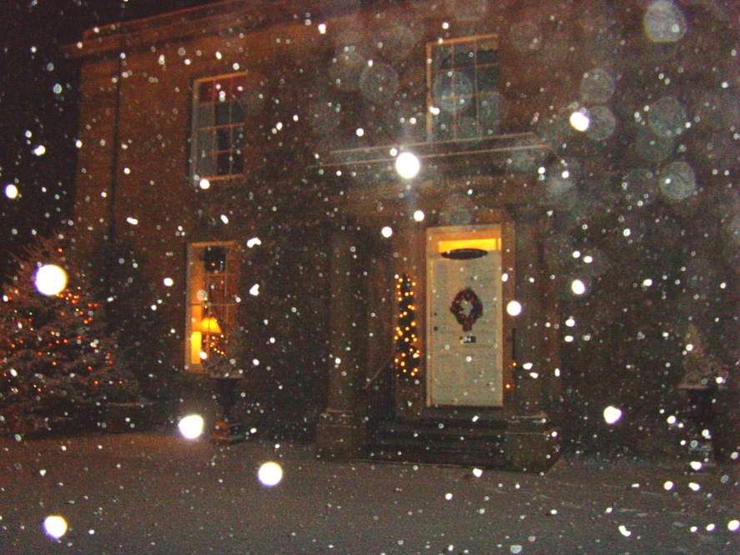
Join us this Festive Season for your Christmas Parties, Christmas Day and Boxing Day.

Gather your family, friends and colleagues for a Festive Party/Meal with an exclusivity option available:
Lunch- £21.50
Dinner - £26.50
Sunday Lunch - £23.50
Christmas Day :
Adults - £75.00
Children under 12 - £40.00
Boxing Day :
Adults - £27.50
Children under 12 - £16.95

See Menus below.
December Party Menu
Lunch - £21.50
Dinner - £26.50
Sunday Lunch £23.50

Roast Parsnip and Apple Soup with Crisp Croutons
***
Smoked Salmon and Prawn Roulade with a Parsley and Chive Mayonnaise
***
Feta Cheese Salad with Pear and Beetroot with a Walnut Dressing
***
Melon Ball and Berry Cocktail with a Clementine Sorbet
***
Chicken Liver and Garlic Pate with Homemade Chutney and Crunchy Salad

**************

Roast Fylde Turkey with Traditional Accompaniments and Seasonal Vegetables
***
Stuffed Peppers with Spiced Cous Cous topped with Melted Goats Cheese and Pesto
***
Roast Beef with Yorkshire Pudding and Red Wine Gravy finished with Fresh Rosemary
***
Lamb Shoulder with Honey Roast Parsnips, Carrots and Redcurrant Jus
***
Pan Fried Salmon with Fennel and Shrimp Sauce

*************

Christmas Pudding with Brandy Sauce
***
Lemon and Ginger Cheesecake with Creme Fraise
***
Blackberry Bakewell Tart with Warm custard
***
Dark Chocolate and Cointreau Mousse served with a Homemade Biscuit
***
A Selection of Wallings Ice Creams
***
Tea/Coffee & Mince Pies

Christmas Day Menu
Adults -£75.00 Children (under 12) -£40.00

Complimentary Glass of Kir Royale & Canapés on arrival

************
Broccoli and Stilton Soup finished with Cream
***
Melon Ball and Berry Cocktail with Clementine Sorbet
***
Goats Cheese, Red Onion Marmalade and Pesto Bruschetta on Mixed Rocket and Cherry Tomatoes
***
King Prawns with Lemon Grass and Chilli cooked in a Garlic Butter with Toasted Ciabatta
***
Field Mushroom filled with Black Pudding and Chorizo with Peppercorn Sauce
***

**************

Roast Fylde Turkey with Traditional Accompaniments and Seasonal Vegetables
***
Roast Sirloin of Beef with Yorkshire Pudding finished with Rosemary Gravy
***
Rack of Lamb with Honey Roasted Parsnips and Carrots and Redcurrants
***
Gently Fried Sea Bream on Wilted Spinach with Prawn Sauce and Creamed Potatoes
***
Brie and Onion Bake with Crisp Salad, Fried New Potatoes and Peppers

*************
Desserts

Traditional Christmas Pudding with Brandy Sauce

***
Seasonally Spiced Apple Strudel with Warm Custard

***
Lemon and Ginger Cheesecake with Raspberry Compote

***
Vanilla Crème Brule with Shortbread and Seasonal Berries

***
A Selection of Wallings Ice Creams
**************

Selection of Cheese and Biscuits

***************

Tea/Coffee & Mince Pies
***
Boxing Day Menu
Adults -£27.50 Children (under 12) -£16.95

Goats Cheese and Leek Souflee on Marinated Plum Tomatoes
***
Cauliflower Cheese Soup finished with Fresh Croutons
***
Melon Ball and Berry Cocktail with Clementine Sorbet
***
Classic Chicken Cesar Salad with Anchovies and Croutons and a Creamy Cesar Dressing
***
King Prawn, Lemon Grass and Chilli Cooked in a Garlic Butter with Toasted Ciabatta

**************

Roast Beef with Yorkshire Pudding and Red Wine Gravy finished with Rosemary
***
Brown Sugar and Honey Glazed Ham with Seasonal Vegetables and Cheese Sauce
***
Stuffed Aubergine with Spicy Rice and Melted Goats Cheese finished under the grill
***
Lamb Shoulder with Honey Roast Parsnips and Carrots and Redcurrants
***
Red Snapper with a panache of Vegetables and Pesto Dressing

*************

Desserts

Springfield Coffee Renoir with Coffee Icing and Toasted Almonds

***
Apple and Rhubarb Crumble Served with Custard

***
Sticky Toffee Pudding with Toffee Sauce and Vanilla Ice Cream

***
Vanilla Panacotta with Poached Pear in Red Wine

***
A Selection of Wallings Ice Creams
***
Selection of Cheese and Biscuits

***
Tea/Coffee & Mince Pies

***

