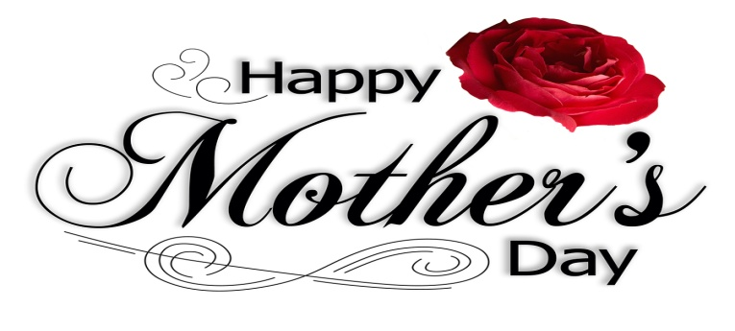
Springfield House Hotel
£24.95 Adults £14.95 Children

Cream of White Onion Soup topped with Parmesan Croutons
***
Pearls of Melon with Fresh Berries, Fruit Coulis & Refreshing Sorbet
***
Goats Cheese & Spring Onion Soufflé on Marinated Tomatoes with Pesto
***
Chicken Liver, Garlic & Rosemary Pate with Homemade Chutney & Melba Toast
***
Flaked Tuna, Cheese & Red Onion Parcel with Crisp Dressed Salad

****************************
Slow Roast Shoulder of Lamb with Glazed Red Cabbage & Light Jus
***
Salmon Fillet with a Chive Mash Potato drizzled with a Prawn & Champagne Sauce
***
Chicken Breast filled with a Spinach & Goats Cheese Mousse with a Tomato Coulis
***
Roast Beef with Seasonal Vegetables, Yorkshire Pudding & Red Wine Gravy
***
Stilton & Mushroom Puff Pastry Tart with Fresh Pesto

*********************

Selection of Desserts

***

Tea/Coffee & Mints
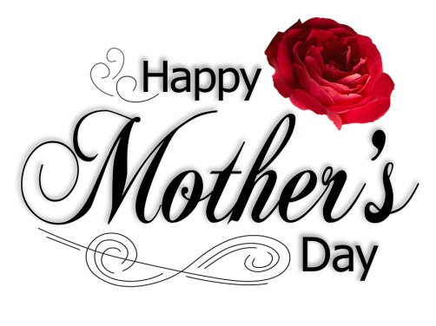
Desserts

Lemon Cream Crunch
Topped with Raspberries
***

Coffee Renoir
Filled with Crème Patisserie topped with Coffee Icing & Almonds
***

Sticky Toffee Pudding
With Toffee Sauce & Vanilla Ice Cream
***

Pineapple Upside Down Cake
Drizzled with Custard
***

Eton Mess
Crushed Meringue, Cream & Strawberries bound together
***
Selection of Wallings Ice-creams
************************

Tea/Coffee & Mints

