Cornwall Inshore Fisheries and Conservation Authority
Chi Gallos
Hayle Marine Renewables Business Park
North Quay
Hayle
Cornwall TR27 4DD
Tel: (01736) 336842
Fax: (01736) 336661
www.cornwall-ifca.gov.uk

Cornwall IFCA new netting byelaw

Informal Consultation on proposed measures - May 2019

Background
Cornwall IFCA is developing a new byelaw to protect salmon and sea trout in key coastal areas around Cornwall. These areas are either where these fish may congregate or where they migrate to and from the entrances to rivers and streams. This will replace an old byelaw which restricted the headline depth of nets in certain coastal areas.

In December 2018, we circulated a consultation to commercial and recreational fishermen, asking for anyone interested to share information with us about the range of netting activities that take place in specific coastal areas, including any interactions between nets and salmon and sea trout. We also asked for information about catches of these species by rod and line, in order to improve our knowledge about their distribution around the coast.

Using knowledge and information shared with us by stakeholders and by the Environment Agency, we have produced some proposals for net restrictions which could be included in a new byelaw. These areas, which are important for salmon and sea trout, are shown on the chartlet below. More detailed chartlets of the individual areas will be made available on our website www.cornwall-ifca.gov.uk/news

Please note: – the width of the areas have been drawn to illustrate their location and are not drawn to the scale shown on chartlet.

Where restricted areas are not inside a straight bay closing line, for example, in Mounts Bay, the areas along the coastline extend up to 0.5 nm offshore, except between Looe Bay and Cawsand Bay where the overall restricted area extends up to 1.0 nm offshore.

Existing restrictions on the use of most fixed and drift nets apply in the streams rivers and estuaries managed under the River and Estuarine Fishing Nets Byelaw 2017.

Byelaw proposals
The proposals made at this stage are to restrict netting in a number of areas. These cover far more of the coastline than the previous byelaw. There are two types of proposed areas shown on the chartlet: restricted (shaded black) and highly restricted (shaded red).

Within these areas, which are listed in full below as well as shown on the chartlet, the following measures have been proposed:

A: A person must not place or use a fixed net or drift net for fishing for or taking sea fish in a restricted area where the mesh size of the net is less than 170mm.

B: A person must not place or use a fixed net for fishing for or taking sea fish in a restricted area where the headline of the net is within three metres of the surface of the sea.

The proposed restricted areas (see chartlet for locations) are:

R1: Entrance to Boscastle, re the River Valency;
R2: Coastal area between Rumps Pt and Trevose Hd, re the River Camel;
R3: Coastal area between Trenance Pt and Towan Hd, re the Porth stream;
R4: Coastal area between Towan Hd and Penhale Pt, re the Gannel;
R5: Coastal area between Godrevy Pt and Clodgy Pt, re the Red River and Hayle River;
R6: Coastal area between Penlee Pt and Cudden Pt, re the Coombe River and Chyandour stream;
R7: Coastal area between Black Hd (Lizard) and Pendennis Pt, re the Helford and Fal estuaries;
R8: St Anthony Hd to Dodman Pt, re the Fal estuary and Caerhays stream;
R9: Dodman Pt to Black Hd (nr Mevagissey), re stream at Pentewan and St Austell river;
R10: Saint Catherine’s Pt to Udder Rk, re the River Fowey;
R11: Hore Stone to Picklecombe Pt, re the Looe River and Tamar rivers.

C: A person must not place or use any fixed net or drift net for fishing for or taking sea fish in a highly restricted area.

The proposed highly restricted areas (see chartlet for locations) are:

HR1: Coastal area between Merope Rocks and Roundhole Pt (Mother Ivey’s Bay and Harlyn Bay);
HR2: Coastal area between Shag Rk and Ligger Point (Perranporth beach);
HR3: Coastal area between Godrevy Pt, Hayle bar, St Ives Hd and Clodgy Pt (Godrevy beach, Porth Kidney, Carbis Bay, Porthmeor beach);
HR4: Coastal area between Penlee Pt, the gear pole and Cudden Pt (Gwavas lake, Longrock, Marazion, Boat Cove, Perranuthno);
HR5: Coastal area between Black Hd (nr Mevagissey) and St Catherines Pt (St Austell Bay, Cannis Rk, Polridmouth, Coombe Hawne);
HR6: Coastal area between Hore Stone, Looe Island, Rame Hd and Picklecombe Pt (Looe Bay, Whitsand Bay, Cawsand Bay).

Have your say

We are looking for your views about these proposals – there is a questionnaire below if you would like to fill this in.

This is part of the informal consultation stage and is intended to help us shape the byelaw to make it fit for purpose. The proposals are our current thoughts. There will probably be some changes made and you will have another opportunity to comment during the statutory formal consultation stage once the byelaw has been made. If you provide us with your contact details we will let you know when this formal consultation starts.

As this proposed byelaw covers a wide area, it is likely to be of interest to a lot of people. Some may be directly affected because they use nets in these areas whilst others may have a direct interest in fishing with hook and line for salmon and sea trout. This information will be sent to a range of organisations and individuals who we have contacts details for and you may wish to send your views in as part of an organisation or group of people. If you know of anybody who may be interested in responding to this consultation, please direct them to our website, or ask them to contact us and we will ensure they receive a copy of the questionnaire.

Please provide as much information as you can.
If you feel that the proposed restrictions (or lack of) will have a financial impact to yourself or your business, the details would be very helpful to know as we have to estimate the costs and benefits of any byelaws we make. This information is used for an impact assessment which will be considered by Defra alongside the byelaw, together with the comments made during the formal consultation stage.

If you feel the proposed restrictions should be changed in any way, it is also helpful if you can provide evidence to support your view.

At the end of the form below is a comments box for you to provide us with any other information that you think would be useful.

You can also download this questionnaire from our website, or you can request additional copies by contacting our office.

You do not have to complete the whole questionnaire and we will still consider forms with areas left blank, including your contact details.

If you can provide us with your name and contact details this would help us as we may wish to contact you for further information or clarification of any issues you raise. For more information about how we will use your personal data please see the statement at the end of the form.

You can complete this form electronically to enquiries@cornwall-ifca.gov.uk or respond by post to our office in Hayle. We would welcome completed forms back by 1 July 2019.

If you would rather speak directly to one of our officers, please call our office on 01736 336842.

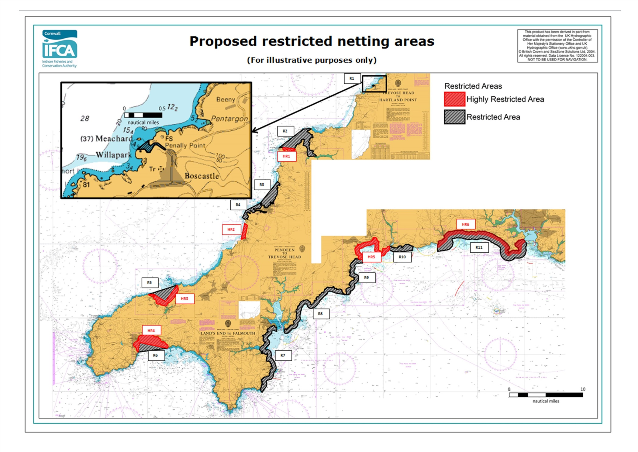

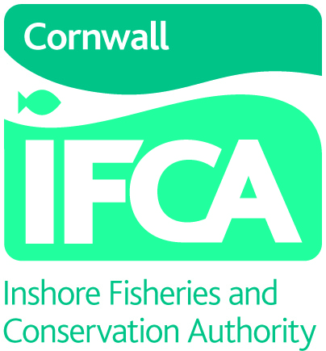 |  |  | Cornwall Inshore Fisheries and Conservation Authority  Chi Gallos  Hayle Marine Renewables Business Park  North Quay  Hayle  Cornwall TR27 4DD  Tel: 01736 336842  Email: enquiries@cornwall-ifca.gov.uk  www.cornwall-ifca.gov.uk
Your name

E-mail address

Postal Address

Please briefly describe your interest in this fishery

If you have a licienced fishing vessel, please can you include its name and PLN

☐ | Tick here if you would like to be contacted to in the event of future consultation on this byelaw.

The purpose of this byelaw is to protect salmon and sea trout around the Cornish coast, particularly around the entrances to rivers and estuaries, but also in a number of bays and along the open coast. It will replace an older byelaw which restricted the headline depth of fixed nets in certain areas, but the proposals are far wider and effect more types of netting.

Please read each of the questions below. Please tell us if these proposals will affect you and provide any additional information you would like. If you do not have a particular view on a proposal, please feel free to leave it blank.

Page left blank

Restricted areas R1 – R11
Within these areas, which are listed in full above as well as shown on the chartlet, the following measures have been proposed:

A: A person must not place or use a fixed net or drift net for fishing for or taking sea fish in a restricted area where the mesh size of the net is less than 170mm.

B: A person must not place or use a fixed net for fishing for or taking sea fish in a restricted area where the headline of the net is within three metres of the surface of the sea.

Q1: Do you fish in any of these restricted areas? If so, which one(s)?

☐ | Yes | ☐ | No
Comments:

Q2: Would these restrictions affect you? If so, what will they do?

Comments:

Q3: Would this have a financial impact on your business? If so, how much could this be annually?
Comments:

Q4: Would these restrictions make you change the way you fish, for example, different fishing methods or fish in a different area?

Comments:

Highly restricted areas HR1 –HR6

Within these areas, which are listed in full above as well as shown on the chartlet, the following measure has been proposed:

C: A person must not place or use any fixed net or drift net for fishing for or taking sea fish in a highly restricted area.

Q5: Do you fish in any of these highly restricted areas? If so, which one(s)?

☐ | Yes | ☐ | No
Comments:

Q6: Will these restrictions affect you? If so, what will they do?

Comments:

Q7: Would this have a financial impact on your business? If so, how much would this be annually?

Comments:

Q8: Would these restrictions make you change the way you fish, for example, different fishing methods or fish in a different area?

Comments:

Q9: Do you have any other comments you would like to make about this byelaw?

Comments:

How we will handle the information you give us.
We (Cornwall IFCA) are asking you to provide us with your personal information. We will hold this information securely and will only use it in connection with this byelaw making process.
Your name and contact information:
We will not pass your personal details on or make them public and we will not use your details to contact you for any reason outside of this byelaw making process.
The information you provide to us in responding to the questions:
The information you provide us with will be stored in connection with your name and contact details to allow us to contact you if the information you provide is of particular use.
We may wish to use some of the figures you provide on this form in public documents as part of the byelaw process, however, this will not be used in a way which could identify you, or harm your business or personal interests.
How long we will hold the information:
This is an informal consultation and is an opportunity for us to engage with key stakeholders as part of shaping the new byelaw. We anticipate this will be a relatively quick process as we hope to have the byelaw made in this financial year. As such we will delete any personal information you provide on 1 April 2020, or if you contact us to request it is deleted sooner.
How you can request your information to be deleted:
You can request that the personal information you supply as part of this process is deleted at any time by contacting us at our office by telephone, email or letter.

