|  |  |  |  |
| --- | --- | --- | --- |
| IFCA_Cornwall_Col | **FAL FISHERY ORDER 2016**  **MONTHLY SHELLFISH CATCH STATISTICS FORM**  **A RETURN MUST BE MADE EVERY MONTH, EVEN FOR NIL RETURNS**  **Please return completed form to Cornwall IFCA within two weeks of reporting month end** |  |  |
| Month |
|  |  |
| Year |

|  |  |  |  |  |  |  |  |  |  |  |  |  |  |  |  |
| --- | --- | --- | --- | --- | --- | --- | --- | --- | --- | --- | --- | --- | --- | --- | --- |
| Date | **Fishing Method**  (one method/line) | | **Time spent fishing**  (hours) | | | **Native Oysters**  (weight in kg) | | | **Other species**  (weight in kg) | | | | | | **Pest species**  (kg) |
| Dredging/  Hand-  gathering | No of licences  in use | (see areas overleaf) | | | Removed from  fishery | | Removed from  lay area  for sale | Mussels | Scallops | Queens | Cockles | Pacific Oysters | Other  (please state) | Slipper  limpets  destroyed |
| A | B | C | for  sale | for  lay area |
| 3rd  EXAMPLE | H | 2 |  |  | 2 | 4 | 1 |  |  |  | 0.5 |  |  | Winkles 1 |  |
| 3rd | D | 4 | 11/2 | 3 |  | 15 | 2 |  | 1 | 0.2 | 2 |  |  |  | 1 |
| 5th | H | 1 |  |  | 2 | 2 | 0.5 | 5 |  |  |  |  |  |  |  |
| 1 |  |  |  |  |  |  |  |  |  |  |  |  |  |  |  |
| 2 |  |  |  |  |  |  |  |  |  |  |  |  |  |  |  |
| 3 |  |  |  |  |  |  |  |  |  |  |  |  |  |  |  |
| 4 |  |  |  |  |  |  |  |  |  |  |  |  |  |  |  |
| 5 |  |  |  |  |  |  |  |  |  |  |  |  |  |  |  |
| 6 |  |  |  |  |  |  |  |  |  |  |  |  |  |  |  |
| 7 |  |  |  |  |  |  |  |  |  |  |  |  |  |  |  |
| 8 |  |  |  |  |  |  |  |  |  |  |  |  |  |  |  |
| 9 |  |  |  |  |  |  |  |  |  |  |  |  |  |  |  |
| 10 |  |  |  |  |  |  |  |  |  |  |  |  |  |  |  |
| 11 |  |  |  |  |  |  |  |  |  |  |  |  |  |  |  |
| 12 |  |  |  |  |  |  |  |  |  |  |  |  |  |  |  |
| 13 |  |  |  |  |  |  |  |  |  |  |  |  |  |  |  |
| 14 |  |  |  |  |  |  |  |  |  |  |  |  |  |  |  |
| 15 |  |  |  |  |  |  |  |  |  |  |  |  |  |  |  |
| 16 |  |  |  |  |  |  |  |  |  |  |  |  |  |  |  |
| 17 |  |  |  |  |  |  |  |  |  |  |  |  |  |  |  |
| 18 |  |  |  |  |  |  |  |  |  |  |  |  |  |  |  |
| 19 |  |  |  |  |  |  |  |  |  |  |  |  |  |  |  |
| 20 |  |  |  |  |  |  |  |  |  |  |  |  |  |  |  |
| 21 |  |  |  |  |  |  |  |  |  |  |  |  |  |  |  |
| 22 |  |  |  |  |  |  |  |  |  |  |  |  |  |  |  |
| 23 |  |  |  |  |  |  |  |  |  |  |  |  |  |  |  |
| 24 |  |  |  |  |  |  |  |  |  |  |  |  |  |  |  |
| 25 |  |  |  |  |  |  |  |  |  |  |  |  |  |  |  |
| 26 |  |  |  |  |  |  |  |  |  |  |  |  |  |  |  |
| 27 |  |  |  |  |  |  |  |  |  |  |  |  |  |  |  |
| 28 |  |  |  |  |  |  |  |  |  |  |  |  |  |  |  |
| 29 |  |  |  |  |  |  |  |  |  |  |  |  |  |  |  |
| 30 |  |  |  |  |  |  |  |  |  |  |  |  |  |  |  |
| 31 |  |  |  |  |  |  |  |  |  |  |  |  |  |  |  |
| **If you had two different activities on the same day, i.e. Dredging and Hand Gathering, enter the details below for the extra activity** | | | | | | | | | | | | | | | |
|  |  |  |  |  |  |  |  |  |  |  |  |  |  |  |  |
|  |  |  |  |  |  |  |  |  |  |  |  |  |  |  |  |
|  |  |  |  |  |  |  |  |  |  |  |  |  |  |  |  |
|  |  |  |  |  |  |  |  |  |  |  |  |  |  |  |  |
|  |  |  |  |  |  |  |  |  |  |  |  |  |  |  |  |

|  |  |  |  |  |  |  |  |  |  |  |  |  |  |  |  |  |  |  |  |  |  |
| --- | --- | --- | --- | --- | --- | --- | --- | --- | --- | --- | --- | --- | --- | --- | --- | --- | --- | --- | --- | --- | --- |
| ***Nil fishing***  ***this month*** | |  | If no fishing has been  carried out this month,  please tick this box. | | | | | | ***Activities finished until*** (advise month)  *…………………………………………………………………..* | | | | | | | ***Activities***  ***finished for***  ***this season*** |  | If you are not intending to take any further oysters or mussels from the Fal Fishery area up to 30th Sept. please tick this box. | | | |
| **I certify that the information given is correct to the best of my knowledge and belief.** | | | | | | | | | | | | | | | | | | | | | |
| Licence No. | |  | | Name | | |  | | | | | | | | Signature |  | | | | Date | // |
| BLOCK CAPITALS | | | | | | | | | | | | | | | DDMMYY | | | | | | |
|  | | | | | | | | | | | | | | | | | | | | | |
| **FOR OFFICE USE ONLY** | | | | S/S | **🞎** | Sc | | **🞎** | | NIL | Ent | **🞎** | Row |  | Received date |  | | |  | | |
| **Comments** | | | | | | | | | | | | | | | | | | | | |

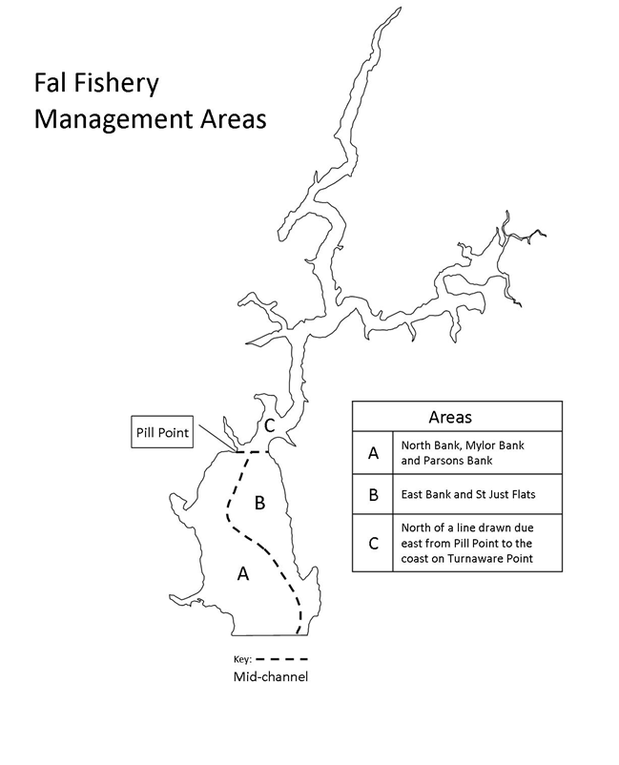

|  |
| --- |
| **Data Protection Statement**  The data supplied on this form is covered by the General Data Protection Regulations 2016. Cornwall IFCA has the right to process this data under Article 6(1)(c) of this Act as your data fulfils a legislative function. Your data is processed by Cornwall IFCA under a legal obligation conferred in Sections 1 and 4(2) of the Sea Fisheries (Shellfish) Act 1967 Act and Section 15(3) of the Sea Fisheries Act 1968 as is required in the Fal Fishery Order 2016.  The data is also held securely on Cornwall Council’s network of servers. We retain your data for two years following your application for a licence, after which it will be removed and paper copies destroyed. Electronic copies will have personal data removed two years after the date on which the licence was issued.  If you would like to access any of the information we hold about you, or you have concerns regarding the way we have processed your information, please contact: Simon Mansell, Data Protection Officer, Cornwall Council, County Hall, Treyew Road, Truro, Cornwall TR1 3AY. Telephone 01872 326424 or email [dpo@cornwall.gov.uk](mailto:dpo@cornwall.gov.uk) |

|  |  |  |  |
| --- | --- | --- | --- |
|  | **Cornwall IFCA**  **Office 2, Chi Gallos**  **Hayle Marine Renewables Business Park**  **North Quay**  **Hayle**  **Cornwall TR27 4DD** |  |  |
|  |
|  |
|  |
|  |
|  |
|  |
|  | Tel: 01872 324284  E-mail: enquiries@cornwall-ifca.gov.uk |