0020

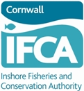 | Cornwall IFCA Monthly Shellfish Statistics  These return forms are required every month and are to be submitted to the Authority by the 15th day of the following month
Name of Vessel: |  |  | Reg No: |  | Permit No:
Base Port:  (main berthing port) |  |  | Month: |  | Year:

 | Area Code  (six figures) |  |  |  |  | Gear |  | Other methods | Species  (estimated weights in kilos)
Day | Please advise only  one main area fished  each day. Complete in  same format as below.  Example for guidance only  29 E4 7 A |  |  |  |  | No. | Metres | (advise) | Edible Crab |  | Spider Crab | Lobster | Crawfish | Velvet  Crab | Green Crab | Crab Claws
Day |  |  |  |  |  | Pots  hauled | Nets  hauled | (T) Trawling  (S) Scalloping | Cocks | Hens |  |  |  |  |  | Edible | Spider
1
2
3
4
5
6
7
8
9
10
11
12
13
14
15
16
17
18
19
20
21
22
23
24
25
26
27
28
29
30
31
FOR OFFICE USE ONLY |  |  |  |  |  | Pots | Nets | Other methods | Cocks | Hens | Spiders | Lobster | Crawfish | Velvets | Green | Ed Claw | Sp Claw
Comments: |  |  | If you wish to provide extra information for byelaw/research purposes, please tick this box and write in the comments box overleaf

A SHELLFISH RETURN MUST BE MADE EVERY MONTH, TO ARRIVE AT THE  CORNWALL IFCA OFFICE NO LATER THAN THE 15TH OF THE FOLLOWING MONTH |  |  | IF THIS IS YOUR LAST SHELLFISH STATS RETURN FOR A WHILE
If there has been ‘nil’ shellfishing in the Cornwall IFCA District this month, please tick the “no fishing” box and give a reason for this.  e.g. outside 6 mile limit, boat re-fit, holiday, illness etc. |  | No shellfishing  in District  this month | For example, gear brought in. Please advise the month you expect to re-commence fishing. Statistics will be due again from that month.
 |  | No shellfishing  in District  this month | I have stopped shellfishing
Reason |  |  | I plan to re-start (advise month)

I certify that the information I have provided is  correct to the best of my knowledge and belief. | Signature of Owner or Representative: |  | Date:

 |  | FOR OFFICE USE ONLY |  |  |  |  |  |  | Please do not write below this line
 |  | S/S |  | Sc |  | NIL |  | Ent |  |  | Row: |  | Received date |  | Nov 2023

Comments

Data Protection Statement
The data supplied on this form is covered by the General Data Protection Regulations 2016. Cornwall IFCA has the right to process this data under Article 6(1)(c) of this Act as your data fulfils a legislative function. Your data is processed by Cornwall IFCA under a legal obligation conferred in sections 155 and 156 of the Marine and Coastal Access Act 2009 to process your permit, as is required in the Lobster, Crawfish and Crab Fishing Permit Byelaw 2016. We retain your data for two years following your application for a permit, after which it will be removed and destroyed. Electronic copies also have personal data removed two years after the permit has been issued. If you would like to access any of the information we hold about you, or you have concerns regarding the way we have processed your information, please contact: Simon Mansell, Data Protection Officer, Cornwall Council, County Hall, Treyew Road, Truro, Cornwall TR1 3AY. Telephone 01872 326424 or email dpo@cornwall.gov.uk

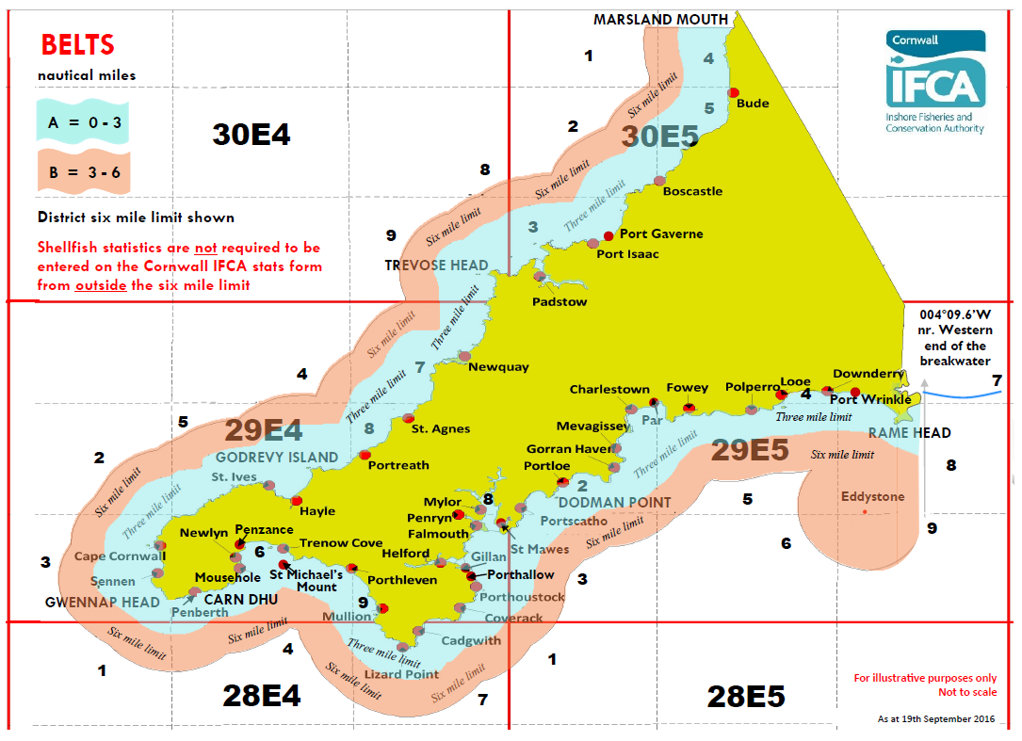

REMINDERS BEFORE SUBMITTING

- Have you advised the full six-figure area code for the main area fished each day? ICES rectangle, sub-rectangle and belt A or B is required.
That is the big red rectangle code, then the smaller sub-rectangle number and then the belt, either A or B. A = 0-3 nautical miles from shore and B = 3-6 nautical miles from shore. E.g. if the main fishing area is within 3nm north of Newquay = 29E47A.
- Cornwall IFCA do not require stats for shellfish caught outside the six mile limit, so do not advise belts C or D on the IFCA stats form.
- Only enter belts A or B on the form – Belt A for the area shaded blue on the District map (or this will appear as the light grey band on black & white copies) or Belt B for the area shaded pink on the map (or this will show as the darker grey band on black & white copies).
- If there was no shellfishing activity at all, or all activity was outside six miles, just tick the nil fishing box on the bottom left of the form. Please note, there is a requirement to submit a monthly return, even if it is a nil.
- On returns that have shellfish activity, have you advised the gear hauled each day?
- Have you estimated in kgs your catch for each species each day?
- Have you signed and dated the form?
- If posting the form, please ensure the correct postage is paid. Underpaid items will not be collected from the Post Office/Sorting Office.
- To save on postage, you can photograph your stats and email them to Cornwall IFCA (please ensure you capture the whole page in the photo, including the OFFICE ONLY section at the bottom) and attach them in an email to enquiries@cornwall-ifca.gov.uk

 | Please return the completed form to:  Cornwall IFCA  Office 2, Chi Gallos  Hayle Marine Renewables Business Park  North Quay  Hayle  Cornwall TR27 4DD | ENQUIRIES  telephone: 01872 324284  e-mail: enquiries@cornwall-ifca.gov.uk  website: www.cornwall-ifca.gov.uk

