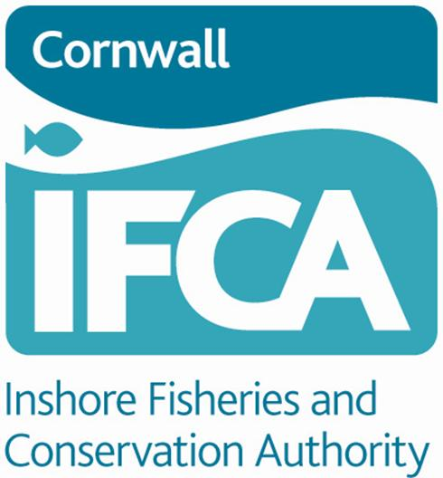
Cornwall IFCA Live Wrasse Fishing Permit

How to apply for a permit 2021 Season

It is an offence to retain live wrasse aboard a commercially licensed vessel from the Cornwall IFCA district unless you hold a Live Wrasse Fishing Permit.

A maximum of five permits will be in circulation at any time. Permits will be issued on a first come first served basis with priority being given to current permit holders.

Applications will only be accepted by Cornwall IFCA after 9am on 2 November. After midnight on the 31 December all permits issued for the previous year will end and as such any unassigned permits will be issued on a first come first served basis.

In order to apply for a live wrasse fishing permit you will need to:
- Complete a Cornwall IFCA Live Wrasse Fishing Permit Application form;
- Provide a copy of the current, valid, Certificate of Registry for the vessel
- A copy of your vessel license; and
- A copy of a contract with a registered fish buyer (under either the English or Scottish registration schemes). The contract must:
  - State that the buyer will require live wrasse to be supplied from the Cornwall IFCA district for the calendar year stated;
  - State the name and address of the registered fish buyer and must be signed and dated by that buyer.

Applications will not be accepted to the Cornwall IFCA office. All applications must be sent to the following address.

Cornwall IFCA Live Wrasse Fishing Permit

Howell Hylton,
24 Cross Street,

Camborne,
Cornwall TR14 8EX

Applications from those not currently holding a Cornwall IFCA Live Wrasse Fishery Permit will be placed on a waiting list on a first come first served basis any available permits will be issued according to this waiting list.

If you are successful in your application you will need to provide the Cornwall IFCA office with £135, by bank transfer or cheque, within 21 days of notification. If payment is not received within this period the offer of a permit will be withdrawn and the permit will be made available for those vessels on the waiting list.

