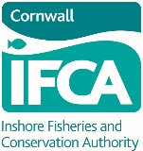
Cornwall IFCA Live Wrasse Fishery
Permit Application Form
* Denotes a mandatory field.
*Applicants Details:
(Applicant must be a registered owner or nominated representative of a corporate owner, in respect of the vessel to be used for live wrasse fishing)
Name:
Address:

Email address:
Contact Number:
*Vessel Name
*Vessel PLN
*Official number (RSS no.):

* Registered owners

Please provide the address and contact telephone number for all registered owners of the named vessel
Master(s) of vessel
(At the time of application, if different from applicant)

Please provide the address and a contact telephone number of the master(s)
We would like to keep you informed about upcoming changes to legislation, informal consultations on future byelaws
and wider initiatives that may affect you. If you are happy to receive this information, please tick this box. ⃞
(Please note that you can withdraw consent at any time by contacting our office by phone, email, letter or in person)

Applicant Signature : | …………………………………………….…………… | Date : | ………………………………………

In order to help us manage the fishery for live wrasse within our district we would appreciate you giving some information on your expected activities in the following year. The following questions are to help us and they won’t limit your activities to the answers you give.

Please indicate the number of pots you
expect to use in the Cornwall IFCA District
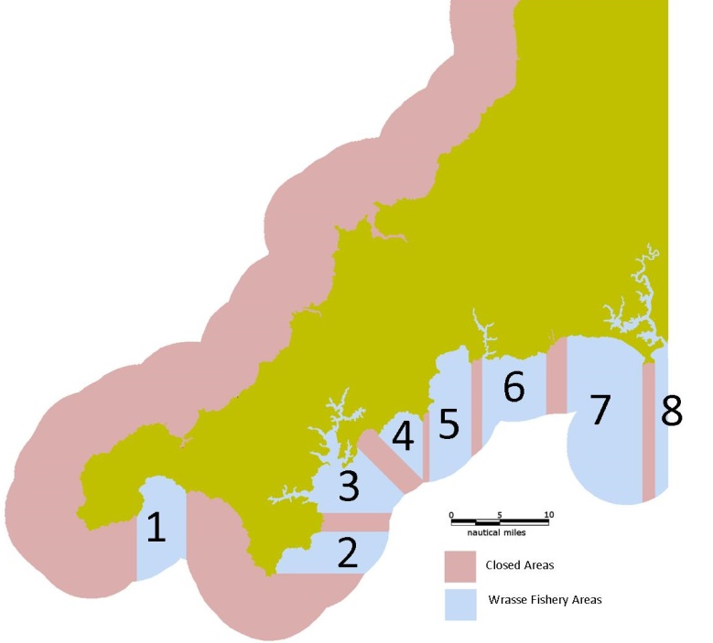
Please indicate the areas in which you intend to fish for live wrasse

1
2
3
4
5
6
7
8

Please confirm that the following are enclosed in your application pack:
- A copy of a contract signed by a registered fish buyer, for the relevant year, which includes:
- Requirement by the registered fish buyer for a supply of live wrasse from the District, with reference to the calendar year for which the contract is made;
- Name and address of the registered fish buyer, signed and dated by the registered fish buyer;
- Name and address of the person who requires a permit to supply the buyer with live wrasse.
- I have enclosed a copy of the current Certificate of Registry for the fishing vessel named in this application.

- I have enclosed a copy of the vessel’s fishing licence
Applications must be delivered in a sealed plain A4 envelope, with “Live wrasse permit application" printed (by hand or machine) on the front, across the top of the envelope. There are to be no signs/logos on the envelope that identify the permit applicant or the vessel to be used for fishing for live wrasse.
Please send your application pack to:

Cornwall Inshore Fisheries and Conservation Authority
Office 2, Chi Gallos
Hayle Marine Renewables Business Park
North Quay
Hayle
Cornwall TR27 4DD

Data Protection Statement The data supplied on this form is covered by the General Data Protection Regulations 2016. Cornwall IFCA has the right to process this data under Article 6(1)(c) of this Act as your data fulfils a legislative function. Your data is processed by Cornwall IFCA under a legal obligation conferred in sections 155 and 156 of the Marine and Coastal Access Act 2009 to process your permit, as is required in the Live Wrasse Fishing (Limited Permit) Byelaw 2018. We retain your data for two years following your application for a permit, after which it will be removed and destroyed. Electronic copies also have personal data removed two years after the permit has been issued. If you would like to access any of the information we hold about you, or you have concerns regarding the way we have processed your information, please contact: Simon Mansell, Data Protection Officer, Cornwall Council, County Hall, Treyew Road, Truro, Cornwall TR1 3AY. Telephone 01872 326424 or email dpo@cornwall.gov.uk

