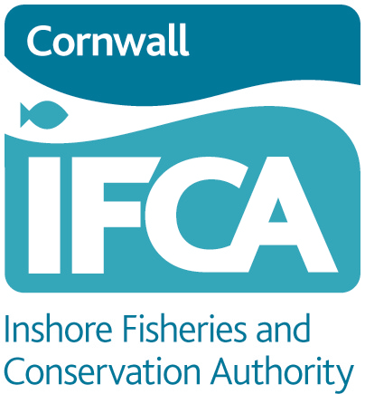

Cornwall IFCA Live Wrasse Fishing (Limited Permit) Byelaw 2018

Application Process for a Live Wrasse Fishing Permit 2021 season
The Live Wrasse Fishing (Limited Permit) Byelaw 2018 makes it an offence for a person to retain live wrasse on board a fishing vessel or land live wrasse from a vessel unless the owner of the vessel holds a relevant permit issued by Cornwall IFCA. This restriction does not apply to a person using an unregistered and unlicensed vessel, where the wrasse is not for sale.

Applications for a Live Wrasse Fishing Permit must be made using the application form provided by Cornwall IFCA.
A maximum of five valid permits will be in circulation at any one time.
The permit application process is set out below, defining the information an applicant will need to provide, when and how to submit it.
Incomplete applications or incorrectly submitted applications will not be accepted.
Cornwall IFCA will prioritise to whom a permit will be offered, by following this process:
- After the first year, priority for the issuing of a new permit for the next calendar year will be given to a person already holding a permit. However, the priority will only apply to such a person where their new permit application is correctly completed and received to the specified address during the application window, and prior to the 31 of December in the year for which a valid permit is currently held. After December, a later valid application for a permit for the year in question will be dealt with in the same way as any other applicant who does not have a current permit, on a first come first serve basis.
- Where applications are received at the same time, for example in the same post, a priority order will be determined by drawing lots for those applications that were received at the same time;
- Individuals can only own one permit, and may only take up one place on the waiting list. Should somebody simultaneously submit more than one correctly completed application for a permit, Cornwall IFCA will reject all such applications from that individual.
- Only one application will be accepted per vessel.
- Applications must consist of a single pack containing:
- A fully completed application form, as provided by the Authority, signed by the named applicant;
- A copy of the current, valid, Certificate of Registry for the vessel
- A copy of your vessel license; and
- A copy of a contract with a registered fish buyer (under either the English or Scottish registration schemes). The contract must:
  - State that the buyer will require live wrasse to be supplied from the Cornwall IFCA district for the calendar year stated;
  - State the name and address of the registered fish buyer and must be signed and dated by that buyer.

  - Successful applicants will be informed in writing, and then have 20 days from the date of the letter in which to confirm that they accept the offer of a permit and provide Cornwall IFCA with a £135 fee (payable by cheque or bank transfer). Please note that funds must have cleared within the 20 days, so if for example payment is by cheque, it must be in time for it to be presented to our bank and money entered into our account, within the 20 day period.
While processing a permit, if any of the details in the original application are found to be incorrect, acceptance of the offer of a permit is not confirmed or the fee is not received/paid in time, or if the buying contract is not deemed to be valid (see application form for details) the application will be considered void, any offer of a permit will be withdrawn, any money received will be reimbursed. Where a requirement to hold a permit remains, the applicant would need to submit a new application.
As applications are considered on a first come first served basis (aside from the previously mentioned prioritisations), when there are five permits in circulation, a live wrasse fishing permit waiting list will be used. Where applications are received at the same time, lots will be drawn to determine where applicants are placed on the waiting list.
If a permit holder chooses to relinquish their permit at any point in the year, the person at the top of the waiting list will be given first refusal for that permit. The waiting list will be cleared each year and any person wishing to be considered for a permit in the following year will need to apply again, as described above.
Please note if a person is convicted of an offence, accepts a Financial Administrative Penalty or a Caution for an offence prescribed under the Live Wrasse Fishing (Limited Permit) Byelaw 2018, the individual will lose their permit for the remainder of that year and no application from them or any owner of the vessel used for fishing illegally for live wrasse will be considered by the Authority for the following year.
Each permit will expire at midnight on the 31st December of the year for which it was issued. During the year for which any permits are current, applications for permits in the following calendar year will be invited from a date specified by the Authority. Any applications received prior to that date in respect of a permit for the following year, will not be valid or accepted for processing.

