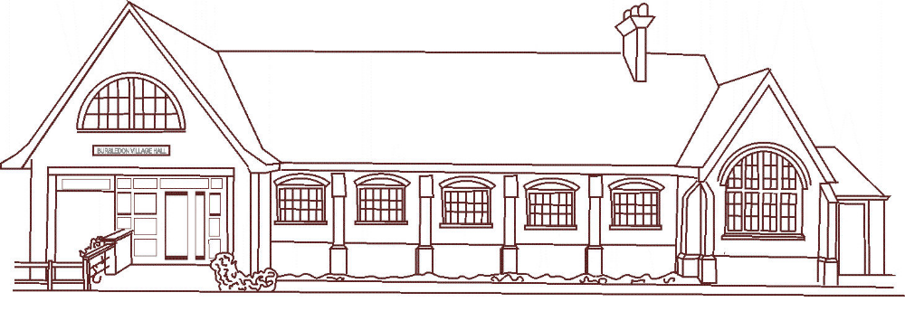
BURSLEDON VILLAGE HALL
CINEMA CLUB
THIRD FRIDAY OF EVERY MONTH
(EXCEPT AUGUST)
AT
7.30PM
NEWLY RELEASED DVD’s ON A LARGE SCREEN

NEW MEMBERS WELCOME
ADMISSION TO MEMBERS ONLY
ANNUAL MEMBERSHIP £25 (FROM DATE OF JOINING)
NO ENTRANCE FEE

WINE BEER SOFT DRINKS TEA COFFEE CRISPS
ON SALE

For further information contact
Pat Hall (02380 403706) John Spiers (02380 403403)

