15 ROCKWELL CRESCENT, THURSO, KW14 7PL
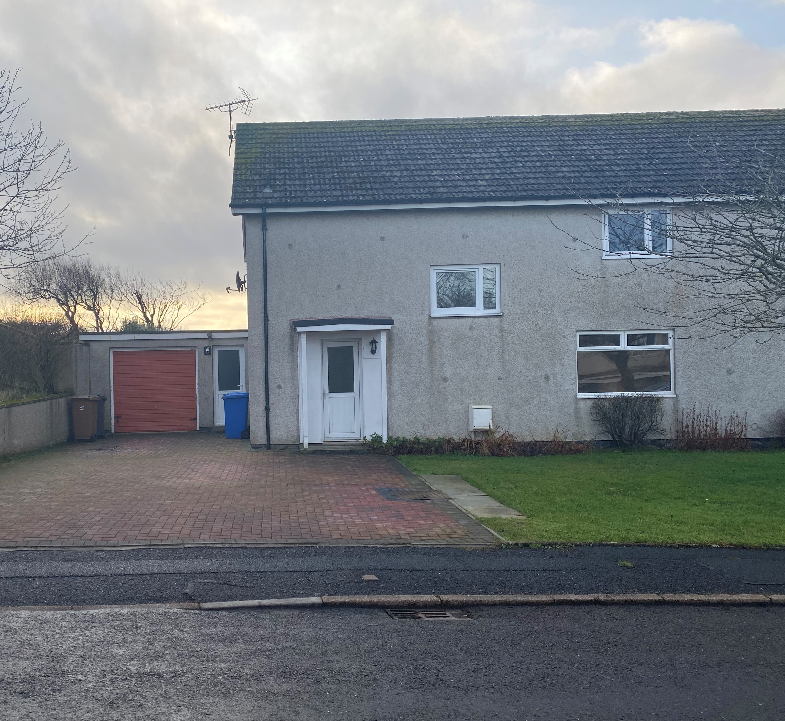

LETTING INFORMATION
CLOSING DATE: 28 January 2020
RENT: £492.10
COUNCIL TAX BAND: B
DATE ADVERTISED: 21 January 2020

KEY FEATURES

- Rent £492.10 per calendar month | - 4 bed semi-detached house
 | - Gas central heating
- Open plan front garden and enclosed back garden

- Garage attached

FULL DESCRIPTION
Pentland Housing Association Ltd has a four bedroom property in Thurso, just a short walk from the town centre, schooling and other amenities. Accommodation comprises lounge, kitchen, 4 bedrooms, WC and a bathroom. The property benefits from gas central heating. It has an open plan front garden and an enclosed back garden and garage attached.
WHO CAN BID:
- Couple/parent with two, three or more children | - Transfer applicants looking to upsize
- Homeless clients with a 3 or 4 bed need

HOW TO BID:
All bids must be in by the above closing date. To register interest in this property fill out the registered interest form. This can be found at any of the offices or your local service point, and return to any of the following services:
- cbl@pentlandhousing.co.uk | - Thurso Service Point
- Wick Service Point | - Pentland Housing Association Ltd
- CAB Thurso | - CAB Wick

USEFUL LINKS:
- Local information: https://www.streetcheck.co.uk/postcode/kw148ae
- Google maps: https://maps.google.co.uk/maps?output=classic&dg=brw
- Council tax bands: http://www.highland.gov.uk/info/701/council_tax/523/council_tax/3

