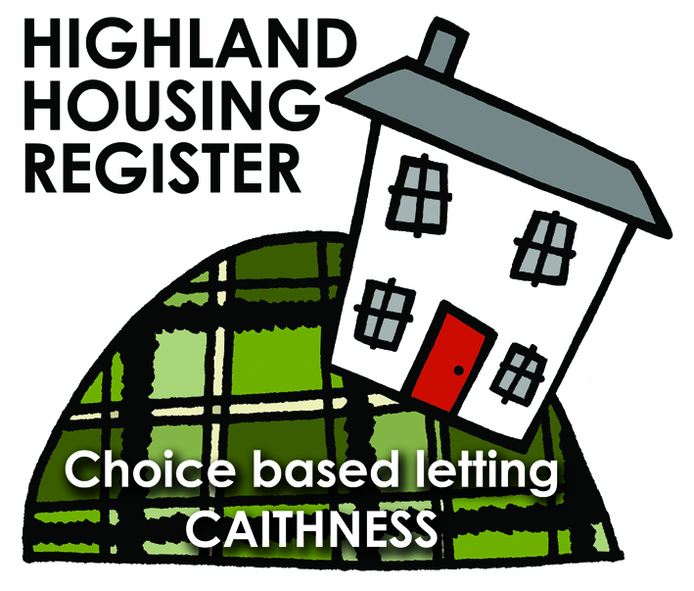
Pentland Housing Association Ltd
34 Telford Street, Wick, KW1 5EQ
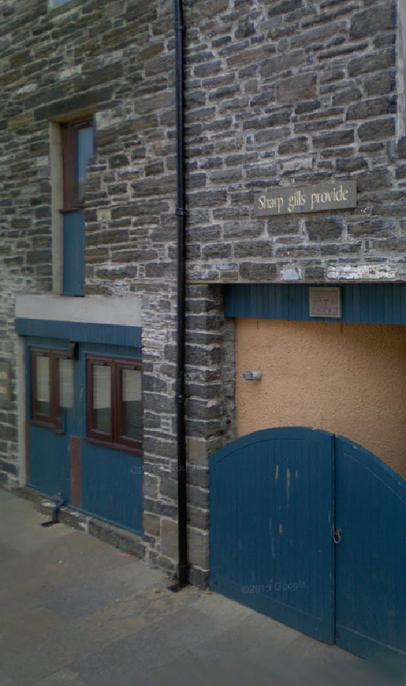

LETTING INFORMATION

CLOSING DATE: 28 January 2020

RENT: £396.49 per calendar month
£91.50 per week

COUNCIL TAX BAND: B

DATE ADVERTISED: 21 January 2020

KEY FEATURES
- Rent £396.49 pcm |  | - 3 Bed, Terraced House
- EPC Rating C |  | - Gas Heating
FULL DESCRIPTION
Pentland Housing Association Ltd has a three bedroom terraced house in Wick, just a short walk from the town centre and other amenities. Accommodation comprises living room, kitchen/diner, three bedrooms, WC and a bathroom. The property benefits from gas central heating.

WHO CAN BID:
- Couple/parent with 2, 3 or more children | - Transfer applicants looking to downsize or upsize
- Homeless clients with a 2 or 3 bed need

HOW TO BID:
All bids must be in by the above closing date. To register interest in this property, fill out the registered interest form. This can be found at any of the offices or your local service point, and return to any of the following services:
- cbl@pentlandhousing.co.uk | - Thurso Service Point
- Wick Service Point | - Pentland Housing Association Ltd
- CAB Thurso | - CAB Wick

USEFUL LINKS:
- Local information: https://www.streetcheck.co.uk/postcode/kw148ae
- Google maps: https://maps.google.co.uk/maps?output=classic&dg=brw
- Council tax bands: http://www.highland.gov.uk/info/701/council_tax/523/council_tax/3

