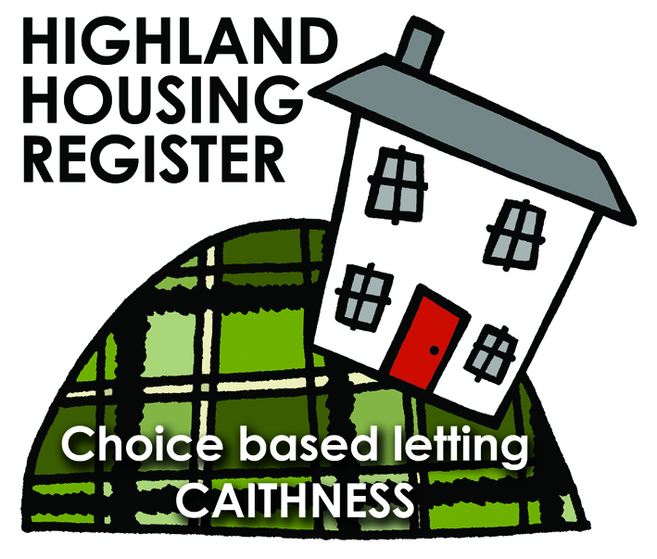
Pentland Housing Association Ltd
12 Strathmore Road, Thurso KW14 7PR
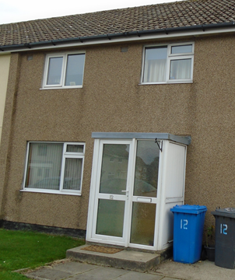
LETTING INFORMATION
CLOSING DATE:
17 October 2018

RENT: £365.94

COUNCIL TAX BAND: A

DATE ADVERTISED:
10 October 2018
KEY FEATURES
- Rent £365.94 per month | - 3 Bed Semi-Detached House
 | - Electric heating
- Open plan front garden, enclosed rear garden

FULL DESCRIPTION
Pentland Housing Association Ltd has a three bedroom semi-detached property in Thurso, just a short walk from the town centre, schooling and other amenities. Accommodation comprises lounge, kitchen/diner, three bedrooms and a bathroom. The property benefits from electric heating. It has an open plan front garden and an enclosed back garden.

WHO CAN BID:
- Couple/parent with two, three or more children | - Transfer applicants looking to upsize or downsize
- Homeless clients with a 2 or 3 bed need

HOW TO BID:
All bids must be in by the above closing date. To register interest in this property fill out the registered interest form. This can be found at any of the offices or your local service point, and return to any of the following services:
- cbl@pentlandhousing.co.uk | - Thurso Service Point
- Wick Service Point | - Pentland Housing Association Ltd
- CAB Thurso | - CAB Wick

USEFUL LINKS:
- Local information: https://www.streetcheck.co.uk/postcode/kw148ae
- Google maps: https://maps.google.co.uk/maps?output=classic&dg=brw
- Council tax bands: http://www.highland.gov.uk/info/701/council_tax/523/council_tax/3
