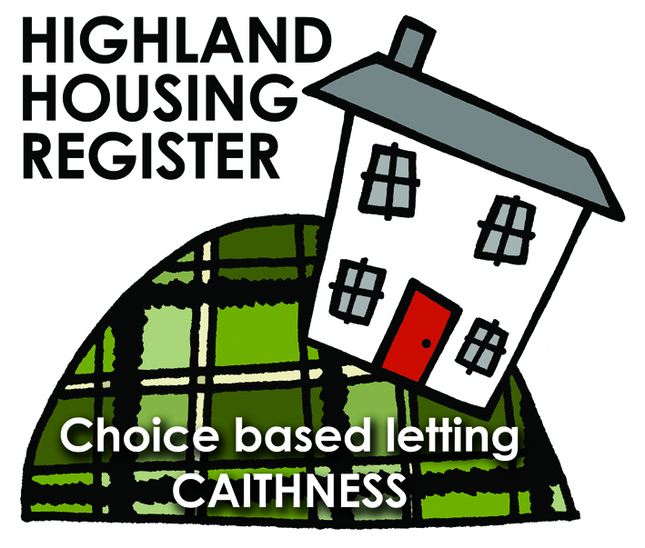
Pentland Housing Association Ltd
13 St Peters Road, THURSO, KW14 7NQ

LETTING INFORMATION
CLOSING DATE:
16 February 2018

RENT: £411.08

COUNCIL TAX BAND: A

DATE ADVERTISED:
09 February 2018
KEY FEATURES

- Rent currently £411.08 per calendar month | - 4 Bed Semi-Detached House
- Open plan front garden and enclosed back garden | - Gas central heating
- Downstairs low level shower

FULL DESCRIPTION
Pentland Housing Association Ltd has a four bedroom semi-detached property in Thurso. Just a short walk from the town centre, schooling and other amenities. Accommodation comprises lounge, kitchen/diner, toilet, four bedrooms, upstairs bathroom, downstairs low level access shower and toilet. The property benefits from gas central heating. It has an open plan front garden and a enclosed back garden.
WHO CAN BID:
- Couple/parent with three, four or more children | - Transfer applicants looking to upsize
- Homeless clients with a 4 bed need

HOW TO BID:
All bids must be in by the above closing date. To register interest in this property fill out the registered interest form. This can be found at any of the offices or your local service point, and return to any of the following services:
- cbl@pentlandhousing.co.uk | - Thurso Service Point
- Wick Service Point | - Pentland Housing Association Ltd
- CAB Thurso | - CAB Wick

USEFUL LINKS:
- Local information: https://www.streetcheck.co.uk/postcode/kw148ae
- Google maps: https://maps.google.co.uk/maps?output=classic&dg=brw
- Council tax bands: http://www.highland.gov.uk/info/701/council_tax/523/council_tax/3
