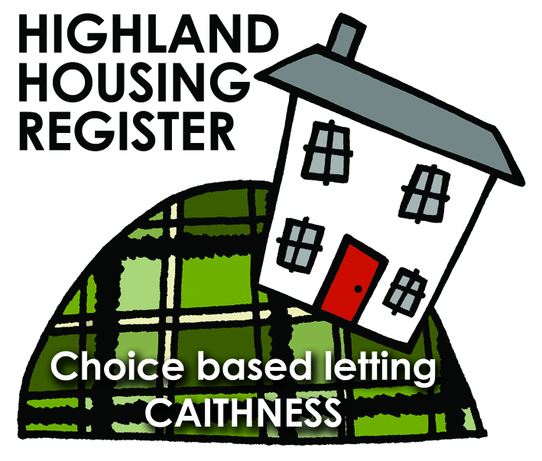
Pentland Housing Association Ltd
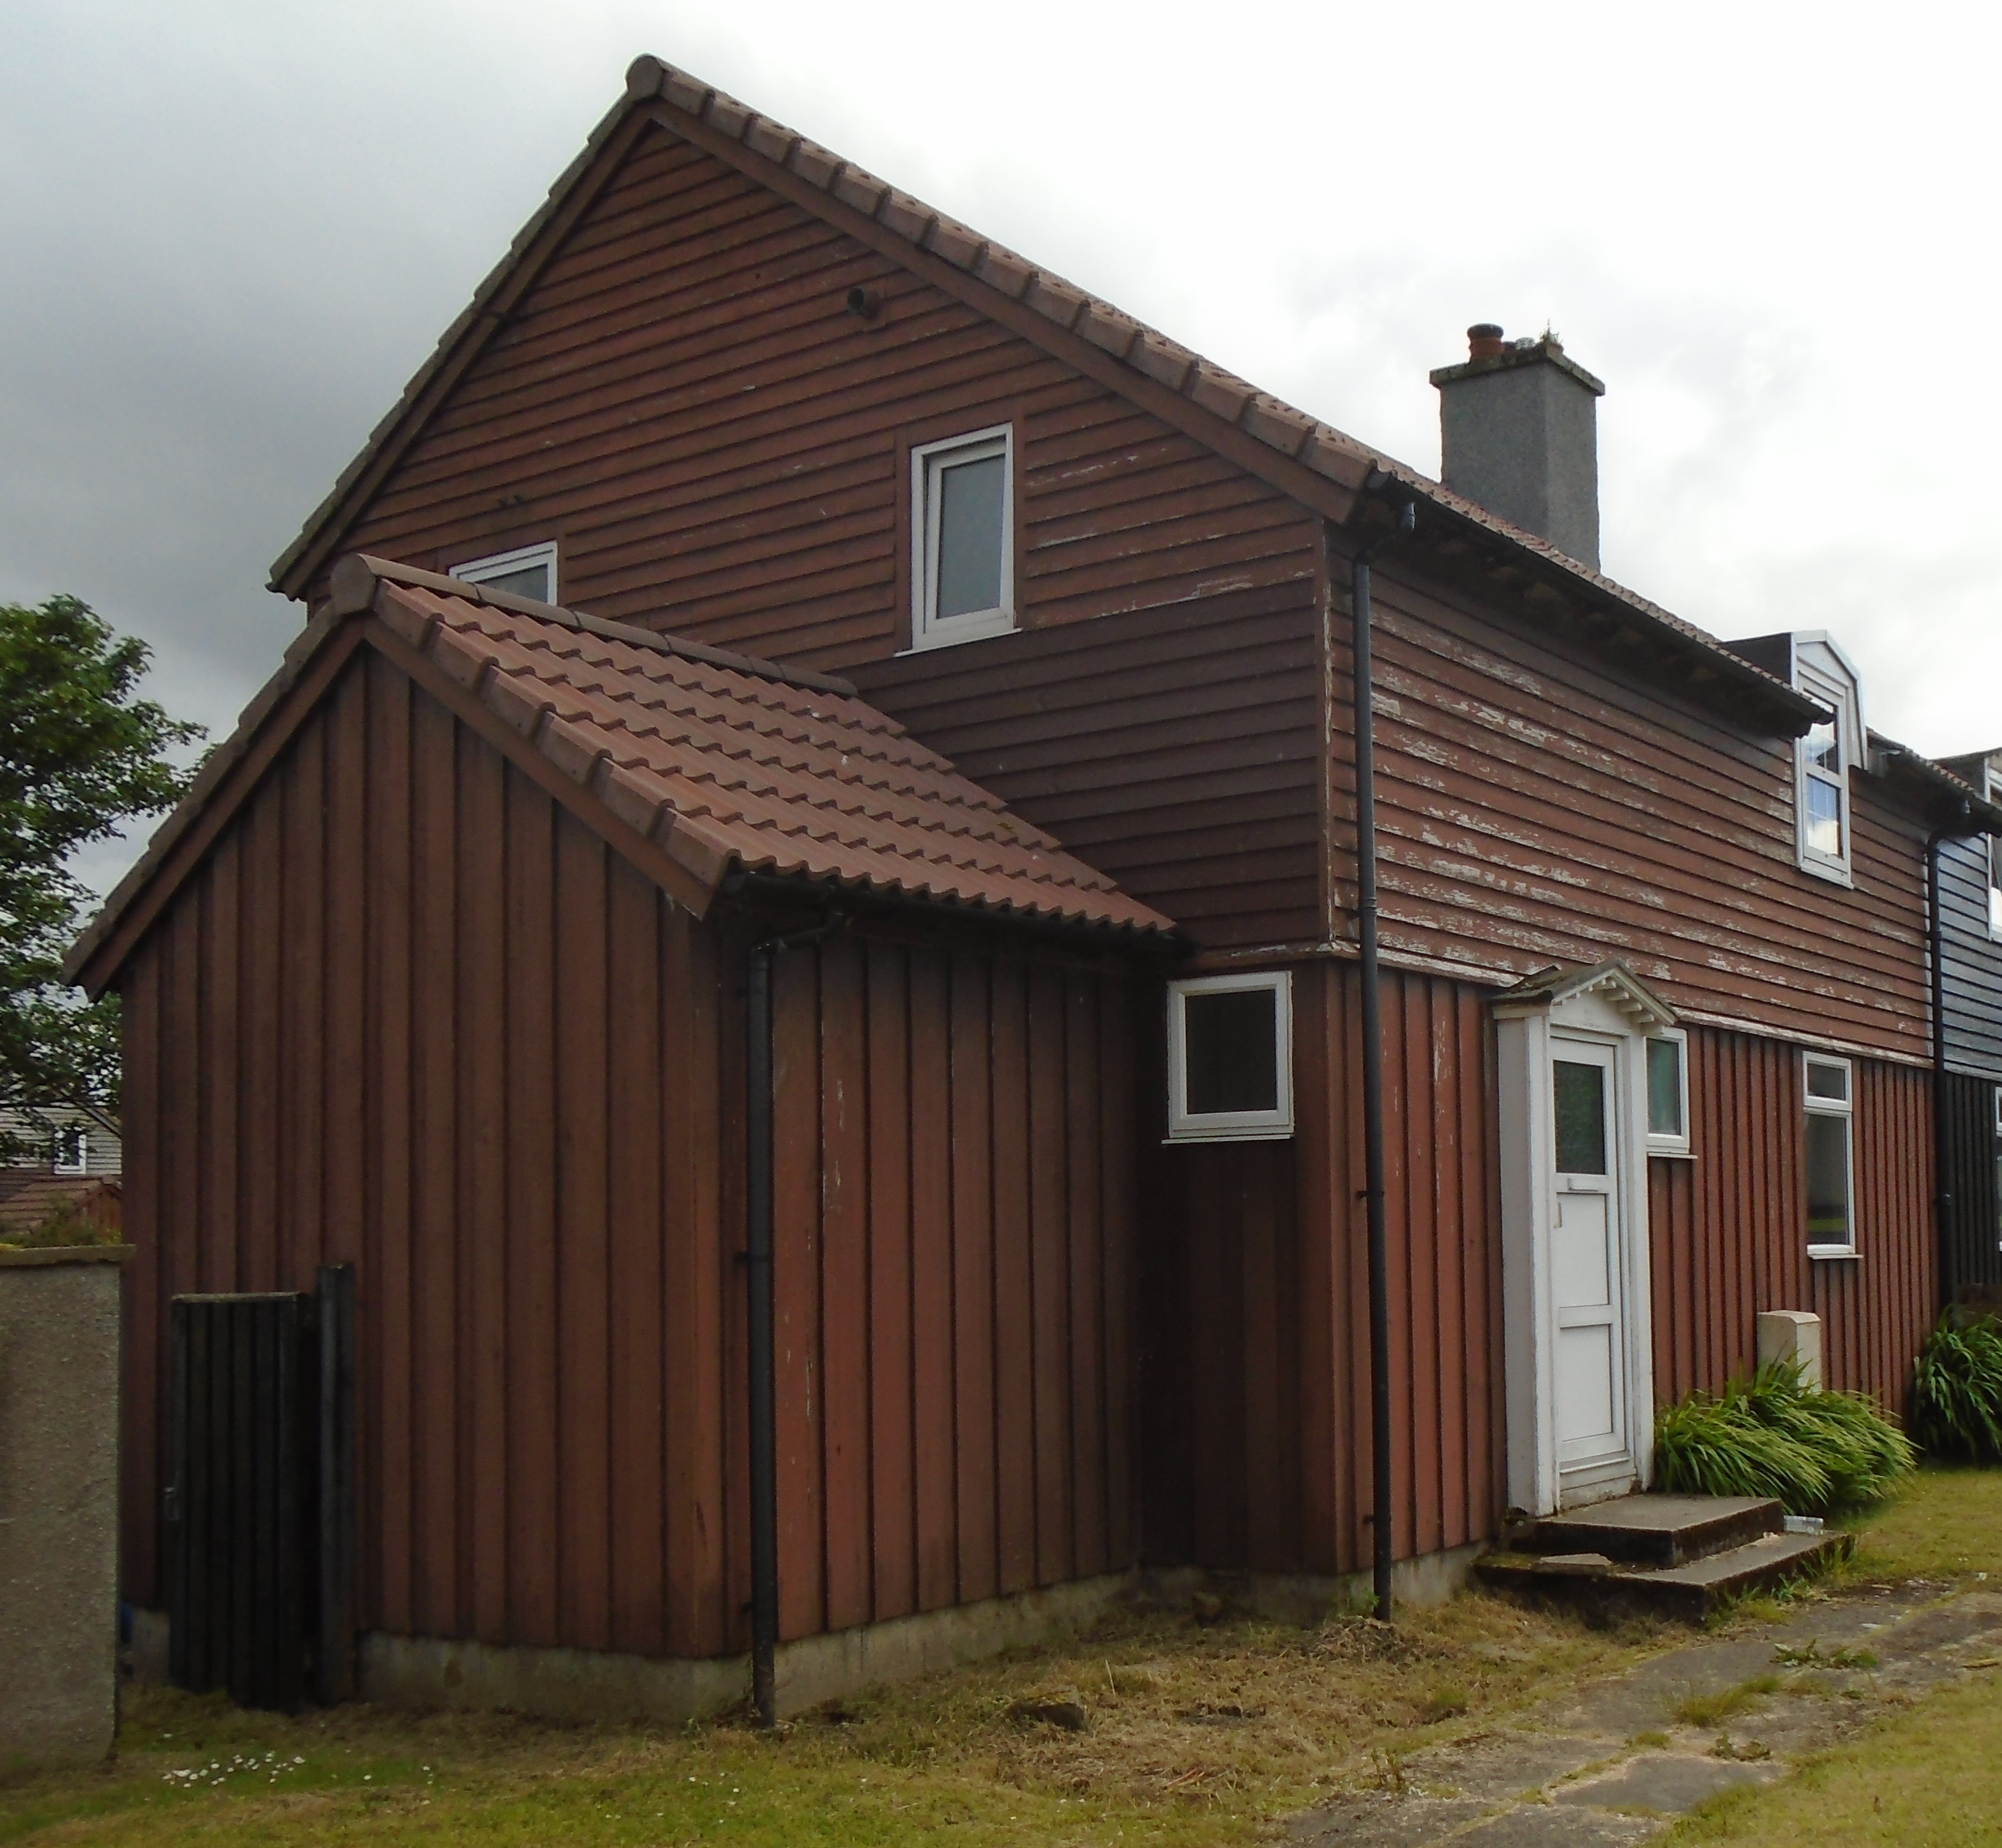
22 St Olaf Road, THURSO KW14 7LY

LETTING INFORMATION
CLOSING DATE:
15 December 2017

RENT: £368.93

COUNCIL TAX BAND: A

DATE ADVERTISED:
08 December 2017

KEY FEATURES
- Rent £368.93 per calendar month | - 3 bed semi house  - EPC  - Gas heating
- Enclosed rear garden

FULL DESCRIPTION
Pentland Housing Association Ltd has a three bedroom semi house in Thurso, just a short walk from the town centre, schooling and other amenities. Accommodation comprises lounge, kitchen, 3 bedrooms, bathroom and a downstairs WC. The property benefits from gas central heating. Open plan front garden with enclosed rear garden.
WHO CAN BID:
- Couple/parent with 2,3 or more children | - Transfer applicants looking to downsize or upsize
- Homeless clients with a 2 or 3 bed need

HOW TO BID:
All bids must be in by the above closing date. To register interest in this property fill out the registered interest form. This can be found at any of the offices or your local service point, and return to any of the following services:
- cbl@pentlandhousing.co.uk | - Thurso Service Point
- Wick Service Point | - Pentland Housing Association Ltd
- CAB Thurso | - CAB Wick

USEFUL LINKS:
- Local information: https://www.streetcheck.co.uk/postcode/kw148ae
- Google maps: https://maps.google.co.uk/maps?output=classic&dg=brw
- Council tax bands: http://www.highland.gov.uk/info/701/council_tax/523/council_tax/3
