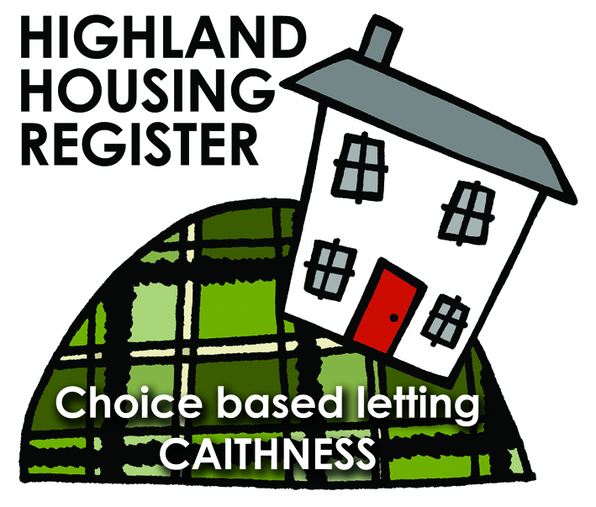
Pentland Housing Association Ltd
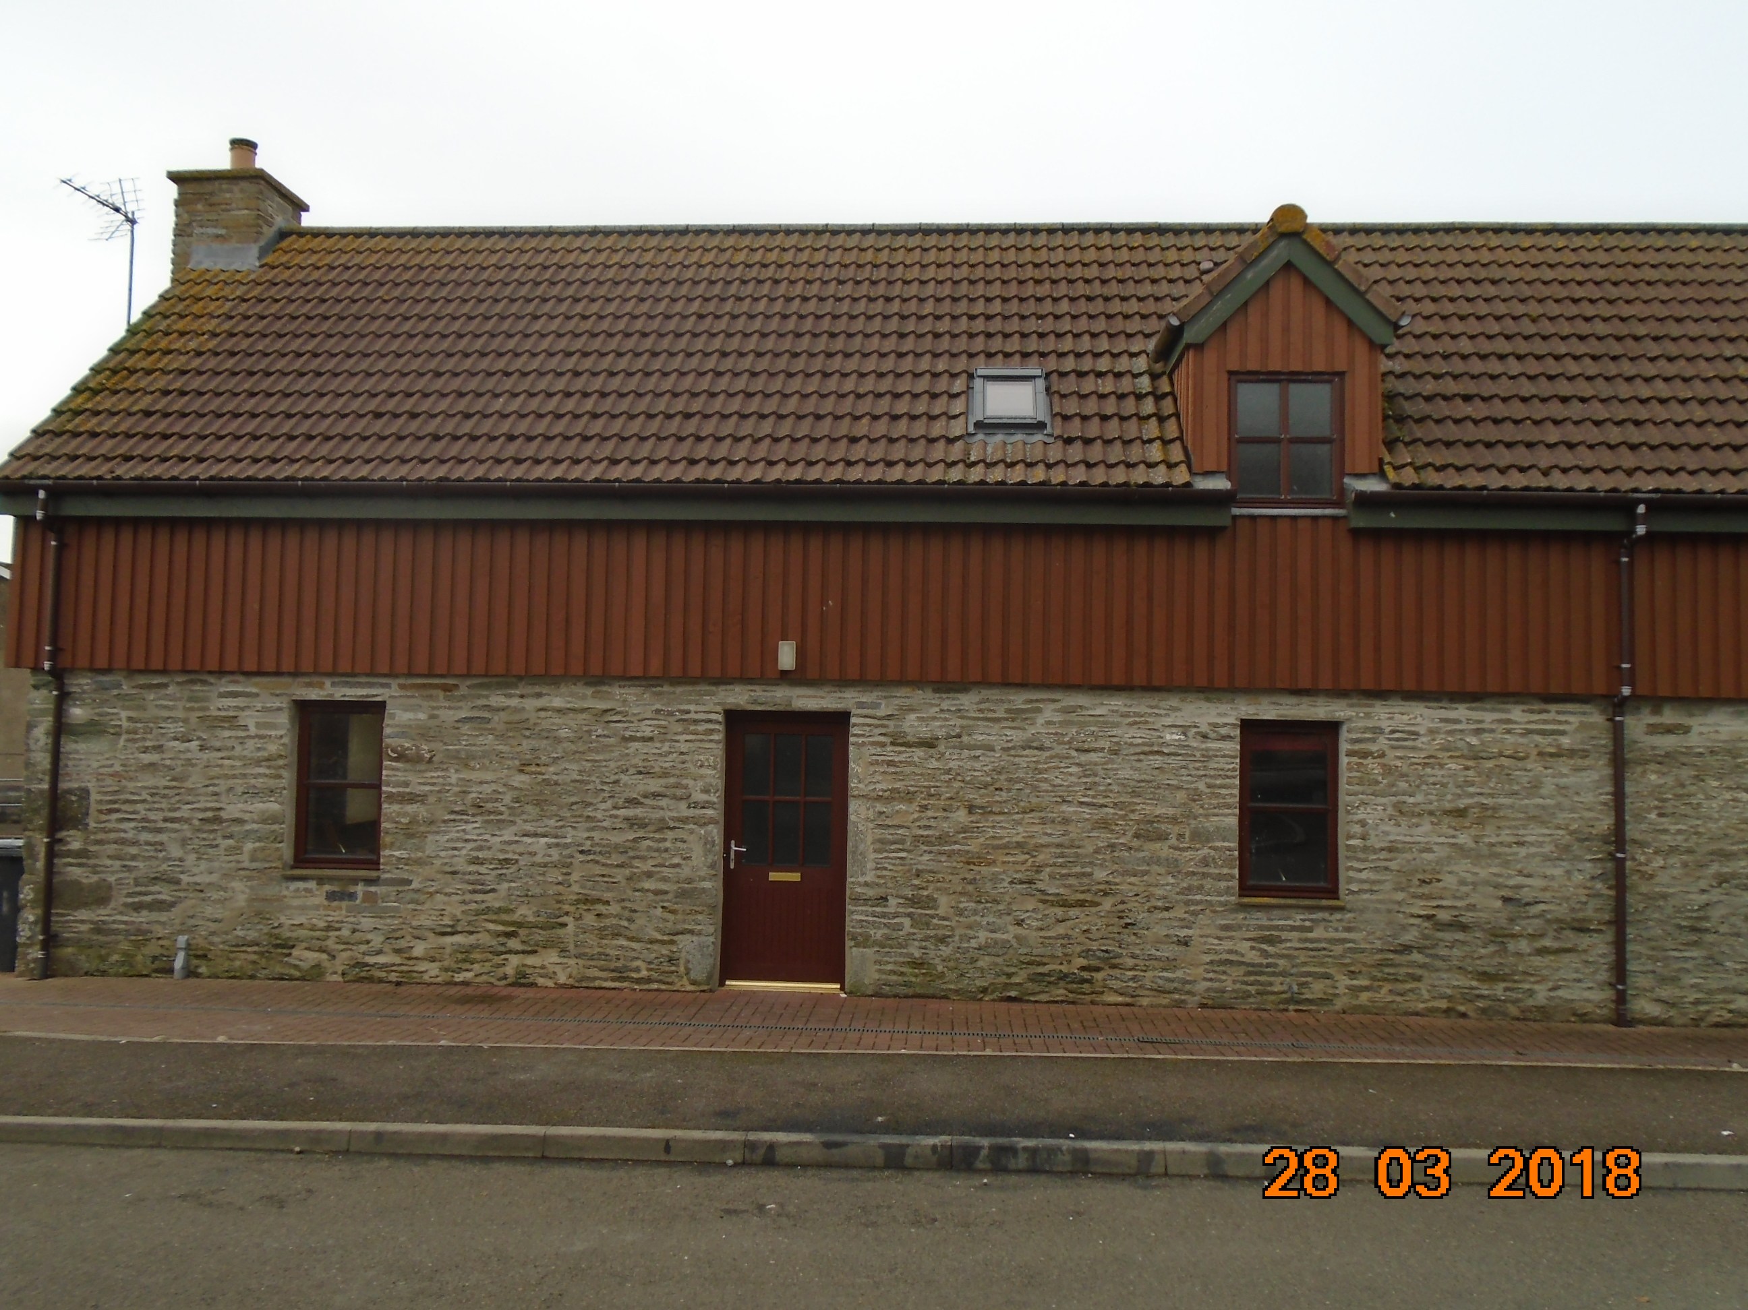
1 Leitch Court, Thurso KW14 8NX

LETTING INFORMATION
RENT: £388.12

COUNCIL TAX BAND: C

DATE ADVERTISED:
25 April 2018
KEY FEATURES

- Rent currently £388.12 per calendar month | - 3 Bed End Terraced House
- No garden | - Electric heating

FULL DESCRIPTION
Pentland Housing Association Ltd has a three bedroom end terraced property in Thurso just a short walk from the town centre, schooling and other amenities. Accommodation comprises lounge, kitchen/diner, toilet, three bedrooms and a bathroom. The property benefits from electric heating. This property does not have a garden.
WHO CAN BID:
- Couple/parent with two, three or more children | - Transfer applicants looking to upsize or downsize
- Homeless clients with a 2 or 3 bed need

HOW TO BID:
All bids must be in by the above closing date. To register interest in this property fill out the registered interest form. This can be found at any of the offices or your local service point, and return to any of the following services:
- cbl@pentlandhousing.co.uk | - Thurso Service Point
- Wick Service Point | - Pentland Housing Association Ltd
- CAB Thurso | - CAB Wick

USEFUL LINKS:
- Local information: https://www.streetcheck.co.uk/postcode/kw148ae
- Google maps: https://maps.google.co.uk/maps?output=classic&dg=brw
- Council tax bands: http://www.highland.gov.uk/info/701/council_tax/523/council_tax/3
