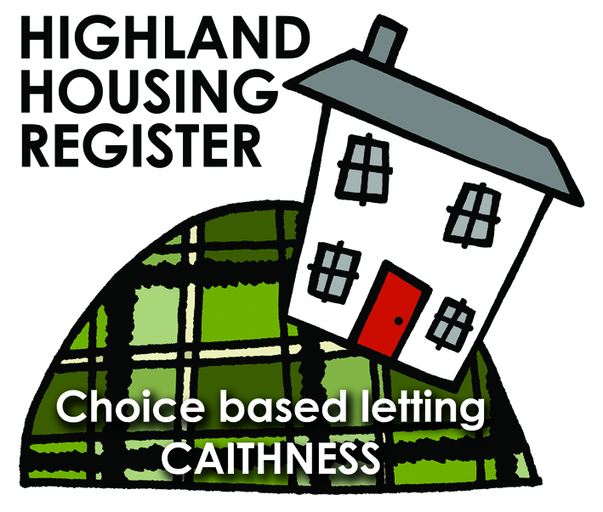
Pentland Housing Association Ltd
11 Calder Drive, Thurso KW14 7NH

LETTING INFORMATION  CLOSING DATE: 25 April 2019  RENT: £ 381.22  COUNCIL TAX BAND: A  DATE ADVERTISED: 18 April 2019 | 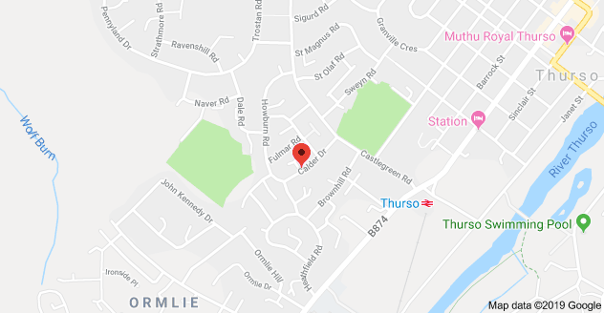
KEY FEATURES
- Rent £381.22 per calendar month | - 3 Bed Semi-Detached House
- EPC Rating D | - Electric heating
- Open plan front garden and enclosed back garden

FULL DESCRIPTION
Pentland Housing Association Ltd has a three bedroom semi-detached property in Thurso, just a short walk from the town centre, schooling and other amenities. Accommodation comprises lounge, kitchen/diner, three bedrooms and a bathroom. The property benefits from electric central heating. It has an open plan front garden and an enclosed back garden.

WHO CAN BID:
- Couple/parent with two, three or more children | - Transfer applicants looking to upsize or downsize
- Homeless clients with a 2 or 3 bed need

HOW TO BID:
All bids must be in by the above closing date. To register an interest in this property fill out the registered interest form. This can be found at any of the offices or your local service point, and return to any of the following services:
- cbl@pentlandhousing.co.uk | - Thurso Service Point
- Wick Service Point | - Pentland Housing Association Ltd
- CAB Thurso | - CAB Wick

USEFUL LINKS:
- Local information: https://www.streetcheck.co.uk/postcode/kw148ae
- Google maps: https://maps.google.co.uk/maps?output=classic&dg=brw
- Council tax bands: http://www.highland.gov.uk/info/701/council_tax/523/council_tax/3
