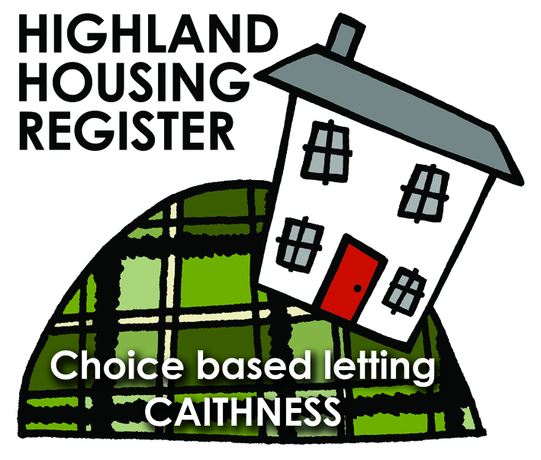
Pentland Housing Association Ltd
2 Grey Coast, Wick KW1 5ET
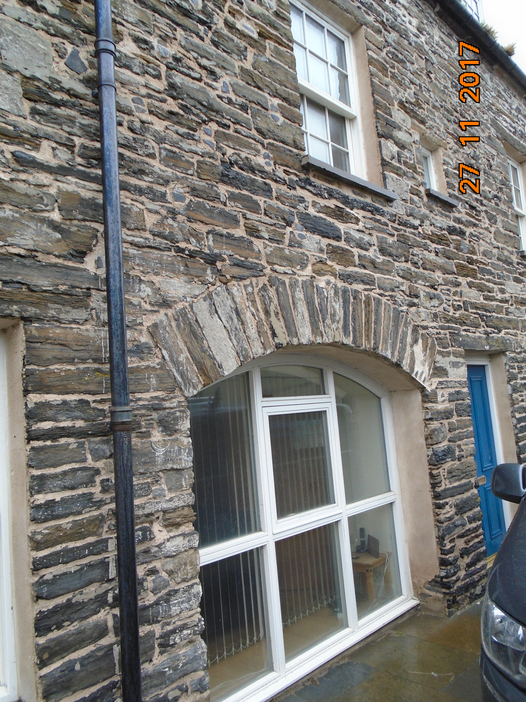

LETTING INFORMATION
CLOSING DATE: 15 December 2017

RENT: £243.75
COUNCIL TAX BAND: B

DATE ADVERTISED: 8 December 2017
KEY FEATURES
- Rent £243.75 per calendar month | - 1 bed ground floor flat
- EPC Rating c | - Gas central heating
FULL DESCRIPTION
Pentland Housing Association Ltd has a one bedroom ground floor flat available in Wick. The property is located in the town centre and is just a short walk from schooling and other amenities. Accommodation comprises lounge, kitchen, one bedroom and a bathroom. The property benefits from gas central heating.
WHO CAN BID:
- Couple/single person | - Transfer applicants looking to downsize
- Homeless clients with a 1 #bed need

HOW TO BID:
All bids must be in by the above closing date. To register interest in this property fill out the registered interest form. This can be found at any of the offices or your local service point, and return to any of the following services:
- cbl@pentlandhousing.co.uk | - Thurso Service Point
- Wick Service Point | - Pentland Housing Association Ltd
- CAB Thurso | - CAB Wick

USEFUL LINKS:
- Local information: https://www.streetcheck.co.uk/postcode/kw15et
- Google maps: https://maps.google.co.uk/maps?output=classic&dg=brw
- Council tax bands: http://www.highland.gov.uk/info/701/council_tax/523/council_tax/3

