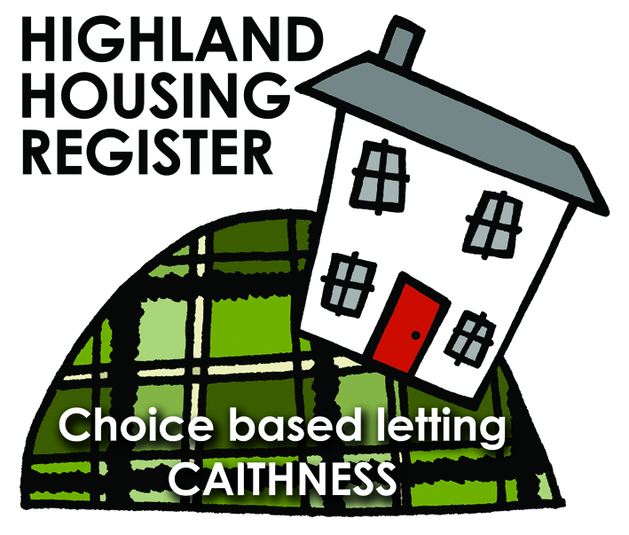
Pentland Housing Association Ltd
29 BROWNHILL ROAD, THURSO KW14 7NL
LETTING INFORMATION
CLOSING DATE: 11 December 2017
RENT: £324.14 per calendar month
COUNCIL TAX BAND: A
DATE ADVERTISED: 04 December 2017
Please note – This property will not be available until January 2018.
KEY FEATURES

- Rent £324.14 per calendar month | - 3 bed first floor flat
- EPC Rating C | - Gas heating
- Open plan front garden and shared enclosed back garden
FULL DESCRIPTION
Pentland Housing Association Ltd has a three bedroom first floor flat in Thurso, just a short walk from the town centre and other amenities. Accommodation comprises lounge, kitchen/diner, three bedrooms and a bathroom. The property benefits from mains gas central heating. It has an open plan front garden and a shared enclosed back garden.

WHO CAN BID:
- Couple/Parent with two, three or more children of High School age  - Single Person/Couple with access to child/children | - Transfer applicants looking to downsize or upsize  - Homeless clients with 2 or 3 bed need
HOW TO BID:
All bids must be in by the above closing date. To register interest in this property fill out the registered interest form. This can be found at any of the offices or your local service point, and return to any of the following services:
- cbl@pentlandhousing.co.uk | - Thurso Service Point
- Wick Service Point | - Pentland Housing Association Ltd
- CAB Thurso | - CAB Wick

USEFUL LINKS:
- Local information: https://www.streetcheck.co.uk/postcode/kw148ae
- Google maps: https://maps.google.co.uk/maps?output=classic&dg=brw
- Council tax bands: http://www.highland.gov.uk/info/701/council_tax/523/council_tax/3

