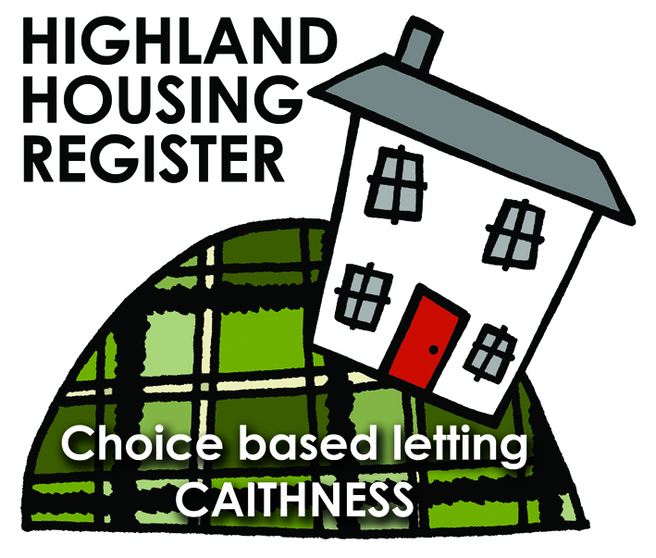
Pentland Housing Association Ltd
9 STRATHMORE PLACE, THURSO KW14 7PU
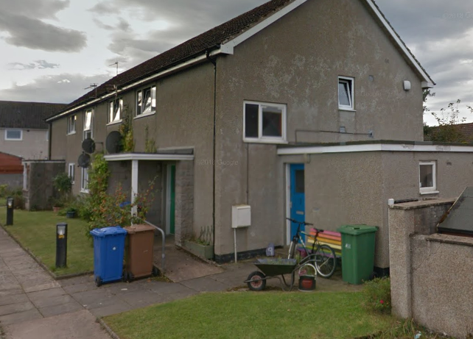

LETTING INFORMATION
CLOSING DATE: 23 May 2018
RENT: £300.78 per calendar month
COUNCIL TAX BAND: A
DATE ADVERTISED: 17 May 2018

KEY FEATURES
- Rent £300.78 per calendar month | - 2 Bed First Floor Flat
- EPC RatingC | - Electric heating
- Open plan front garden, enclosed backgarden
FULL DESCRIPTION
Pentland Housing Association Ltd has a two bedroom first floor flat in Thurso, just a short walk from the town centre and other amenities. Accommodation comprises lounge, kitchen/diner, two bedrooms and a bathroom. The property benefits from electric central heating. It has an open plan front garden and enclosed back garden.
WHO CAN BID:
- Couple/Single person | - Transfer applicants looking to downsize or upsize
- Homeless clients with a 1 or 2 bed need
HOW TO BID:
All bids must be in by the above closing date. To register interest in this property fill out the registered interest form. This can be found at any of the offices or your local service point, and return to any of the following services:
- cbl@pentlandhousing.co.uk | - Thurso Service Point
- Wick Service Point | - Pentland Housing Association Ltd
- CAB Thurso | - CAB Wick

USEFUL LINKS:
- Local information: https://www.streetcheck.co.uk/postcode/kw148ae
- Google maps: https://maps.google.co.uk/maps?output=classic&dg=brw
- Council tax bands: http://www.highland.gov.uk/info/701/council_tax/523/council_tax/3

