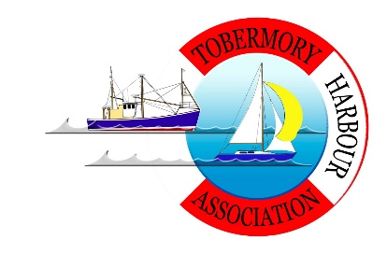

We are having some issues with phishing e:mails so have decided to take the accounting information down from our website meantime.

If you want information about the Tobermory Harbour Association please apply to the office or speak to Richard West who is the finance director.

