Oxford Diocesan Schools Trust
School Effectiveness Service
Church House Oxford Langford Locks Kidlington Oxford OX5 1GF
DEALING WITH ABUSIVE OR VIOLENT VISITORS TO SCHOOLS

4 | ODST Policy Guidance (Schools may use this to inform the drafting of their non-statutory policy)

This document is intended to provide advice and guidance to staff members of the Oxford Diocesan Schools Trust (ODST), local governing body members in ODST schools and directors of the Trust on dealing with abusive or violent visitors to schools. Its contents are drawn from guidance available on government national archives and from the National Association of Headteachers (NAHT).

Introduction

- ODST is committed to ensuring that all members of its school communities, and all visitors to its member schools, can be confident that they are within a safe environment and that a zero-tolerance approach will be adopted towards any acts of abusive, violent or threatening behaviour.

- Day to day access to a school is within the control of the Headteacher. Normally parents/carers (and those with parental responsibility) are granted “limited licence” to visit the grounds and buildings of a school.

- ODST member schools will often establish local procedures which set out: the acceptable purposes for such visits; the areas of the school that may be entered at particular times and the standard of behaviour expected.

- Where there is a breach of such procedures the school, as a member of ODST, should respond in a measured way, taking into account the seriousness of any inappropriate conduct.

- It is possible that a Headteacher may initiate action on their own authority, but it is less likely to lead to personal confrontation if the more serious sanctions are initiated through the ODST.

Overview

- As a general rule, schools are orderly, safe places, where relationships between staff and visitors, especially parents/carers, demonstrate mutual respect and recognition of shared responsibility for pupils’ welfare and educational progress. Parental involvement is an important factor in educational success and in dealing with emerging problems at an early stage.

- However, on occasion, the behaviour of a few parents/ carers can cause severe disruption or worse, resulting in abusive or aggressive behaviour towards staff, pupils, or other members of the school community.

- ODST has a responsibility for protecting the health and safety of their staff and pupils and takes this responsibility seriously.

- This guidance is mainly about dealing with violence, threatening behaviour or abuse by parents of a pupil in a school.

- Violence, threatening behaviour and abuse against school staff or other members of the school community will not be tolerated. All members of the school community have a right to expect that their school is a safe place in which to work and learn. Where such behaviour does occur, ODST in conjunction with the Headteacher will play a proactive role in taking all possible action to deal with it.

- In certain circumstances, this may mean that ODST will take the lead in initiating action on the school’s behalf with the school’s support, and in other circumstances ODST will support the school in action that the school itself will initiate. It is key though that in any such situations there is dialogue between the Headteacher and ODST at the earliest possible opportunity.

- Headteachers should in the first instance ask ODST for advice on the appropriateness of any remedies available and ODST will, where they have the power to do so, take the lead in initiating action. In circumstances where power does not lie with ODST (e.g. under criminal law) the Trust will support and advise schools with a view to removing as much of the burden from them as possible.

School policy for dealing with incidents

- Where a school seeks to introduce a policy covering incidents involving abusive, threatening or violent adult visitors, such policies should be adopted following consultation with staff and parents. Typically, such a policy will provide a readily available set of procedures on:
  - what to do when an incident arises (e.g. ask the person to leave, or invite them into a room away from other people);
  - whom to contact during an emergency (i.e. at the school, local authority and police);
  - how to record incidents and who to report the incident to;
  - what follow up action is possible (i.e. any legal action to be taken; if a parent, whether they should be refused entry to the premises);
  - what support is available from the employer, (e.g. counselling, occupational health or legal support);
  - liaison with the police whenever necessary.

- The existence of the policy can be publicised, by displaying suitable posters in areas of the school that may be entered by visitors.

- Some ODST schools may be involved in safer school partnerships under which an operational police officer will be based on school premises. The main aim of this approach is to provide a safer environment by minimising the risk of such incidents (whether they involve pupils, parents or others) and enabling incidents which do occur to be quickly and effectively dealt with. Where a partnership has been established, policy and procedures for dealing with violence, threatening and abusive behaviour by parents should be developed within the context of this.

Conducting a risk assessment

- Whether an ODST school has a formal policy or not, a risk assessment to staff and others from abusive or violent visitors should be documented. This does not need to be a complicated process, but simply involves raising a number of questions to which you seek answers.

A risk assessment should:
  - identify and assess the risks;
  - determine appropriate actions;
  - implement the actions;
  - monitor the results; and
  - provide feedback.

- It is good practice to ask staff directly about the extent of problems that they are aware of as part of the process of assessing risk. It is also helpful to consult school health and safety representatives about possible risks.

- A risk assessment should identify what the risks are (e.g. abuse, threatening behaviour, violence, and from whom), and who is likely to be at risk (e.g. reception staff, teachers, school keeper). Once these are identified consideration can be given as to how to manage these risks and how they can be minimised.

- In some cases, potential violence can be reduced and even prevented if members of staff have the skills to spot conflict before it leads to aggression and to use techniques to reduce aggression before violence occurs.

- ODST schools may also consider offering members of staff personal safety training, which can help in:
  - reducing violent attacks by parents and others;
  - enabling staff to defuse aggression and prevent situations escalating;
  - teaching staff to recognize verbal and nonverbal precursors to aggression and use techniques to calm a potential assailant;
  - improving staff confidence in dealing with aggression and the resulting stress; and
  - minimising the risk of an attack causing injury.

- Guidance on risk assessments can be found on the HSE website (details at the end of this document).

- Model incident report form and publicity

- This is included in Appendix A and will assist with the recording of any incidents of abuse, threatening behaviour or violence against any members of the school community. A record of an incident will help in the collection of evidence where necessary, such as when proceedings are being brought against an alleged assailant. Available photographic evidence of any injuries or damage, or relevant CCTV footage, can also be helpful. Recording details of incidents will also help in reviewing the school’s policy, and should ideally inform future risk assessments.

- If there is an injury to staff from an assault, the school may need to report the injury to the health and safety executive (HSE) under the requirements of the Reporting of Injuries, Diseases and Dangerous Occurrences Regulations 1995 (RIDDOR), as amended in 2012.

- A poster that schools may wish to display is included at Appendix B, setting out clearly the rights and responsibilities of visitors to the school, and explaining that steps may be taken to remove visitors who are violent, threatening or abusive to any member of the school community;

- Section 547, Education Act 1996

- A parent/carer of a child attending a school normally has implied permission (limited licence) to be on the school’s premises at certain times and for certain purposes but if their behaviour is unreasonable this permission may be withdrawn and they will become a trespasser. This is covered under section 547 of the Education Act 1996 and template letters can be provided to ODST schools to support any such action taken under this clause.

- Section 547 makes it an offence for a trespasser on school premises to cause or permit a nuisance or disturbance, and allows for the removal and prosecution of any person believed to have committed the offence.

- In addition to any action taken on behalf of ODST by the Headteacher, the police are authorised to remove someone from school premises and to bring proceedings for an offence under this section.

- It is not set down in law how a person should be authorised but ODST would recommend that this is documented in writing within any school policy. Appropriate training should also be provided to all such persons.

- Schools wishing action to be taken against someone they believe has committed an offence under s547 should contact ODST. If the police have been involved the school should clarify whether the police intend to summons or charge and whether the Crown Prosecution Service has decided that there is sufficient evidence to prosecute. In most cases, it will be in the public interest to prosecute if there is sufficient evidence to support a prosecution.

- The Headteacher will need to assemble the full facts before proceeding, making sure that all those involved in any incidents, or witnesses to those incidents, make a full written record as soon as possible. Crucial elements of the process include:
  - writing to the parent/carer/intruder to record in detail the incident and why it is unacceptable;
  - explaining that the school/ ODST will consider banning the parent, giving the parent a period in which they may respond in writing giving their version and why they should not be banned;
  - telling the parent when a decision will be made.

- Even where a parent/carer has been banned from the school premises, they retain their right to an annual consultation in relation to the educational progress of their child/ren. However, the school may determine who will be present at the meeting (e.g. a senior member of staff might accompany the class teacher) and its location (e.g. it may well be arranged off site). The interests of the child should continue to be paramount.

- Using powers under section 547 allows for action which ODST, working in conjunction with the school, can take on behalf of a school and which can be straightforward, quick and effective in removing violent, aggressive or abusive people from school premises. In practice, it is amongst the most widely used remedies. However, it is not a decision that should be taken lightly and Headteachers should always seek guidance from ODST when considering such action.

- There may be occasions when Section 547 will not be the most appropriate remedy and in instances of serious violence, repeated harassment or racially aggravated behaviour for example, criminal sanctions may be warranted. ODST would support the school in any such situation and would take a proactive approach.

- Summary

- ODST is committed to ensuring that all members of the school community, and all visitors to its member schools, can be confident that they are within a safe environment and that a zero-tolerance approach will be adopted towards any acts of abusive, violent or threatening behaviour.

- The actions outlined above are examples of strategies that ODST schools can adopt to reduce the likelihood of, and mitigate the impact of, a situation in which a visitor to an ODST school demonstrates abusive, threatening or violent behaviour.

- Staff members are encouraged to report any concerns to their line manager/ Headteacher so that appropriate investigation and action can be taken.

- Support and guidance are available centrally to ODST Headteachers to enable effective management of any such situations.

Useful Information

Additional information can be found on-line at:

Safeguarding:

http://webarchive.nationalarchives.gov.uk/20110218194057/http:/teachernet.gov.uk/wholeschool/healthandsafety/schoolsecurity/abusivebehaviour/

http://webarchive.nationalarchives.gov.uk/20110218194057/http:/www.teachernet.gov.uk/docbank/index.cfm?id=1607
http://www.naht.org.uk/EasysiteWeb/getresource.axd?AssetID=30404&type=full&servicetype=Attachment

Risk assessment and accident reporting:

http://www.hse.gov.uk/pubns/raindex.htm

http://www.hse.gov.uk/pubns/edis1.htm

SAMPLE LETTERS

LETTER FROM HEADTEACHER
Dear
I am writing following your visit to the school on XXXX and to note that the school’s policy on aggressive or abusive behaviour to staff or pupils on the school site does not tolerate the behaviour you exhibited on that occasion.
I would remind you that you were in school and (nature of incident or incidents)
I am satisfied that you (details of incident & effects on school, staff or children).
You will appreciate that the school and its governors cannot not tolerate aggressive or abusive conduct on its premises, and that it has a responsibility towards its staff and pupils to ensure that they are kept safe. Such behaviour is totally unacceptable and may result in you being banned from the site.
PHASE 1
I would be grateful if you could contact me by telephone or in writing by XX_______ in order to discuss these allegations in a calmer way.
I shall then consider what further action may be necessary including the possibility of imposing a ban on your entry to the school premises.
PHASE 2
Having taken advise from the trustees of ODST I must instruct you not to appear on the school premises (other than by prior written agreement or written invitation by or on behalf of the Headteacher*) (*if relevant).
[For KS1 and KS2, and others as appropriate, insert –
For the duration of this decision you may bring ……<Child>…………….. to school and collect them/him/her at the end of the school day, but you must not go beyond the school gate which would mean entering the school premises.
For KS1/YR, also insert –
Arrangements have been made for ………………….. to be collected and returned to you at the school gate by a member of the school’s staff.]
If necessary action may be taken to remove and/or prosecute any person causing nuisance or disturbance on education premises. Anyone convicted of this offence is liable to a fine of up to £500.
This letter has immediate effect as an instruction to you, for a temporary period, not to enter the school premises. However, before confirming this, I would like to give you an opportunity to make any comments of your own relating to the information I have outlined above. To do so, please send any written comments within 10 school days, for the attention of XXXXXX

Yours sincerely,
CC Director of Schools (ODST)
LETTER FROM ODST
Dear…………..
SCHOOL
I am writing on behalf of the trustees of the Oxford Diocesan Schools Trust who are authorised by the Secretary of State to run the above school as an academy.
The Headteacher has reported to me that (nature of incident or incidents)
The headteacher reports that you (details of incident, nature & effects on school, staff or children).
You will appreciate that the Oxford Diocesan Schools Trust will not tolerate aggressive or abusive conduct on its premises, and that it has a responsibility towards its staff and pupils. On the advice of the headteacher I am instructing you not to appear again on the school premises. If you do not comply with this instruction I shall arrange for your removal and may prosecute you under Section 547 of the Education Act 1996, for causing nuisance or disturbance on education premises. Anyone convicted of this offence is liable to a fine of up to £500.
I am happy to receive written comments on the above case and will consider the period of the ban alongside any comment you may wish to make. Should you wish to comment you have a period of 10 working days from the date of this letter to respond.
(I am aware that your last visit was in relation to a complaint to the school about …………………………………………………………………….I have asked the headteacher and chairman of governors to ensure that these concerns are dealt with through the school’s complaint arrangements, and investigated and responded to accordingly.)
Yours sincerely,
Director of Schools
CC: Headteacher …………………………… school

SECOND LETTER
Dear
SCHOOL
On ………. , acting on behalf of the Oxford Diocesan Schools Trust (ODST), I wrote to you informing you that on the advice of the headteacher, I had withdrawn permission for you to come onto the premises of (insert name) School. To enable me to determine whether to confirm this decision for a longer period, I gave you the opportunity to give your written comments on the incident concerned by …………
I have not received a written response from you / I have now received a letter from you dated ………., the contents of which I have noted.
In the circumstances, and after further consideration of the headteacher’s report, I have determined that the decision to withdraw permission for you to come onto school premises should be confirmed. I am therefore instructing that until further notice you are not to come onto the premises of the School without the prior knowledge and approval of the headteacher. If you do not comply with this instruction I shall arrange for you to be removed from the premises and prosecuted under Section 547 of the Education Act 1996. If convicted, you are liable to a fine of up to £500.
Notwithstanding this decision, the headteacher and staff at …………….. School remain committed to the education of your child/children, who must continue to attend school as normal, (KS1 & KS2 - with the arrangements for their collection and delivery at the beginning and end of the school day as set out in my previous letter).
ODST will take steps to review the continuance of this decision with the headteacher on ………. When deciding whether it is necessary to extend the withdrawal of permission to come onto the School’s premises, ODST will consider the extent of your compliance with the decision, any appropriate expressions of regret and assurance of future good conduct received from yourself and any evidence of your co-operation with the School in other respects.
Finally, I would advise you that I have asked the headteacher to ensure that your complaint about ………………………is considered under the appropriate stage of the School’s parental complaints procedure. You will be contacted about this by the School in due course.

Yours faithfully
Director of Schools
CC Headteacher of …………. school
THIRD LETTER
Dear
SCHOOL
On ………. , acting on behalf of the Oxford Diocesan Schools Trust, I wrote to you informing you that on the advice of the headteacher, I had withdrawn permission for you to come onto the premises of (insert name) School. To enable me to determine whether to confirm this decision for a longer period, I gave you the opportunity to give your written comments on the
incident concerned by …………
I have not received a written response from you / I have now received a letter from you
dated ………., the contents of which I have noted.
In the circumstances, and after further consideration of additional reports from the headteacher’s, I have determined that it is not necessary to continue the decision to withdraw permission for you to come onto school premises, and I am therefore restoring to you permission to come onto the school premises, with immediate effect.
Nevertheless, I remain very concerned at the incident to which my earlier letter referred, and I must warn you that if there is any repetition of your behaviour on that occasion, I shall not hesitate to withdraw permission for you to come onto the premises again.
Yours faithfully,
Director of Schools
CC Headteacher ………………………….School

Appendix A - Model Incident Report form

Relevant incidents include trespass, nuisance or disturbance on school premises, verbal abuse, sexual or racial abuse, threats, aggression, physical violence and intentional damage to property.

Where possible, the form should be completed before any discussion between witnesses is possible, as this might lead to allegations of collusion.

This form should be completed as fully as possible please, using a continuation sheet, if necessary. For any incident involving or witnessed by a pupil or parent/carer/visitor, a member of staff should complete the form on their behalf.

The completed form should be passed to the Headteacher for appropriate action and recording.

Date of incident

Time of incident

Name of person reporting incident

Date incident reported

Member of staff recording incident

Date incident recorded

Name(s) of person(s) causing incident
(where name(s) is/are unknown, provide other details of which may allow their identification)

Status(es) (parents/carers/visitors/trespassers)

Full description of incident (e.g. names of persons involved; location; nature of any injuries; attendance of emergency services)

Names of any witnesses (and status)

Initial action/outcome (e.g. Informal conciliation; police intervention; warning or banning letter issued)

Summary of subsequent actions taken by the school, including risk assessments

Any linked incidents (if appropriate)

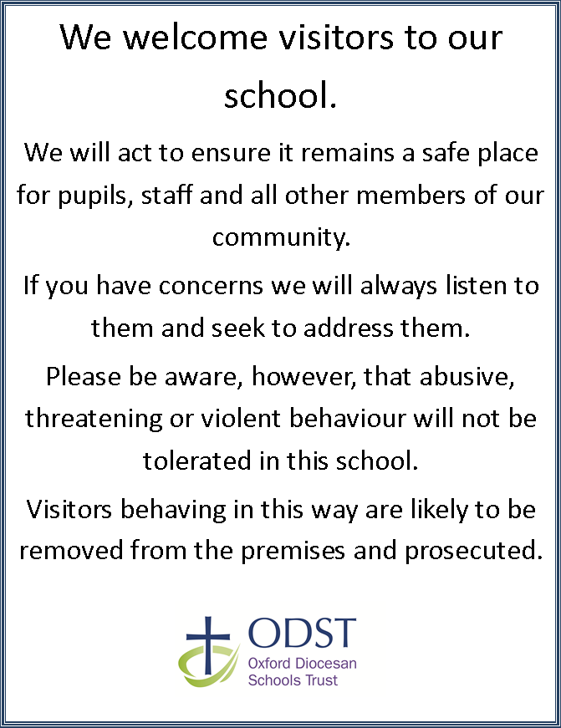
Appendix B
INSERT SCHOOL BADGE/LOGO HERE

