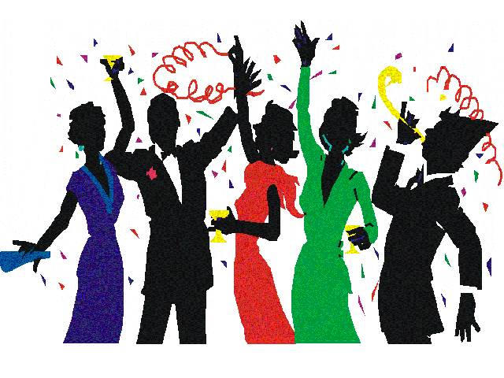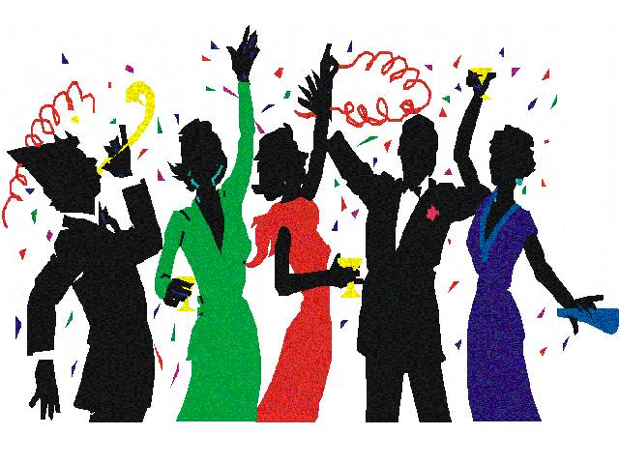

Gala Dinner Dance

Celebrate the New Year in Style

a glass of Paul Langier champagne & Canapés on arrival

**Starters**King scallops with pork belly and saffron apple puree

(V) Sweet potato and carrot soup with garlic croutons

Shredded duck and pancake roulade with mascarpone mango puree

(V)Asparagus cauliflower tempura withchunks of buffalomozzarella & black truffle pieces

Game terrine with crispy pancetta, apple chutney and chili garlic baguette

**2nd Course**Salmon and lobster souffléwith lemon cream sauce

**Main Courses**

English roast rack of lamb with port and rosemary sauce, ratatouille and chestnut potato cake

Grilledfillet of turbot, king prawns, shallot basil cream sauce,

caramelised red onion, mint new potatoesand vegetables

Grilled Scottish fillet of beef with Madeirawine cream sauce,gratin potatoes and asparagus roast duckling with crispy rosti potatoes, orange Bordeauxwine sauce & green vegetables

(V)Stuffed red peppers with smokey crushed aubergine and deep fried gnocchi potatoes

**Desserts**

MC900022601[1]**MC900022601[1]**

Freddie’s assiette of Desserts

Freddie’s vanilla pod Crème Brulée and shortbread

Chocolate mango bavarois entremets with sorbet

Cheese Platter served with walnut bread &biscuits

Coffee &Petit Fours

£ 84.95pp

Discretionary 10% service charge will be added to your total bill