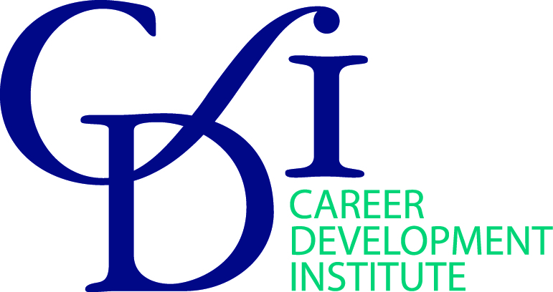

At the Cutting Edge-Research into Practice
Careers Guidance with Refugees: Practical Lessons from Research
11 February, 10.00 am-16.00 pm – The Welcome Centre, Coventry
(10 minutes from Coventry Station) http://www.thewelcomecentre.co.uk/location/

Twice each year NICEC and the Career Development Institute collaborate on a Cutting Edge event for practitioners. This latest Cutting Edge event in Coventry, a city of Sanctuary, will provide career practitioners with practical tools, ideas and insights from a transnational EU funded project led in the UK by Professor Hazel Reid of Canterbury and Dr Anne Chant from Canterbury Christ Church University. Six different countries are collaborating on solutions for integrating refugees and migrants into labour markets. Themes include working with diverse clients, inclusion, celebration of difference, the impact of severe disruption on people’s future life course and the power of courage and hope. The day will enable participants to sample materials from the six modules of the higher education course and help us consider lessons for work both with refugees and a broader base of clients. The day will include insights and learning from community based projects.

9.30 Registration – Tea and Coffee
10.00 -10.30 Introductions and welcome – chaired by Rosemary McLean, NICEC
Icebreaker – Quiz – Based on the Training Needs Analysis for the Project
10.30 -12.15 Overview of recent migration and implications for career guidance
An overview of work in Coventry – Coventry Refugee and Migrant Centre, the Friendly Cities development
Discussion groups on experiences working with refugees and parallels in work with other clients
Introducing the CMiNAR Project – the key partners and a brief introduction to national approaches in Turkey, Italy, Germany and Sweden
Taster sessions for the first 3 units of the HE Course – Anne Chant
      - Introduction and knowledge gaps
      - Critical reflection
      - Language and intercultural communication
12.15- 13.15 pm Lunch/Networking Break
13.15-13.45 Sharing lessons and good practice from the work of Afghanistan and Central Asian Association – Rabia Nasimi
13.45 Taster session for remaining 3 units – Claire Nix
4. Migration complexity
5. Access and inclusion in the system
6. Personal progression and moving beyond
15.30 - 16.00 Conclusion and close
About NICEC
NICEC is a Learned Society with a network of Fellows, in the UK and abroad, who are career education and counselling researchers and practitioners drawn from a wide range of settings. Fellows believe passionately in improving policy and practice through discovering and sharing evidence and developing career education and counselling theory. We share our knowledge and learn from others through our Seminar series, the NICEC Journal and our publications. There are close working links with the CDI including through the delivery of two Cutting Edge events each year.
Contributor Profiles
Dr Anne Chant - Anne qualified as a careers adviser 20 years ago and has worked as a practitioner, working with young people, in the University sector and with adult career changers. She is the programme director for the MA Career Management and is the Assistant Director of the Centre for Career and Personal Development. In addition to teaching and managing the centre Anne is also engaged in a number of national and international projects, including two European projects developing careers work with refugees and asylum seekers.

Rosemary McLean - Rosemary is a registered Career Practitioner and Chartered Occupational Psychologist with many years’ experience in the careers field. She now enables organisations to develop and shape career development strategy to support business goals and align individual aspirations and passions with internal opportunities. Her consultancy work within Career Innovation Ltd is international, increasingly virtual, and underpinned by research. She also designs and delivers career development workshops, and has recently been involved in developing a next generation on-line careers tool platform to scale up careers support, and an innovative on-line career development course ‘Be Bold in your Career’. When working with organisations the focus is on how to support and improve career conversations.

Rabia Nasimi – Now 25 years old, Rabia arrived in the UK in 1999, on the back of a refrigerated lorry, aged just five-years-old. Rabia’s family were forced to flee Afghanistan after her father, an academic, had become a target under the Taliban’s destructive rule. She is studying for a PhD at Cambridge University. Alongside this, she supports the education of other refugees in the UK through work for the Afghanistan and Central Asian Association (ACAA). She recently won a We Are the City ‘Rising Star’ award. Rabia says: “We saw Britain as a place of freedom and safety and were attracted by its model of integration, where people can express their identity and religion openly. We worked hard to adjust to our new community and some of the challenges we identified as we settled into the UK led my father to create the ACAA. Informed by our own first-hand experiences, we have been able to design holistic support for other refugees adapting to their new life here.” In June 2018 Rabia was a winner of the WeAreTheCity Top 100 Rising Stars awards. The awards showcase 100 up and coming female role models. She was also on the 2018 shortlist for the Women of the Future Award.

Claire Nix - Claire is a careers adviser with experience as a manager, trainer and consultant in the education sector. She has been an external examiner for Canterbury Christ Church University and is a qualified assessor. She is relishing this opportunity to work with Anne on a transnational project focusing on such an important aspect of career guidance.
With thanks to Gill Frigerio of the University of Warwick for contacts and advice for the day.

Booking onto this event

This one-day CPD event is free to CDI and NICEC members. It is part funded by the European Commission through the Erasmus+ funding. Please book your place, so we get the catering right, through the website –
https://www.thecdi.net/Skills-Training-Events/Careers-Guidance-with-Refugees-Practical-Lessons-from-Research-Coventry/63505

