10 Years a Saint: The Enduring Witness of Junípero Serra
A decade after his canonization, St. Junípero Serra remains a powerful symbol of evangelization, resilience and spiritual renewal across the Americas.
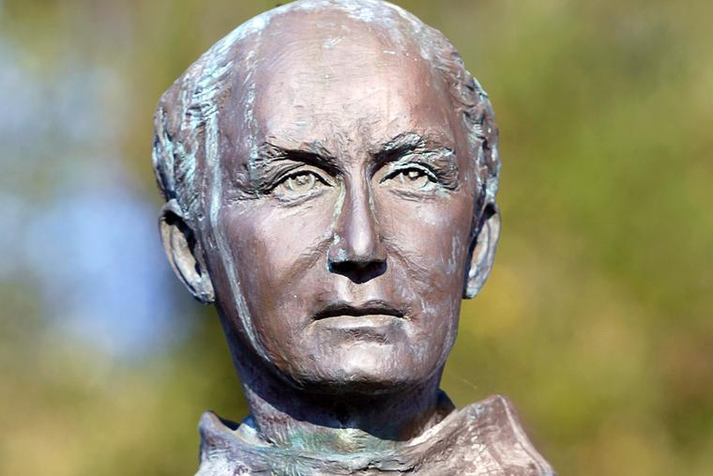 A statue of St. Junípero Serra stands outside of Mission San Jose in Fremont, California
We are marking 10 years since the historic moment on Sept. 23, 2015, when Junípero Serra (1713-1784), the founder of the California missions, was raised to the altars.
Junípero Serra was canonized at the Basilica of the National Shrine of the Immaculate Conception in Washington, D.C. His feast day is July 1 in the United States and Aug. 28 — the date of his death — elsewhere. He is the patron of vocations and known as the Father of the California Missions, Apostle of California, a Founding Father of the United States, and our nation’s first Hispanic saint.
St. Junípero Serra, the Mallorca-born, 5’2”, Franciscan priest, entered San Diego on July 1, 1769, and founded the first mission in Nueva California, San Diego de Alcalá, the first of nine begun during his tenure as father president.
Junípero Serra’s canonization was the first to take place on American soil. What has taken place since?
Following Serra’s canonization and during the social unrest in the summer of 2020, public statues of Junípero Serra were vandalized throughout California. Some were also desecrated on church property — at Mission Carmel, Old Mission Santa Barbara, Mission San Gabriel, Mission San Rafael and Mission San Jose. Only one act, at Mission San Rafael, led to an arrest.
Mission San Gabriel almost burned to the ground on July 11, 2020.
The good news is that one of the statues, at Ventura, was taken down peacefully during the dead of night on July 23, 2020, and put into storage, eventually finding its way to its new home at Mission San Buenaventura on Feb. 29, 2024. St. Junípero Serra founded Mission San Buenaventura on March 31, 1782, the ninth of the 21 California missions, and the last founded during his lifetime, one of six he personally dedicated. Like Rocky, Serra is hard to knock down.
There is more good news.
In 2021, Mission San Gabriel celebrated its 250th anniversary. The mission was fully restored and reopened to the public on July 1, 2023. Last month, on Aug. 22, John David Corey pleaded no contest to one count of arson to historic Mission San Gabriel.
Relics of St. Junípero Serra were among the six saints from North America in the altar at Redemptor Hominis Church, Saint John Paul II National Shrine, Washington, D.C., dedicated on Oct. 2, 2015.
Parishes in South Windsor, Connecticut (March 31, 2017) and Seaside Park, New Jersey (July 1, 2018) were named in Serra’s honor.
Pilgrims continue to visit and pray at the missions, like a group from Nevada did the year after the canonization. The missions are among the most popular tourist destinations in California, attracting millions of visitors each year. Some even walk to them.
Two annual pilgrimage routes have been named after Serra.
Camino Serra is an 85-mile route that is done over eight days, starting on June 23. The pilgrimage connects Mission Santa Clara de Asís (1777) and Mission Santa Cruz (1791). Pilgrims continue to Mission San Carlos Borroméo (1771), where Mass is celebrated at the Shrine of St. Junípero Serra on the Apostle of California’s feast day, July 1.
St. Junipero Serra Walking Pilgrimage is a two-day walk of a 35-mile stretch that joins Mission Santa Bárbara (1786) and San Buenaventura Mission Basilica (1782).
One, Camino de California, is a pilgrimage group that connects California's 21 missions. According to its website, they are a “movement seeking to further revive the evangelistic and spiritual pilgrimage first established over 250 years ago by Saint Junipero Serra.”
In 2024, Eucharistic processions took place along four pilgrimage routes, all ending in Indianapolis, the site of the National Eucharistic Congress. The Western Route started in San Francisco and was the longest route at approximately 2,200 miles. It was named after Serra.
Many images of Serra exist in Spain, Mexico and the United States. In 2017, a new statue of St. Junipero Serra was blessed at the Basilica of the National Shrine of the Immaculate Conception in Washington, D.C. In 2022, “St. Junipero Serra and the American Saints” by artist Bernadette Carstensen and Missa Sancti Juniperi Serra, a new Mass in the extraordinary form, were commissioned by the Benedict XVI Institute.
In 2019 and 2020, Serra International held its three-day Serra Rally in Ventura, just blocks away from the mission that gave the city its name. Serrans are lay Catholics who are dedicated to promoting and fostering vocations. Junípero Serra is the patron saint of vocations.
The chief diocesan program specifically designed for the direct catechesis of the faithful within the Diocese of Fort Worth was named the St. Junipero Serra Institute.
To get to know Saint Junípero Serra better, great places to start are by reading the homily of Pope Francis at the canonization Mass of Blessed Junípero Serra and the Writings of Junípero Serra. One will learn what his vision was, motivations were, as well as his challenges, dreams, and successes. He will not disappoint, but inspire one to walk the via positiva while participating in the New Evangelization.
Saint Junípero Serra and Pablo Tac — holy California mission Indian, seminarian, scholar, saint-in-waiting — pray for us! ¡Siempre adelante y nunca para atrás!

- st. junípero serra
- california missions
Courtesies:-Christian Clifford Christian Clifford is an author who lives in the San Francisco Bay Area with his wife and son.

