Serra Connects July ‘26

Vigil for vocations
Responding to our Holy Fathers’ Messages for vocations on Vocations Sunday, Good Shepherd Sunday, Serrans throughout Great Britain hold Vigils for vocations usually the Thursday or Friday night prior to vocations Sunday. This Vigil of just a few in our calendar, principally focuses on the yearly Messages of our Holy Fathers and their themes. This year’s theme taken from Pope Leo’s message for the 63rd world day of prayer for vocations.
The Interior Discovery of God’s Gift
Our Vigil for vocations started back in 1989 some 37 years ago here in the City of Glasgow continuing every year with the exception of that covid year. This vocations vigil was adopted by our Serra international board in the year 2000 and promoted as an International event which we understand is still going strongly today.
The vigil may last throughout the entire night starting with celebration of the Eucharist, with adoration, rosary for vocations, benediction, with speakers reflecting on their own vocation and ending early morning with morning prayer even on a hillside or church. Today, we being a little older, the vigil may last two hours ending with Night prayer.
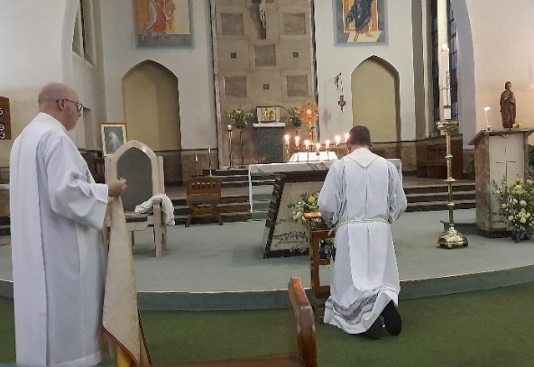
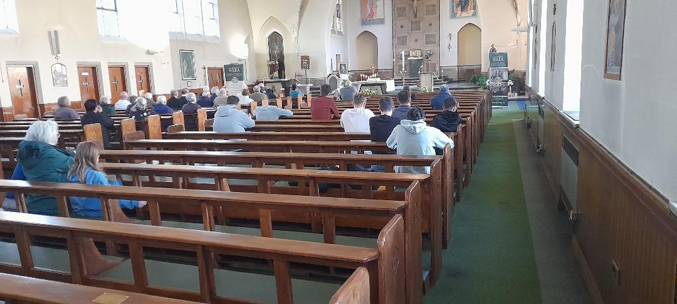
Our invites to hold the vigil may go out to one or several parishes within a diocese. This year was particularly good with a large turnout including many young people. We hope and pray that the seeds for new vocations are planted in the minds and heart of our young people allowing Our Lord to make that call.

