The Tartan Lounge
Bar & Restaurant
Self-Catering Accommodation
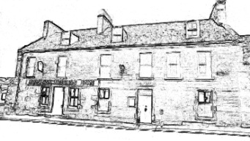
The Bannockburn Inn, Stafford Street, Helmsdale, Sutherland KW8 6JY
01431 821461
 | Single Occupancy | Double Occupancy | Triple Occupancy |  | Full Occupancy
Double Room with shared bathroom  TV, Tea, Coffee, milk sugar and towels supplied | £50.00 | £55.00 | NA |  | £55.00
Twin Room (2 available) with shared bathroom  TV, Tea, Coffee, milk sugar and towels supplied | £40.00 | £50.00 | NA |  | £50.00
Family Room with shared bathroom  TV, Tea, Coffee, milk sugar and towels supplied | £60.00 | £65.00 | £75.00 |  | £80.00
Family Room with ensuite  TV, Tea, Coffee, milk sugar and towels supplied | £65.00 | £70.00 | £75.00 |  | £85.00
Apartment 1: South Wing  This tariff is per night for two bedrooms plus kitchen and bathroom, based on no less than two persons and up to five. |  |  |  | £90.00
Apartment 2: North Wing  This tariff is per night for three bedrooms plus kitchen and bathroom, based on no less than two persons and up to eight. |  |  |  | £150.00
Booking Notes:
Payment:
Charges for overnight stays are payable in advance. If you are staying for longer, bills can be settled on departure.

Bathrooms and Kitchens:
Hand and body wash are available in all the bathrooms. Kitchens are fully equipped with oven, microwaves, fridge, washing machine (see laundry) and additional tea, coffee and sugar, and a choice of cereals.

Breakfast
We are self-catering, however, we do supply, free of charge, fresh milk and cereals in the kitchens.

Laundry
Iron & ironing board or hairdryer are available on request. Use of washing machine and drying facilities is free if you are staying for three nights or longer. For shorter stays there is a small charge of £6.00.

Damages
Any damages must be reported and paid for.

Car parking and Wi-Fi are free to all our customers. Please note Wi-Fi service may be interrupted by weather conditions and bandwidth use.

