First Stop Beauty
Price list

Pam: 07984424082 for appointment

Email: pam@firststopbeauty.co.uk
Website: www.firststopbeauty.co.uk

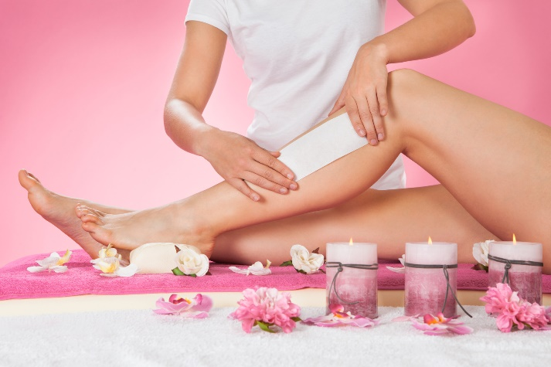

‘Excellent Therapist’ see testimonials
Fully qualified and licenced
City & Guilds
BABTAC

FACIAL TREATMENTS:
Platinum Micro-current Lift
Bio-Ultimate micro-current technology to help lift and tone muscles whilst stimulating collagen and elastin in the face and decollate. £65.00
(Course of 6 recommended)
(buy 6 get 50% off the first monthly top-up).

Platinum Micro-current Lift
With collagen masque added. £75.00

Bio-Therapeutic Cocktail Lift
Mini service of Micro-current lifting
on cheeks and eye area, combined with serums and firming gels for a skin that’s tighter and glowing.
(course of 5 recommended) £50.00

Pro 60 DEEP CLEANSE FACIAL
A customized 60 min facial to cleanse, tone, steam, extraction of blocked pores, massage, masque, serum and moisturizer. £65.00

TEEN FACIAL TREATMENT
Cleanse, exfoliate, steam, extract blockages in the pores, massage, masque and moisturise skin.
(allow 55mins) £39.00

PRO POWER PEEL £65.00
Using Alpha Hydroxy Acids
or Beta Hydroxy Acids to exfoliate top layer of the skin, targeting: fine lines,
wrinkles, uneven pigmentation or breakouts. (patch test required).

MICRO NEEDLING (allow 1 hr)
BtNano pen stimulates the dermal layer to promote new collagen and elastin within the skin and is
great for acne prone scarring, hyperpigmentation, fine lines, wrinkles and luminosity. £120.00

NANO NEEDLING (without needles)
A thorough exfoliation of the top surface layers of the skin to reveal
a fresh new surface layer. Great on all skin tones. £100.00

WAXING TREATMENTS
HALF LEG WAX (lower leg) £19.00
HALF LEG AND BASIC BIK £25.00
UPPER HALF LEG WAX £25.00
¾ LEG WAX £25.00
FULL LEG WAX £30.00
FULL LEG AND BASIC BIKINI £35.00
UNDERARM WAX £10.00
THONG BIKINI £16.00
FOREARM £15.00
FULL ARM WAX £20.00
CHIN £ 6.00
LIP £ 6.00
SIDES OF FACE £10.00
EYEBROW SHAPE WAX £11.00

HOT WAXING /AND STRIP AVAILABLE:
BRAZILLIAN BIKINI £25.00
HOLLYWOOD BIKINI £28.00

MENS WAXING
MENS BACK £33.00
MENS CHEST £33.00

EYES AND BROWS
Eye lash tinting £16.50
Eye brow tinting £ 6.00
Eye lash and eyebrow tinting £20.00
Eye brow re-shape £10.00

EYE LASH LIFT CURL (IVL) £52.00
Lashes tinted and solutions
applied to curl lashes, it lasts
for up to 6 weeks. (patch test)

ELECTROLYSIS:
(using short wave diathermy)
A method of permanent hair removal
5 MINUTES £15.00
10 MINUTES £20.00
15 MINUTES £25.00
20 MINUTES £30.00
25 MINUTES £35.00
30 MINUTES £40.00
ADVANCED COSMETIC ELECTROLYSIS
Using sterile probe and short wave diathermy (heat) to remove blemishes on the skin:
Skin tags and broken capillaries. Free consultation £ varies

MANICURES:
GEL manicure for longer lasting polish. £30.00
TRADITIONAL manicure £24.00
Soak off the gels £10.00

LUXURIOUS PEDICURE £40.00 Soak feet, remove hard skin, cut toenails, shape nails, massage feet and varnish.
GEL PEDICURE £40.00
RE-VARNISH £10.00
PARAFIN WAX TREATMENT
Have hands dipped in a hot softening paraffin wax to help soften skin and relax aching joints, finish with hand crème. £20.00

MASSAGE TREATMENTS:
BACK MASSAGE
30 minute massage tailored to any
Specific aches and pains you may have in your neck, shoulders or back area. £38.00

MECHANICAL G5 GYRATORY MASSAGE (30 mins) £30.00
Powerful massage machine to help
breakdown stubborn fat deposits and
cellulite on legs and buttock areas.
Buy course of 6 get 7th at 50% off

EAR PIERCING
Using Sterex sterile innovative ear
piercing gun. Sterile pre-packed studs
pierce ears in 3 seconds, ready for you to go! Both ears pierced £30.00
Healing ear car solution £3.00

DERMALOGICA PRODUCTS
BIO THERAPEUTIC PRODUCTS
O.P.I. NAILS

GIFT VOUCHERS ARE AVAILABLE

24 hour notice is required when cancelling an appointment or a 50% treatment fee will be charged

