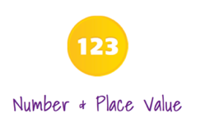
Prior Learning Assessment
Year 4 Place Value Answers
(introduction to numbers over 1000)

Prior Learning:
I feel
I feel
Question 1:
I can count over 1000 objects.

Practical:
Look at the different objects on each table and count how many of each object there is .

Observe for children counting over a thousand objects. Look for accuracy when counting especially when crossing a ten, hundred or thousand boundary.

Prior Learning:
Question 2:
I can organise objects in groups of
ones, ten, hundred and thousand.

I feel

Practical:
Can you place the objects into groups of ten, hundred and thousand? How many objects do you have altogether?

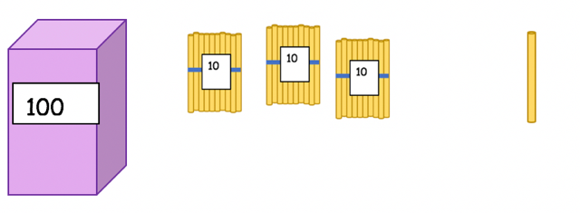

1000

Look for children’s understanding of grouping items to help with counting and their understanding of how the number system works.

Prior Learning:
Question 3:
I can identify the number of thousands,
hundreds, tens and ones in a number.

I feel

Write the number of thousands, hundreds, tens and ones in each number:
I feel

5098
4360
1435

8 ones
4 thousands
1 thousands

3 hundreds
9 tens
4 hundreds

6 tens
0 hundreds
3 tens

5 thousands
5 ones
0 ones

Prior Learning:
Question 4:
I can say the value of each digit in a
N number.

Look out for children who are unable to say the value of the digit 8 and use the correct vocabulary.

1891
800 or eight hundred

2108
8 or eight

8000 or eight thousand

8100

80 or eighty

5286
Prior Learning:

Question 5:
I can read 4 digit amounts.

I feel

Read these amounts aloud or write each amount in words.

one thousand, four hundred and fifty two
1452

7623
seven thousand, six hundred and twenty three

three thousand, four hundred and fifteen
Observe any children who make an error with the fifteen.
3415

2198
two thousand, one hundred and ninety eight

Prior Learning :
Question 6:
I can read 4 digit amounts that
contain zero.

I feel

Read these amounts aloud or write each amount in words.

two thousand and ninety one

2091

4709
four thousand, seven hundred and nine

6100
six thousand and one hundred

seven thousand, six hundred and ten
Spot any children who have made errors with place value when a zero is used .

7610

Prior Learning:
Question 7:
I can write 4 digit amounts in figures.

I feel

Question 8:
I can write 4 digit amounts in figures
when a zero is needed.

I feel

Write these amounts down using digits.

1763 thousand and ninety one

one thousand, seven hundred and sixty three

four thousand, five hundred and ninety seven

4597

six thousand, two hundred and eleven

6211

Prior Learning:

Write these amounts down using digits.

three thousand and fifteen
3015

five thousand, one hundred and eight

5108

two thousand, six hundred and forty

2640

Prior Learning:
Question 9:
I can make realistic estimates
of amounts over 1000.

I feel

I feel

Practical:
Look at the groups of objects given to you . Estimate how many objects there are.
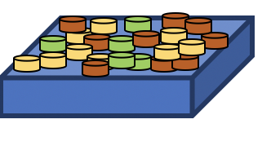

Observe the children’s estimation skills and look out for any children who make unrealistic estimates.

Prior Learning:
Question 10:
I can say which number is the largest
and which is the smallest.

I feel
109 165 94 237

In each set of numbers, write the numbers in order from smallest to largest.

In each set of numbers , put L next to the largest number and
S next to the smallest number.

1253 3428 9862 2198
S
L

5342 5182 7210 7302

S
L

S
L
4261 4093 4892 498

Prior Learning:

I feel

Question 11:
I can order sets of numbers up to
ten thousand.

Place each set of numbers in order from the smallest to the largest amount:
7868 6543 8876 9000

9000

8876

7868

6543

5060 5006 5660 5659

5060

5659

5660

5006

Prior Learning:
Question 12:
I can find 1 more or 1 less than a number.

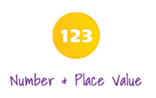
I feel

Answer these sums:

654 - 1 = 653
947 + 1 = 948

1398 - 1 = 1397
2034 + 1 = 2035

4550 - 1 = 4549
8769 + 1 = 8770

7599 + 1 = 7600
6000 - 1 = 5999

Prior Learning:

Question 13 a :
I can find 10 more or 10 less than a number.
I feel

Answer these sums:

1568 - 10 = 1558
1046 + 10 = 1056

9821 - 10 = 9811
2678 + 10 = 2688

4603 - 10 = 4593
8798 + 10 = 8808

5992 + 10 = 6002
2002 - 10 = 1992

Question 13 b :
I can find 100 more or less than a number.

I feel
2009 - 100 = 1909
5432 - 100 = 5332
1890 - 100 = 1790
7240 + 100 = 7340
4698 + 100 = 4798

Answer these sums:

2191 + 100 = 2291

7087- 100 = 6987
6909 + 100 = 7009

Prior Learning:
Question 14:
I can find 1000 more or less than a number.

I feel
Answer these sums:

1890 - 1000 = 890
4698 + 1000 = 5698

8372 - 1000 = 7372
240 + 1000 = 1240

3425 – 3000 = 425
4812 + 2000 = 6812

Prior Learning:
I feel

Question 15:
I can round numbers to the nearest ten.

Round each amount to the nearest ten. Draw a line from each of these numbers to the correct box.

78 152 997 1109

140
70
900
1000

1100
80
150
1110

Assess if the child demonstrates a lack of understanding of the word rounding or whether they show inaccuracy when rounding. Some children may round 152 to 140 as they know that they need to round down but change the ten to the one below as the ten changes when rounding up.

Prior Learning:

Question 16:
I can round numbers to the nearest hundred.

I feel

Round each number to the nearest hundred:

167 652

1830 5650
700

200

5700

1800

Look out for children that can round to the next hundred but do not include the thousands.
Question 17:
I can round numbers to the nearest
thousand.

I feel

Round each number to the nearest thousand:

1092 3572

9456 789
4000

1000

1000

9000

Question 18:
I can count backwards and forwards and
use negative numbers.

I feel

Fill in the missing boxes:

4

0 1 2 3
-1

-2

-3

Observe to see if children are aware of numbers below zero.
Prior Learning:
Question 19:
I can read Roman numerals.

I feel

Write these Roman numerals in figures:

a) XXVI =

b) LXII =

c) XIV =

26

62

14

© Copyright 2018 Brickwork Mathematics

