The Calf - what is the cause of pain and persistent tightness

I'm sure you can think of a time when you have tweaked or strained your calf during training or during a competitive sports event, you feel a mild tightening, strain or in the extreme like you have been shot in your calf. On the flip side of that, I'm sure there are those of you that can think of a time that you have had persistent tightness in your calf and no matter how much stretching you do, it just doesn't seem to influence it, or you get calf muscle soreness with no event, that typically gets worse or stays the same as you run.

It's important to have a think about how and when your calf started to get tight or sore and if there was a precipitating event in order to address the problem.

There certainly can be more complex reasons for theses problems, these can be compartment syndrome within the calf muscle fascia or referred pain from higher up the chain namely your lower back, and/or tightness and trigger point issues in your gluteal region. Now if you are getting subtle weakness in the effected side and other neurological signs, like pins and needles or shooting pains then seek medical or health care attention.

I have to say in my experience we find that the cause is generally a lot more straight forward than that, with the main culprit being calf fatigue and de-conditioning. One of the first questions I ask runners in particular is what is your accumulative running volume per week? Followed by 'what do you do for the strength component of your training?' I generally get a fairly standard response. 'I don't do any strengthening'. This is the usually the primary reason why we see these issues.

If you are a runner or undertake a sport that has a potential for calf fatigue then with the absence of specific calf strengthening you will be susceptible to potentially calf tightness, ongoing soreness or eventually true calf muscle injury. The reason for this is because the calf can become overloaded and weak and simply lack the endurance capacity for your sport or activity.

The first test is comparing your calf endurance with a simple repeated single leg calf raise.

- Hold onto something fixed so that you can maintain your balance and push up onto your toes getting the heel as high as possible into a calf raise and do as many as possible then compare your left side to your right side.

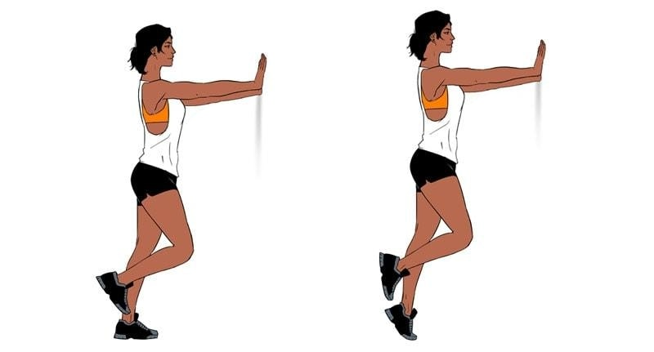

The spurious number I use as my guide is 40 reps, I find that the majority of people who have ongoing tightness or calf pain struggle to get to this number, this should feel fairly easy, if it’s a challenge then get onto those calf raises, If you have a deficit then the obvious answer is to address it!

I find that people aren't too bad with a simple straight leg calf raise, however the issue can be the other muscle in the calf that is very often neglected. This muscle is the Soleus.

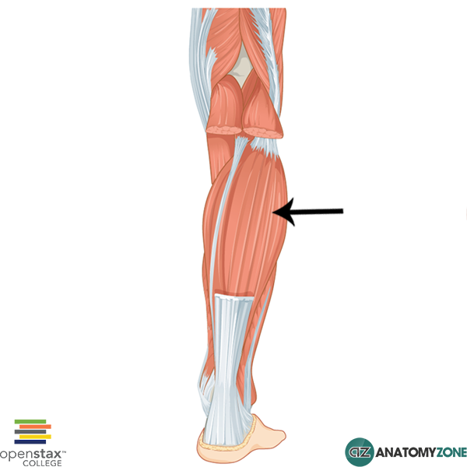

As you can see it's pretty big accounting for a large amount of force. Soleus is a crucial muscle and its lack of capacity is often the cause of many of the calf issues I see.

To test Soleus you need to perform a bent knee calf raise just as above but with the knee slightly bent and maintained in a bent position throughout the movement. Remember your ankle does all the moving not you knee.
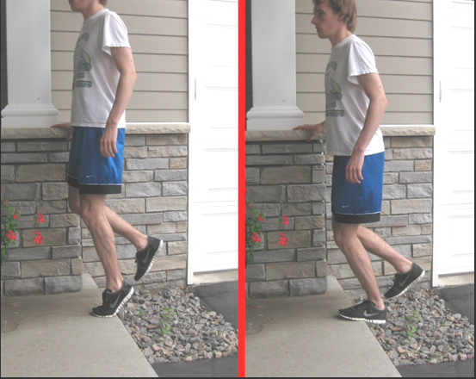

Historically we find that the throw away advice by most people trained or otherwise is if it's tight then stretch it. However thinking has changed thankfully; the reason for tightness that doesn't change with stretching and if you have ongoing aching or calf pain is simply because your calf is not tolerating the load that you are putting it through. The great news is it is easy to self diagnose and just involves the undertaking of the tests above, then starting the simple exercises to build some calf capacity

Start on the floor undertaking 3 x 15 reps with a minute rest and build up to 3 x 30 reps with 2 mins rest in between, progressing to off a step and then starting again at 3 x 15-20 reps and build up to 3 x 30 again. Then we move to a calf raise machine or calf raises on the leg press, if the gym is not accessible then use a back pack and load it with some weight or hold onto a dumbbell being progressive in your increase in external weight.

It's important to mention that you must do this on your non running/training days and aim to do this 2-3 x weekly.

Now this is all very well but I can't sign off without saying that your ongoing calf tightness or discomfort can be due to overtraining, or having not had enough rest and everything is just feeling overloaded. Make sure that you are implementing some recovery strategies i.e. stretching (straight leg and bent knee), foam rolling, adequate warm up and rest.

You simply can't go wrong getting strong.

Taylormade Physio
bookings@taylormadephysio.co.uk
01276 473787
www.taylormadephysio.co.uk

