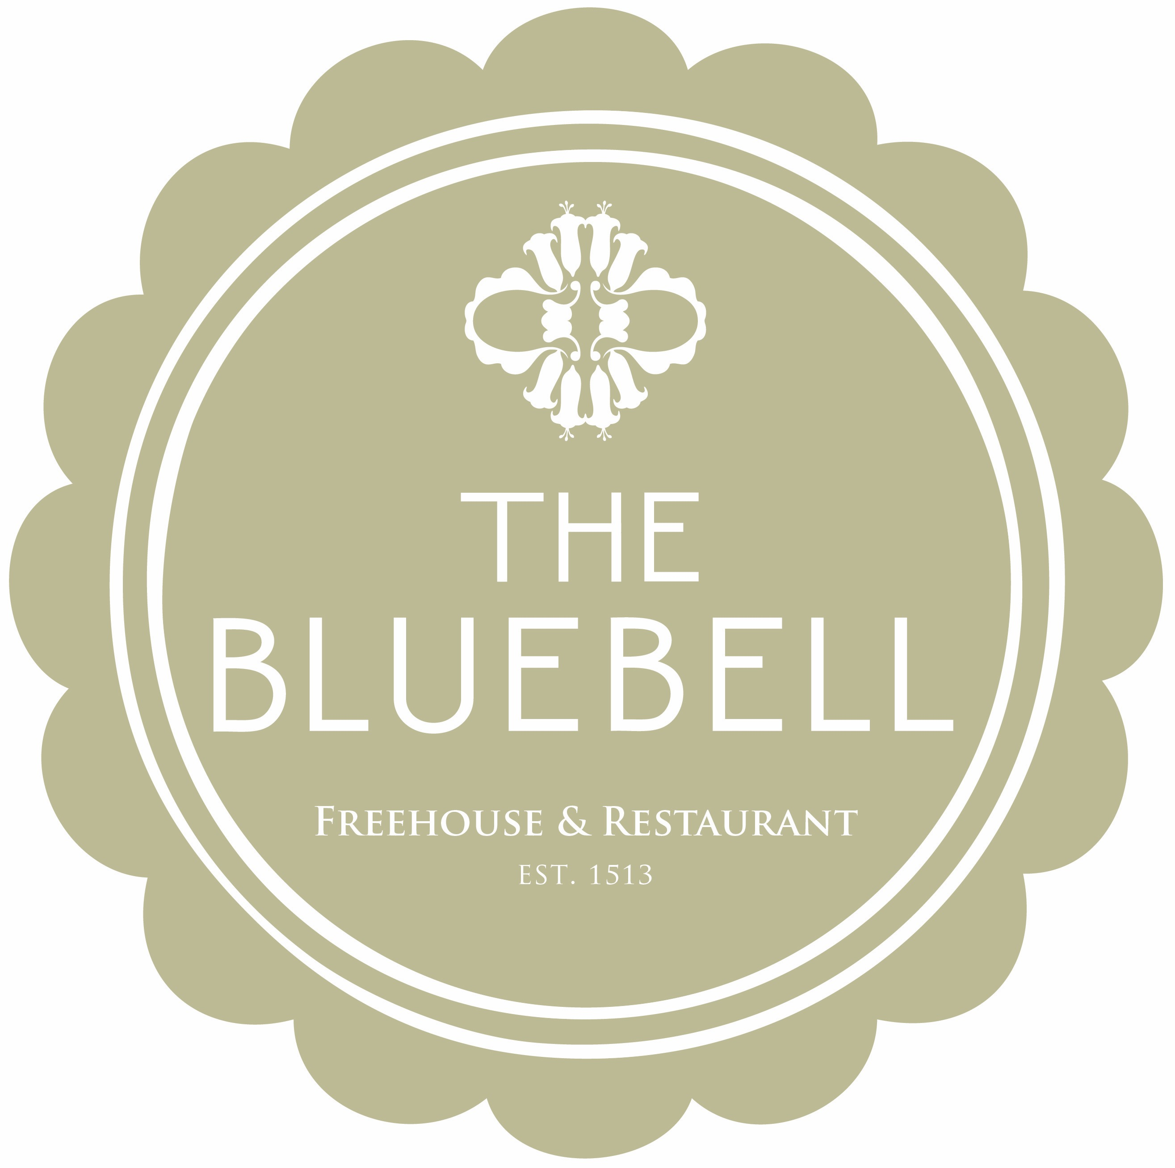

The Bluebell Express Lunch Menu

A Healthy Salad of Quinoa, Fennel, Avocado, Apple &
Orange , Brown Crab Dressing
£12

Mini Fish & Fries, Tartare Sauce
£11

Sandwich of the moment with Soup, fries
£7

Truffled Brie, Hummus & Tempura Tenderstem Broccoli
£10

Maple Cured Gammon Ribeye, Hens Egg & Triple Cooked Chips
£12
Lashfords Sausage & mash, Red Onion Gravy
£12

Black Pudding Scotched Hens Egg & fries
£8

We will aim to deliver your dishes within 10-15 minuets from the moment the ticket arrives in the kitchen
All dishes are fresh, seasonal and cooked to order so please be aware as a result or may indeed become unavailable
copyright the bluebell 2019 We do use nuts in our kitchen so please do advise a member of the team if you have any allergies at all.

