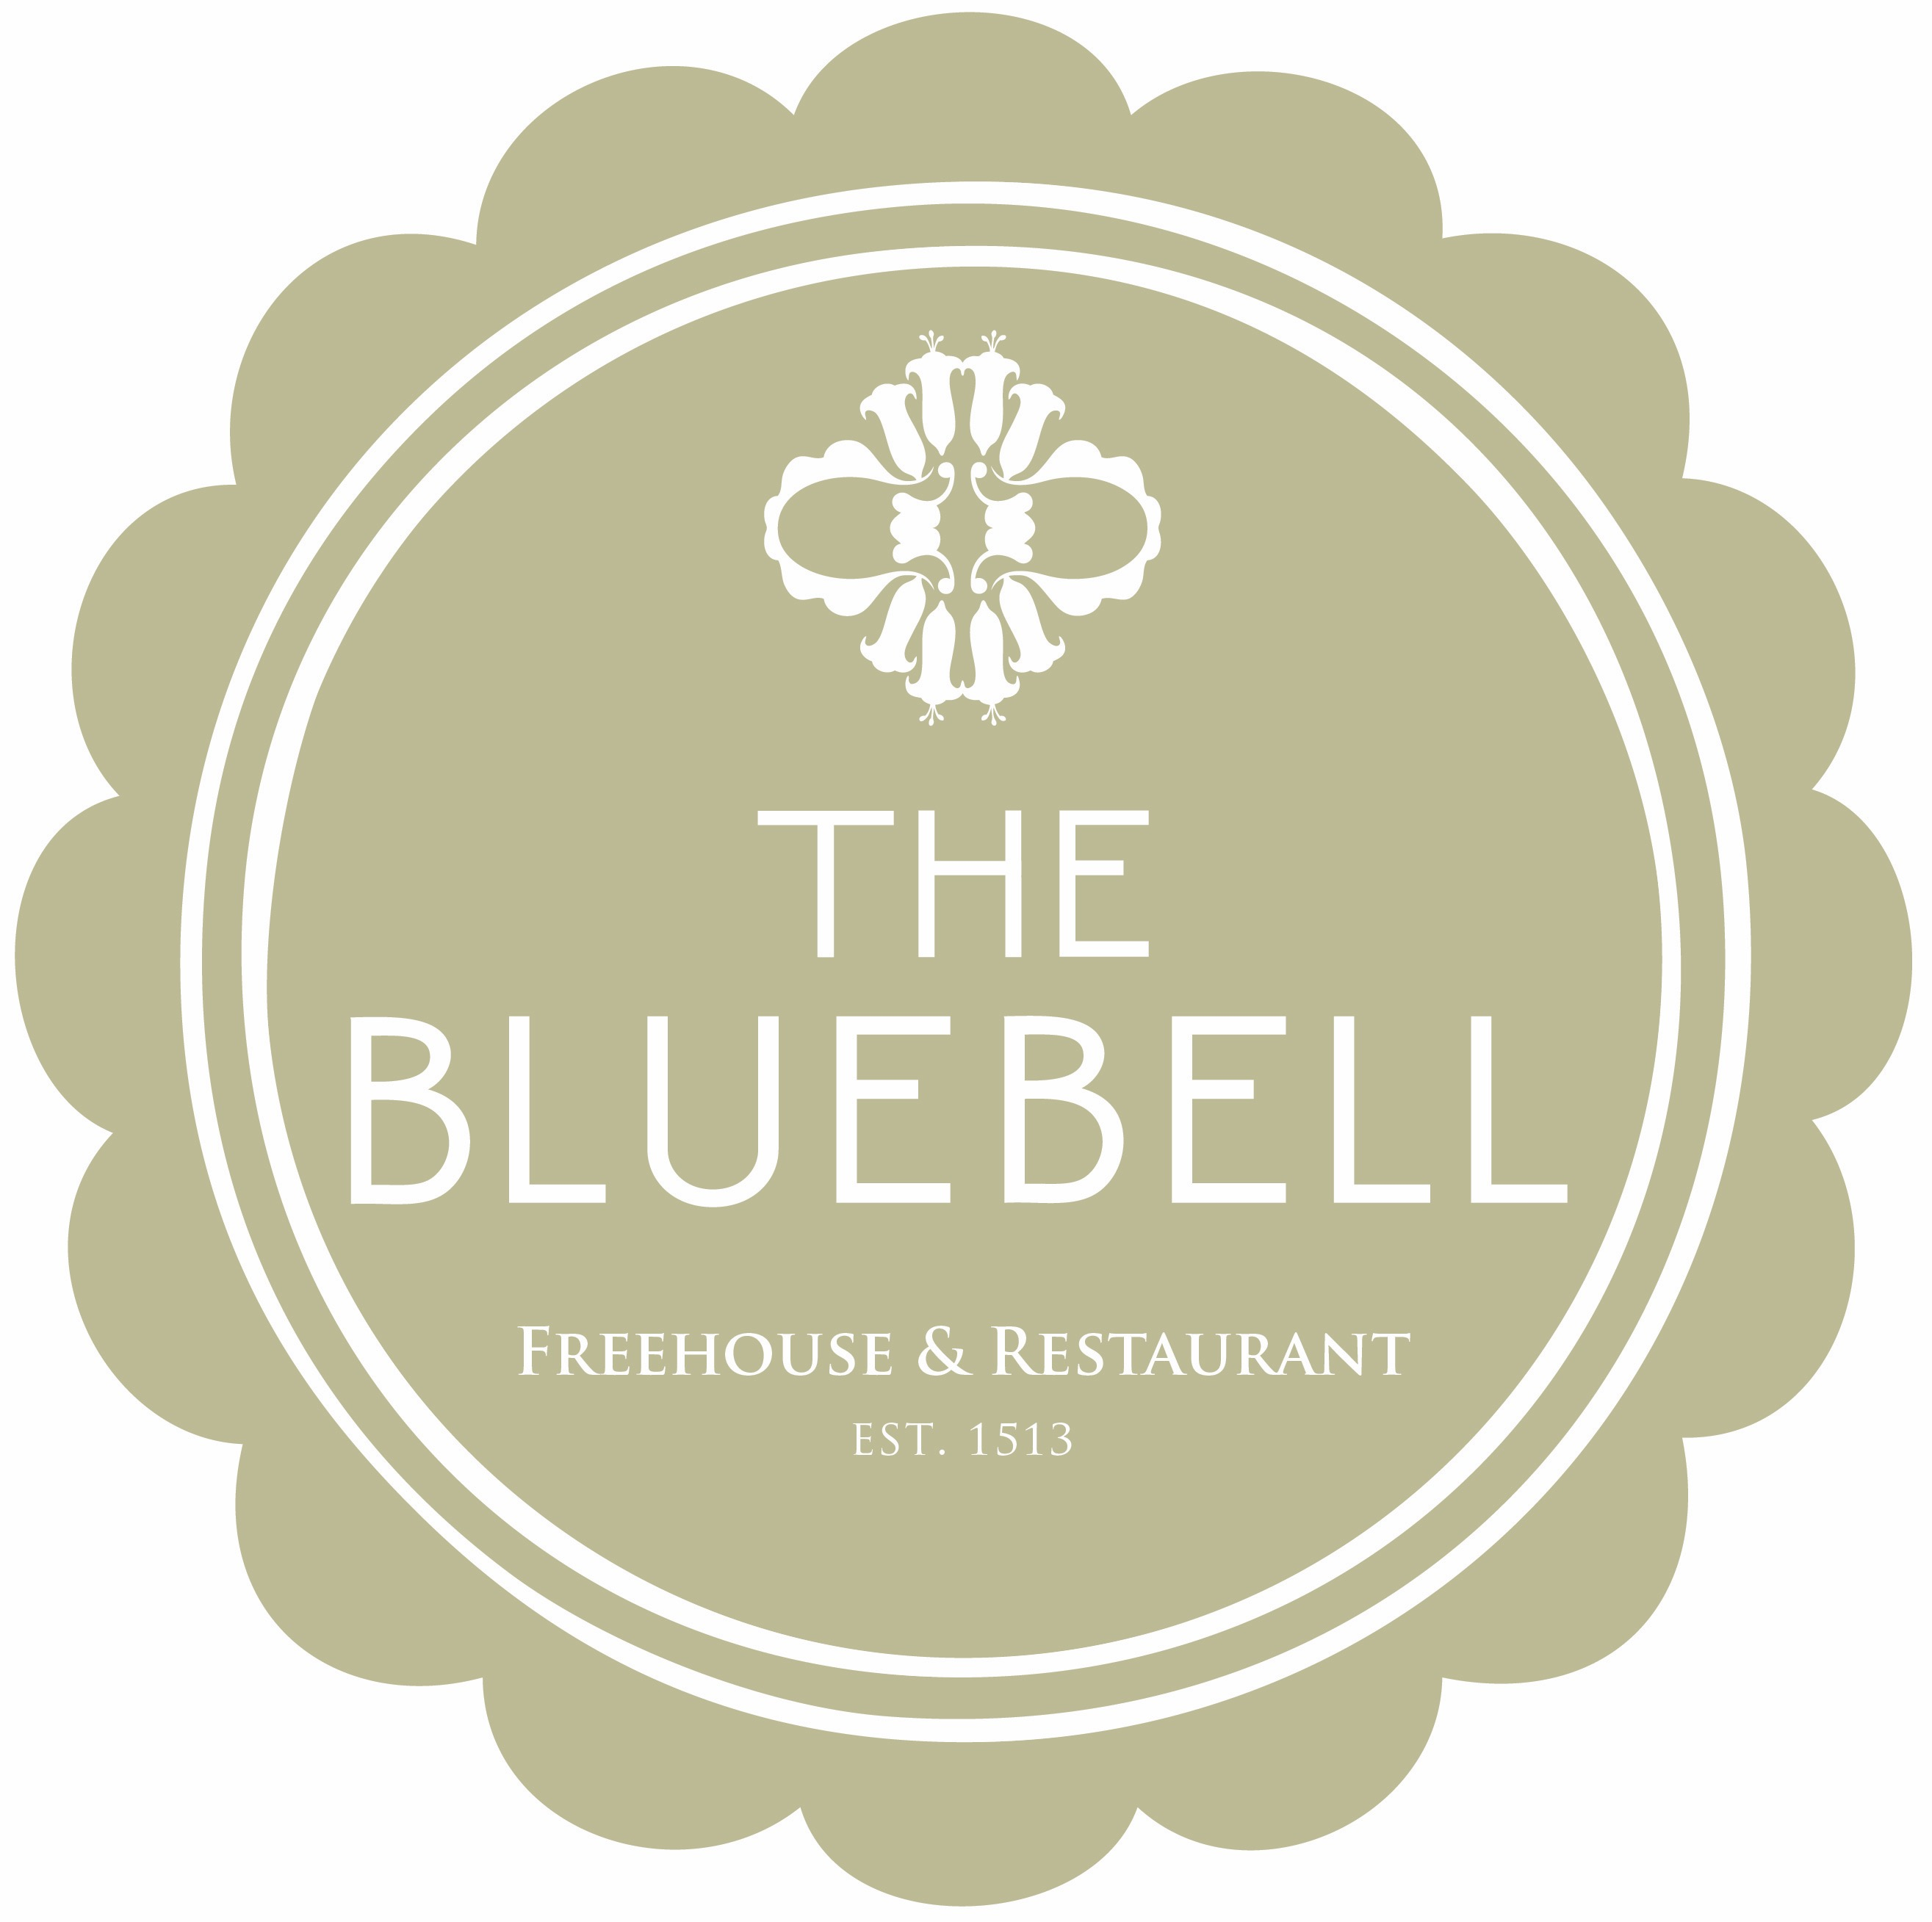

Served Tuesday - Friday Lunch 12-2.30pm

Lunch

Snacks

Homemade Sourdough and Netherend Farm Butter £2.00
Black pudding Scotch Egg, Homemade Piccalilli £6.50
English Charcuterie Board, Berkswell Cheddar, Red Onion Marmalade, Sourdough Bread £9.95

Salad

Superfood salad
Starter £6.50 Main £9.95
– Add a breast of chicken (£4.90)

Sandwiches

Chicken Salad £6.95 (Choice of Chips or Soup)
Cheese, Mayo, Red onion Marmalade £6.95 (Chips or Soup)

Pub Classics
Welsh Rarebit, Heritage Tomato & Sourdough £7.00

Ham & Chicken Terrine, English Mustard Mayonnaise, Parsley & Gherkin Salad £6.50

8oz Gammon Ribeye, Homemade Piccalilli, Fried Hens Egg, Triple Cooked Chips £11.50

Toasted Sourdough bap with 3oz Steak, Mustard Mayo, Fried Hens Egg, Triple Cooked Chips £9.50

