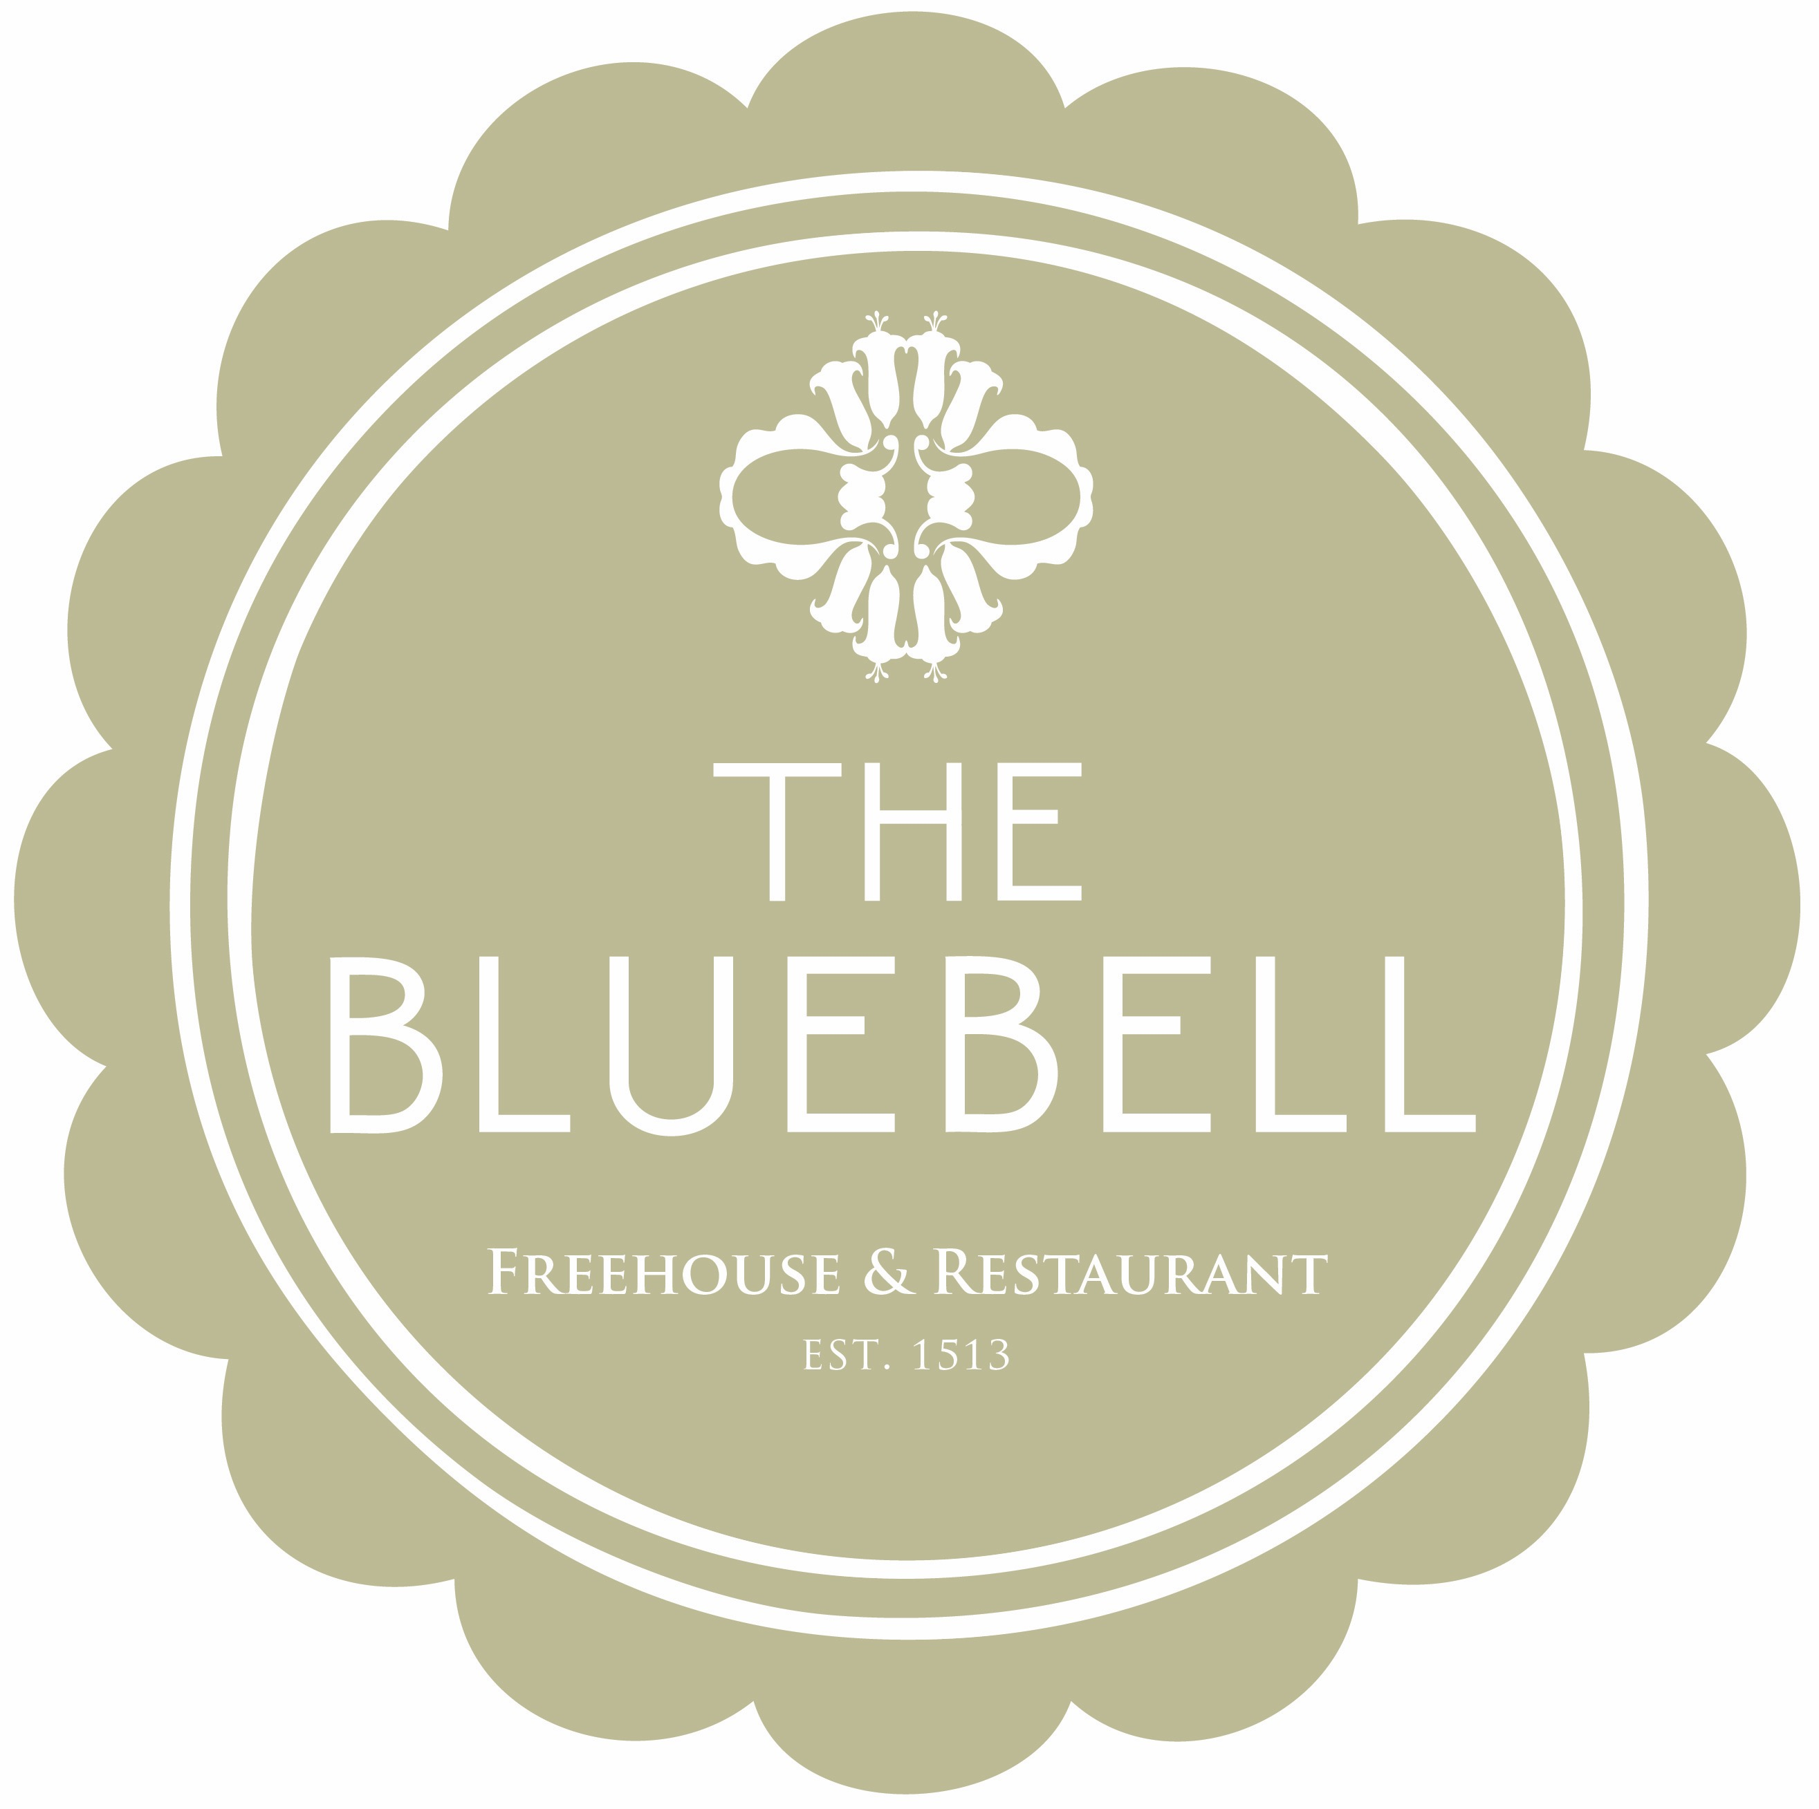

Sunday Lunch at The Bluebell Free House Pub & Restaurant we use only seasonal produce. Our beef and poultry is sourced from Aubrey Allen Butchers, the fish we use is sourced from the Cornish coast and all Vegetables are carefully selected from the market by Chef, something taught by his late father.
Starters
Selection of English Charcuterie, Berkswell Cheese, Pickles, Sourdough Bread £9.95
Marinated Olives £3.00
The Bluebell Sourdough (Born 01/10/16) Netherend Butter £2.25
Baked Camembert Cheese, Smoky Bacon, Ciabatta Croutons £9.50
Black Pudding Scotch Hens Egg & Piccalilli £6.50
Crisp Parma ham, Melon three ways; Compressed Watermelon, BBQ Gala and Cantaloupe £7.00
Chicken Parfait, Cherry, Plum Chutney, Brioche £6.50
Pan-fried Scallops, Saffron Giant Couscous, White Chocolate Aero, Orange & Dill Oil £9.00
Slow Cooked Smoked Loch Duart Salmon, Avocado, Puffed Wild Rice, Lemon Oil £7.75
Warm Goats Cheese Soufflé, Black Olive & Cheddar Cheese Sauce £7.00
Cornish Crab, Heritage Tomatoes, Charred Cucumber, Sourdough Crumb £7.70
Fillet of Beef Tartare, Cured Egg Yolk, Shaved Parmesan, Sourdough Toast £8.50
The Bluebell Atlantic Prawn Cocktail, Saffron & Garlic Mayonnaise, Granary Bread £6.50
Smoked slow cooked Loch Duart Salmon, wasabi dressed Potato, Avocado, Puffed Wild Rice, Lemon Oil £7.75
Venison, Chicken liver & Pistachio terrine, Caramelized Onion Puree, Dressed Green Beans, Toasted Bread £7.50
Mains
Roasted Strip Loin of Heritage Beef, Duck Fat Potatoes, Yorkshire Pudding & Red Wine Gravy £16.95
Roasted Leg of Lighthorne Lamb, Duck Fat Potatoes, Yorkshire pudding & Red Wine Gravy £15.95
Slow Cooked Belly of Jimmy Butlers Pork, Duck Fat Potatoes, Yorkshire pudding,
Apple Puree & Crackling £14.95
Roast Cornfed Chicken, Duck Fat Roast Potatoes, Red Wine Sauce £14.95
(All Roasts Served with Seasonal Greens and Cauliflower Cheese)
Lightly Battered Coastal Fish & Triple Cooked Chips, Crushed Peas & Tartare Sauce £15.00
Lash ford Sausages & Buttered Mash, Red Onion Gravy £12.50
Pan Fried Duck Breast, Violet potato, Turnip, Dark Chocolate & Black Cherries £17.00
Pan Fried Cornish Cod, Chorizo sausage, Saffron risotto, Broad beans & Peas £16.50
Chickpea Curry, Puffed Wild Rice, Halloumi Cheese, Purple Sprouting broccoli £13.95 v
Pan Fried Peppered Duck Breast, Violet Potato, Radish, Turnip, Black Cherry, Red Wine Sauce £17.00
6 oz Fillet Medallions, Vine Tomato, Triple Cooked Chips, Leaves & Garlic Crème Fraiche £19

Dessert
Baked Alaska, Maple Syrup Jelly, Chocolate Cake, Garden Blackberries £6.50
Banana Bread, Banana & Lime Sorbet, Salted Caramel & Glazed Banana £6.50
Fig, White chocolate & Almond Frangipani , Orange Ice Cream £6.50
Damson cheesecake, Dark Chocolate and Vanilla Ice Cream £6 .50
Warm Treacle Tart, Salted Caramel sauce, Creme fraiche Ice Cream £6.50
1 Scoop £2.00 2 scoop £3.50 3 scoop £5.50 of Ice cream and Sorbets
Bramley Apple Crumble with Vanilla Ice Cream or Custard £6
Vanilla Pannacotta, Poached English Strawberries, Strawberry Sorbet £6.50
Cheese Selection
Tunworth / Single Gloucester / Roquefort Vieux Berger/ Warwickshire Forest Blue / Warwickshire Truckle Served with Red Grapes, Onion Chutney and Crackers. 3 cheeses £8.50 5 Cheese £11.00

2 courses 21.50 3 courses 24.00
Excluding Steak……Scallops/Cheese Supplement £3.95
A discretionary optional service charge of 10% Applies for party of 6 and above. We do use nuts in our kitchen so please do advise a member of the team if you have any allergies.
All main courses are fresh, seasonal and cooked to order. As a result, please be aware some dishes can take 20-30 minutes to prepare or indeed become unavailable. Copyright to the bluebell 2017

