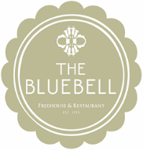
Upon Arrival
Glass of Rose Champagne or Our Valentines Cocktail
Valentine’s Menu
Dill and Whisky Cured Loch Duarte Salmon, Pickled Cucumber, Sour Cream, Caviar
Lamb Keeftico, Miso Glazed Shallots, Mint Mayonnaise & Dauphinoise Potato
Tunworth Cheese, Pear & Walnut Oil
Dark Chocolate Orange Crumble Soufflé, Mandarin Sorbet
Tea or Coffee

