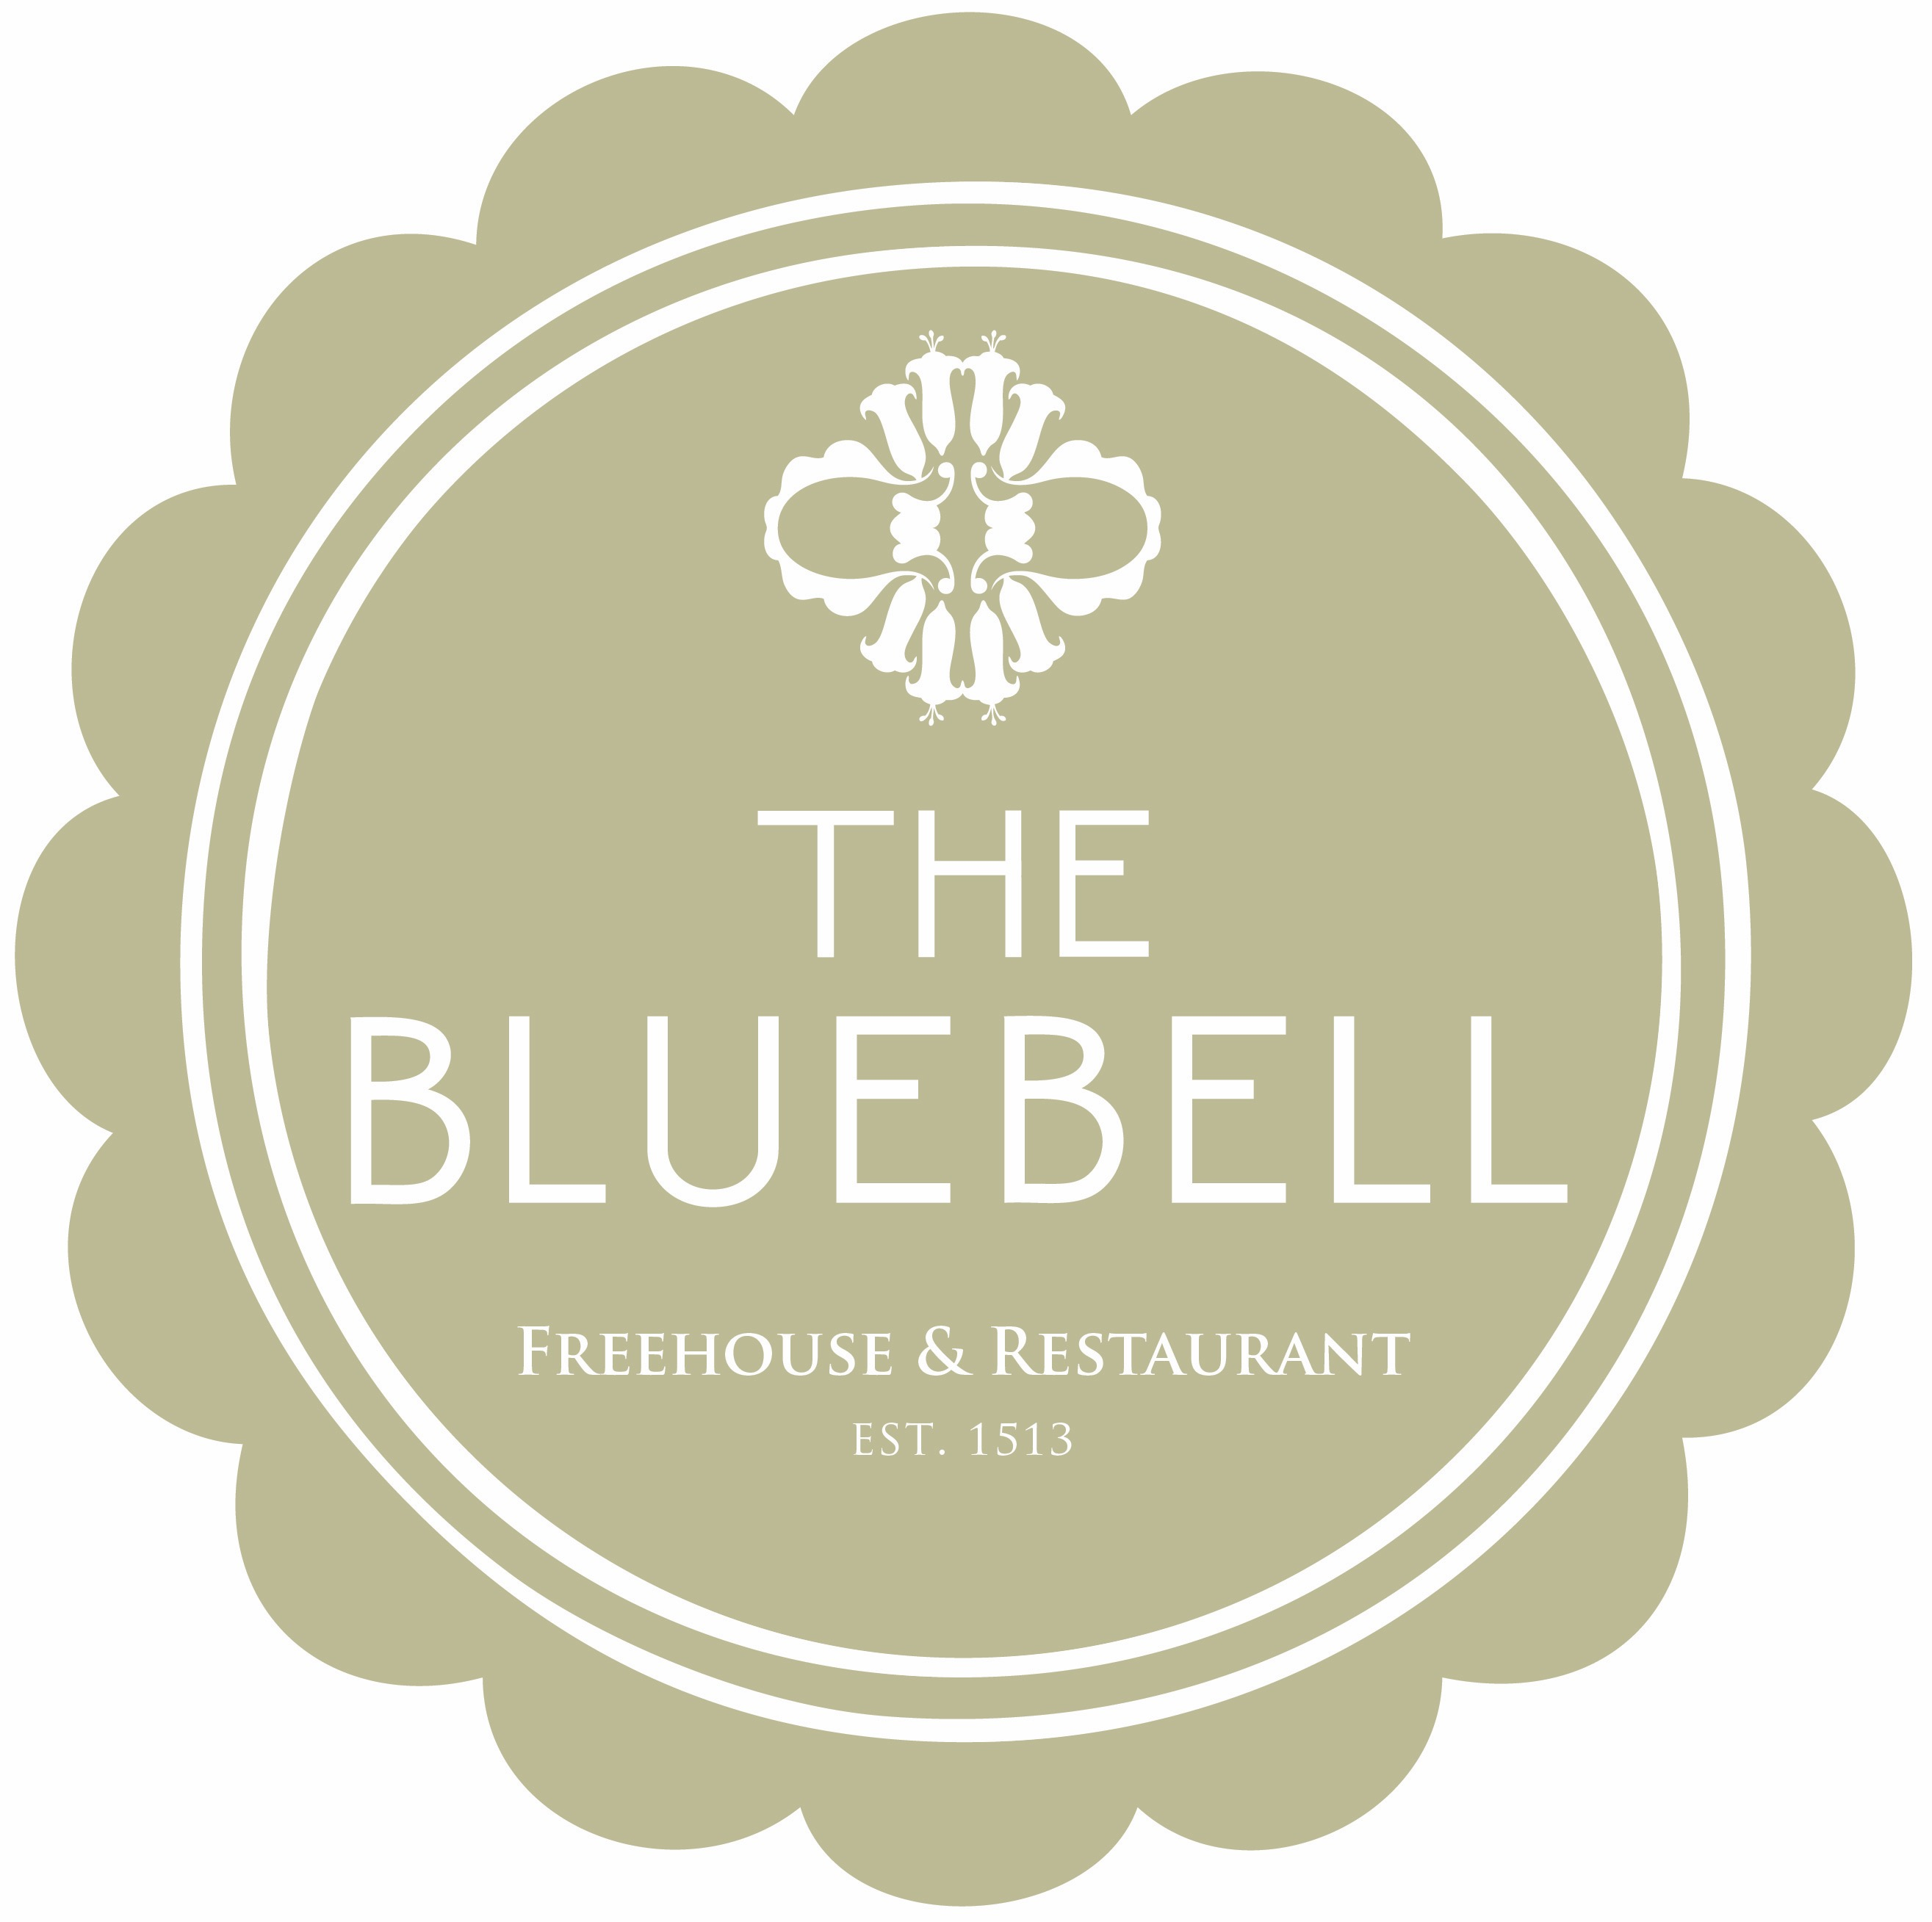

The Bluebell Express Lunch Menu

Mini Fish & Chips, Tartare Sauce
£10

Sandwich of the moment with Soup, fries
£7.5

Spiced Roasted Cauliflower, Hummus & Tempura Tenderstem Broccoli £10

Maple Cured Gammon Ribeye, Hens Egg & Triple Cooked Chips
£11

Fish Finger Sandwich, Tartare Sauce & fries
£8.5

3oz Fillet Steak, Tripple cooked Chips, Peppercorn Sauce £12

Black Pudding Scotched Hens Egg & fries
£8

We will aim to deliver your dishes within 10-15 minuets from the moment the ticket arrives in the kitchen
All dishes are fresh, seasonal and cooked to order so please be aware as a result or may indeed become unavailable
copyright the bluebell 2018 We do use nuts in our kitchen so please do advise a member of the team if you have any allergies at all.

