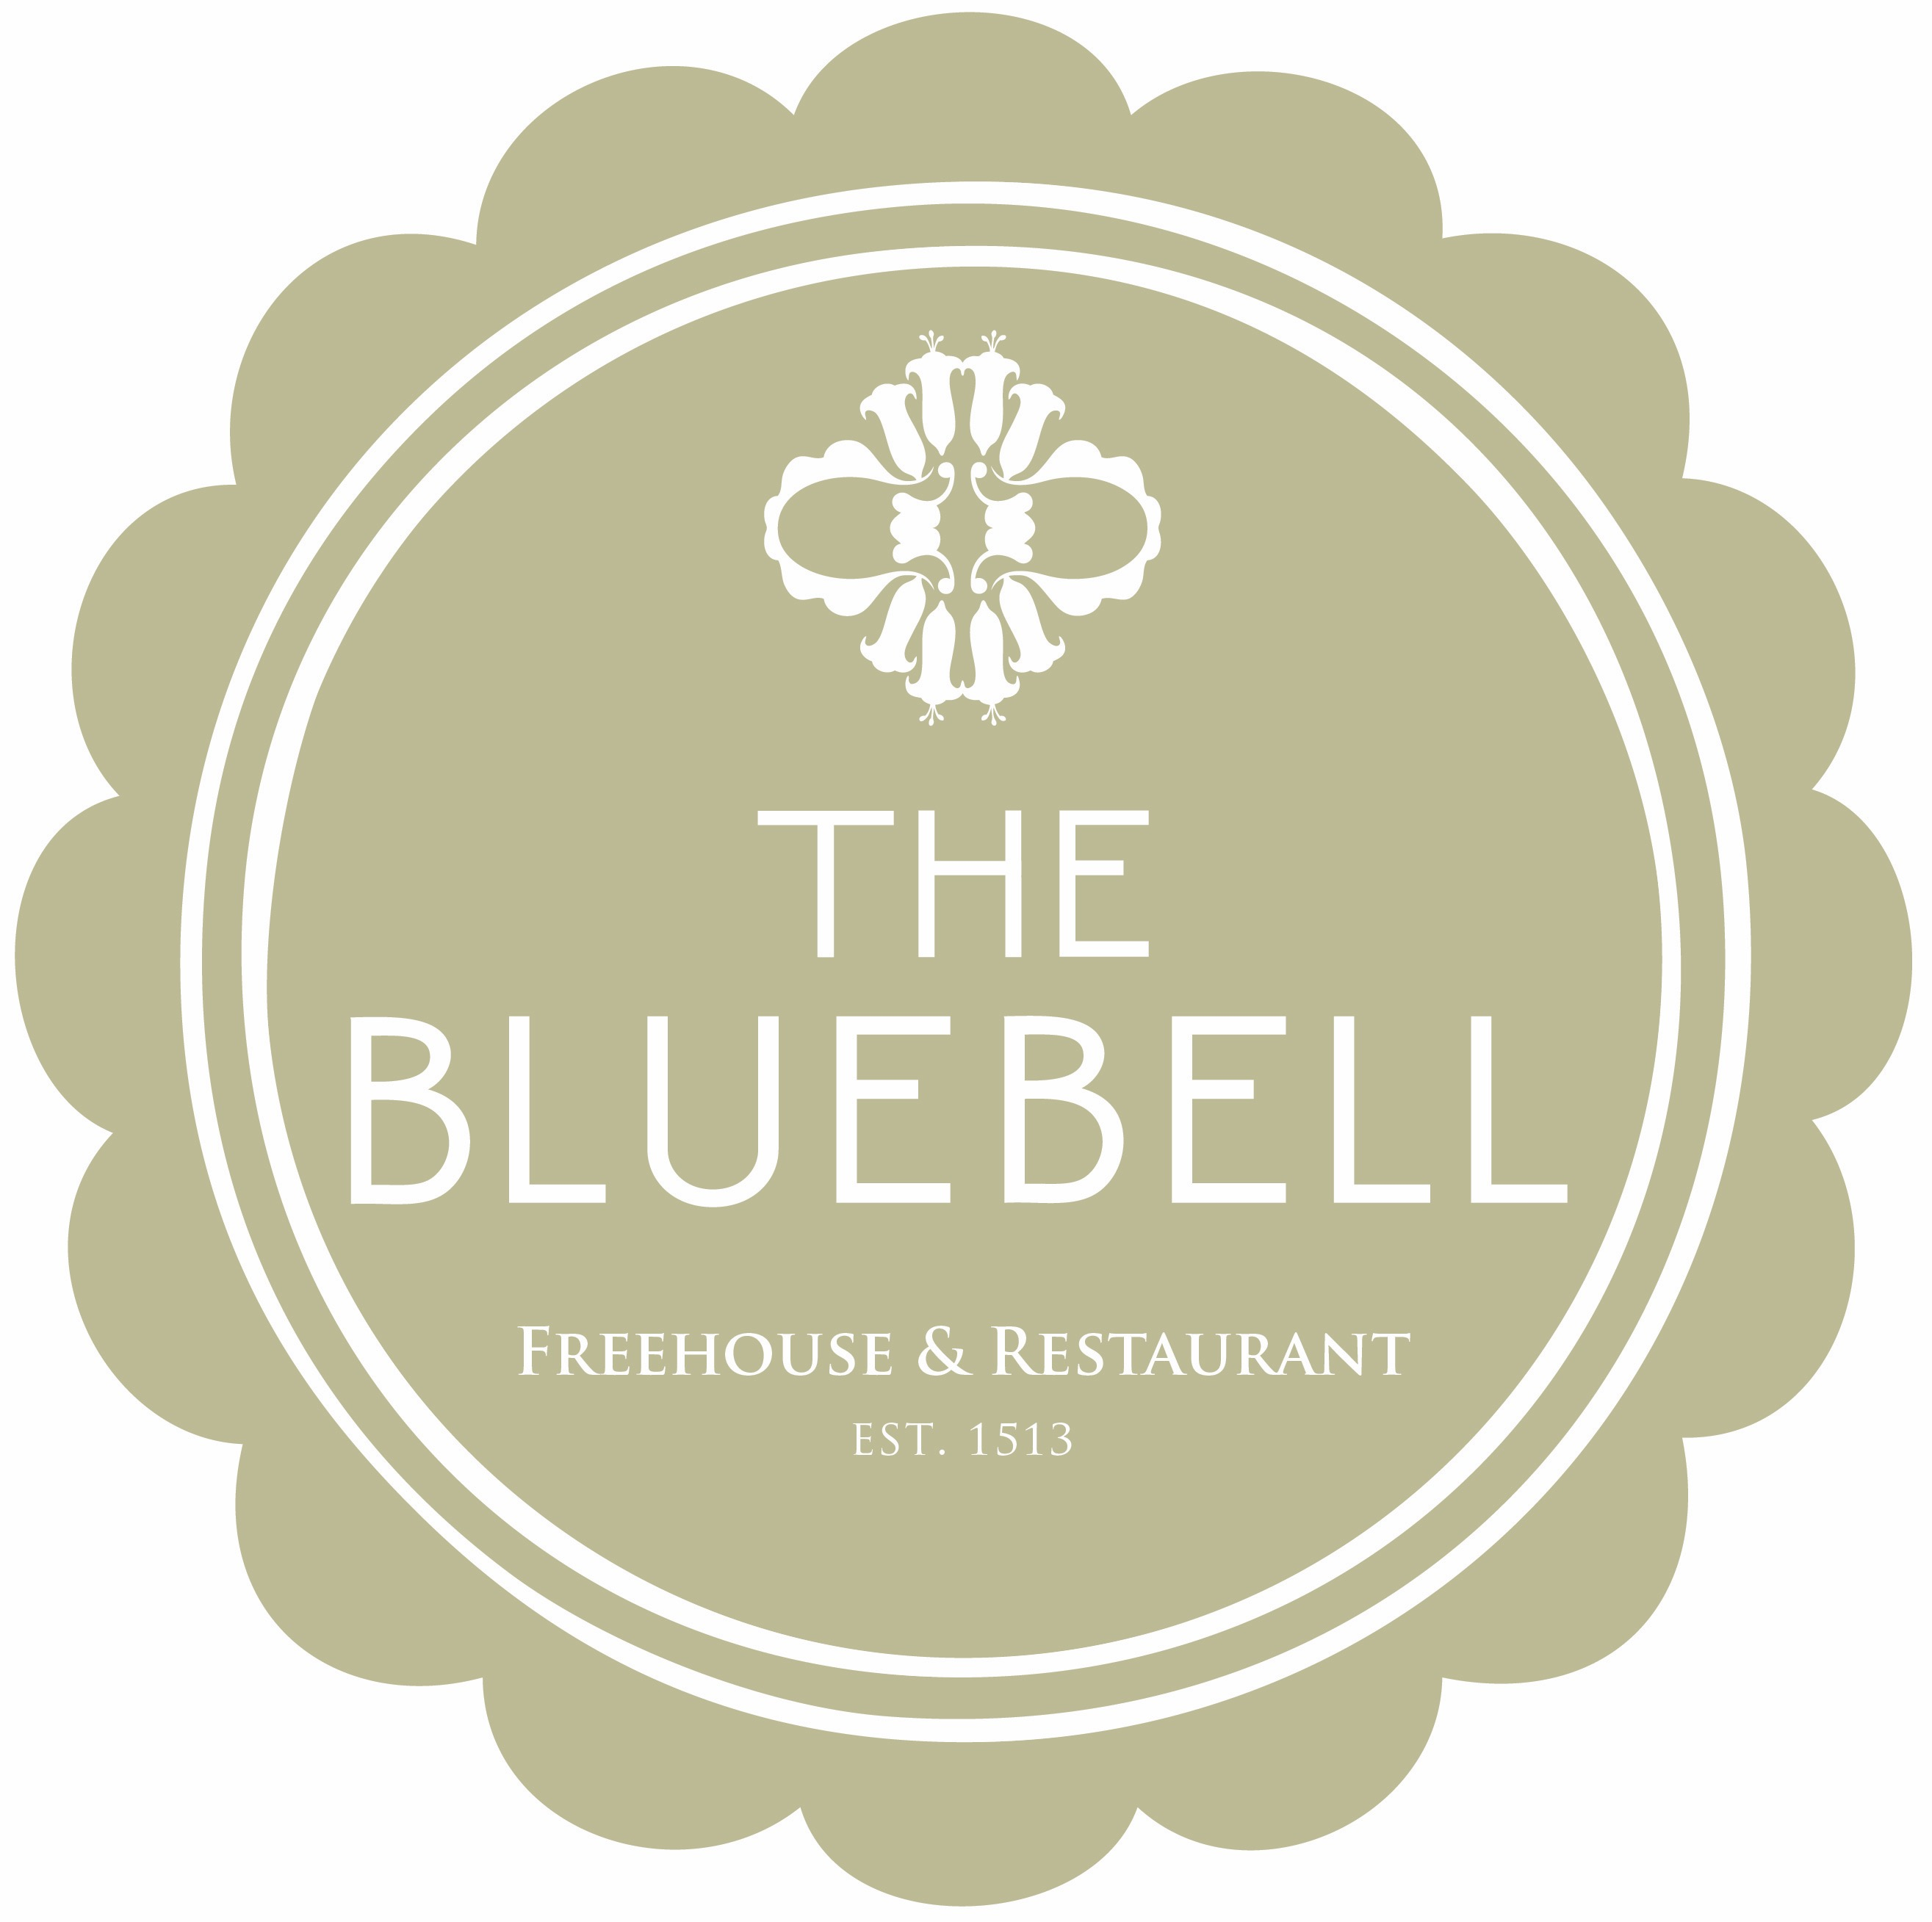

Mother’s Day Lunch at The Bluebell Free House Pub & Restaurant we use only seasonal produce. Our beef and poultry is sourced from Butchers Rowley’s, the fish we use is sourced from the Cornish coast and all Vegetables are carefully selected from the market by Chef, something taught by his late father.
The Bluebell Bloody Mary (£7.95)
Starters
Selection of English Charcuterie, Berkswell Cheese, Pickles, Sourdough Bread
The Bluebell Sourdough (Born 01/10/16) Whipped Beef Dripping
Carrot & Ginger Volute, Toasted Ciabatta, Cream Cheese & Pinenuts
Black Pudding Scotch Hens Egg
Pan-fried Scallops, Toasted Almonds, Cauliflower and parmesan crisp
BBQ Smoked Slow Cook Loch Duarte Salmon, Puffed Wild Rice, Avocado, Lemon Oil
Ham Hock & Pig heads Fritter, Caramelized Onion Puree, Apple & English mustard
Beetroot Carpaccio, Pickled Candy, Cerney Ash Bon Bons, Horseradish Snow
Parfait of Chicken Liver, Nuts & Seeds with Brioche
Cornish Dressed Crab, Brown Crab Meat Set Cream, Granny Smith Apple, Caviar
Grilled Asparagus, Poached Hens Egg, Tarragon Hollandaise
The Bluebell Prawn Cocktail, Saffron Mayonnaise, Granary Bread
Mains
Roasted Strip Loin of Heritage Beef, Duck Fat Potatoes, Yorkshire Pudding & Red Wine Gravy
Slow Cooked Belly of Jimmy Butlers Pork, Duck Fat Potatoes, Apple Puree & Crackling
Leg of Cotswold Lamb, Pressed Lamb Breast, Duck Fat Roast Potatoes, Red Wine Sauce
Cornfed Chicken Breast, Bread Sauce, Duck Fat Roast Potatoes
(All Roasts Served with Seasonal Greens and Cauliflower Cheese)
Lightly Battered Coastal Fish & Triple Cooked Chips, Crushed Peas & Tartare Sauce
Lash ford Sausages & Buttered Mash, Red Onion Gravy
Seabass Bass, Garlic Crushed Potatoes, Samphire & Caviar Sauce
Rump of Lamb, Braised Neck, Garlic Potato, Smoked Anchovies Mayonnaise
Pan Fried Merrifield Farm Duck Breast, Puy lentils, Pressed Potato terrine, Red wine sauce
Warwickshire Smoked Truckle Twice Baked Soufflé, Caramelized Shallots, Watercress, Chervil & onion Salad
Steaks
12oz Rump cap £24
8oz Ribeye £23
Two 3oz Fillet Medallions £20
8oz Onglet £18

All Steaks are served with beer glazed Onions, watercress

Served with Garlic Crème Fraiche

Dessert
Warm Chocolate Fondant, Salt Carmel Ice Cream
“Affogato” Coffee, Vanilla Ice Cream with A Choice of Liqueur
Orange and Mint Pudding with Chocolate Ice Cream
Crème Carmel, Lemon Madeline
Artic Roll, White Chocolate Ice Cream, Passion Fruit & Hazelnuts
Vanilla Crème Brulee, Shortbread
Warm Chocolate Fondant, Salt Carmel Ice Cream
Lemon Tart, Yogurt Sorbet
Selection of ice creams
Warm Apple Crumble, Vanilla Ice Cream or Custard
Cheese Selection
Tunworth / Single Gloucester / Roquefort Vieux Berger/ Warwickshire Forest Blue / Warwickshire Truckle Served with Red Grapes, Onion Chutney and Crackers. 3 Cheeses
2 courses £27.00 3 courses £31
Excluding Steak…… Scallops/Cheese/Supplement £3.00
A discretionary optional service charge of 8% Applies for party of 8 and above. We do use nuts in our kitchen so please do advise a member of the team if you have any allergies.
There May be a Slight Change to dishes on the menu due to market changes and seasonality, so this menu is an example

All main courses are fresh, seasonal and cooked to order. As a result, please be aware some dishes can take 20-30 minutes to prepare or indeed become unavailable, Some dishes are served warm not hot.
Copyright to the bluebell 2017

