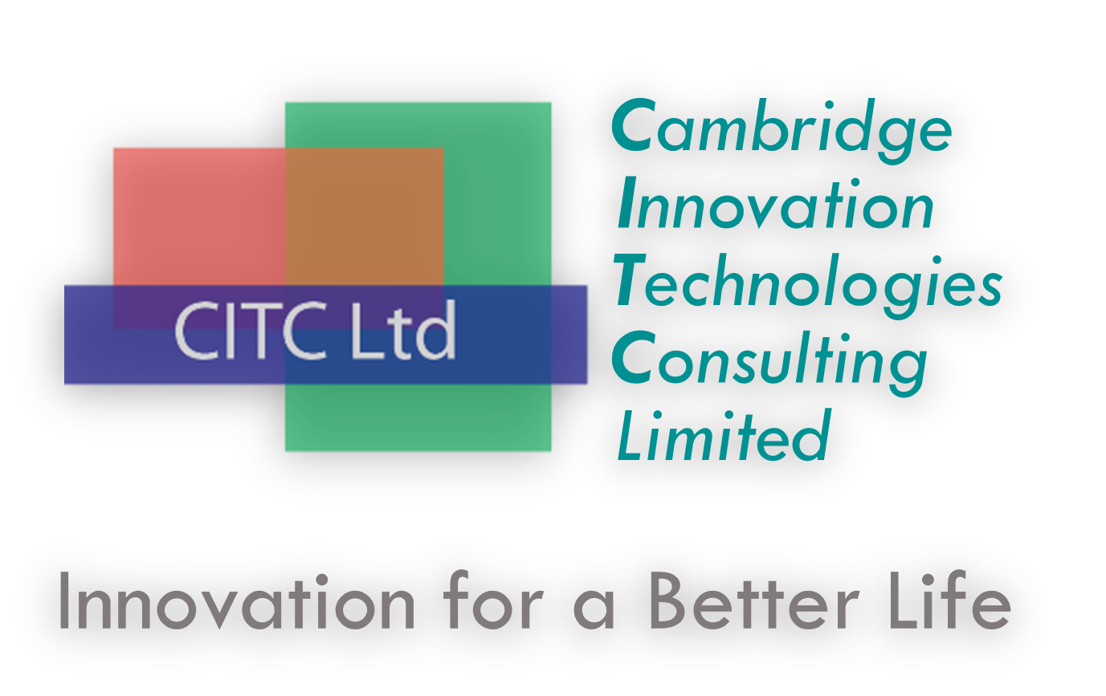
Press release:
Cambridge University scientists partner with CITC Ltd to advance a novel therapeutic enzyme from the bench to the bedside

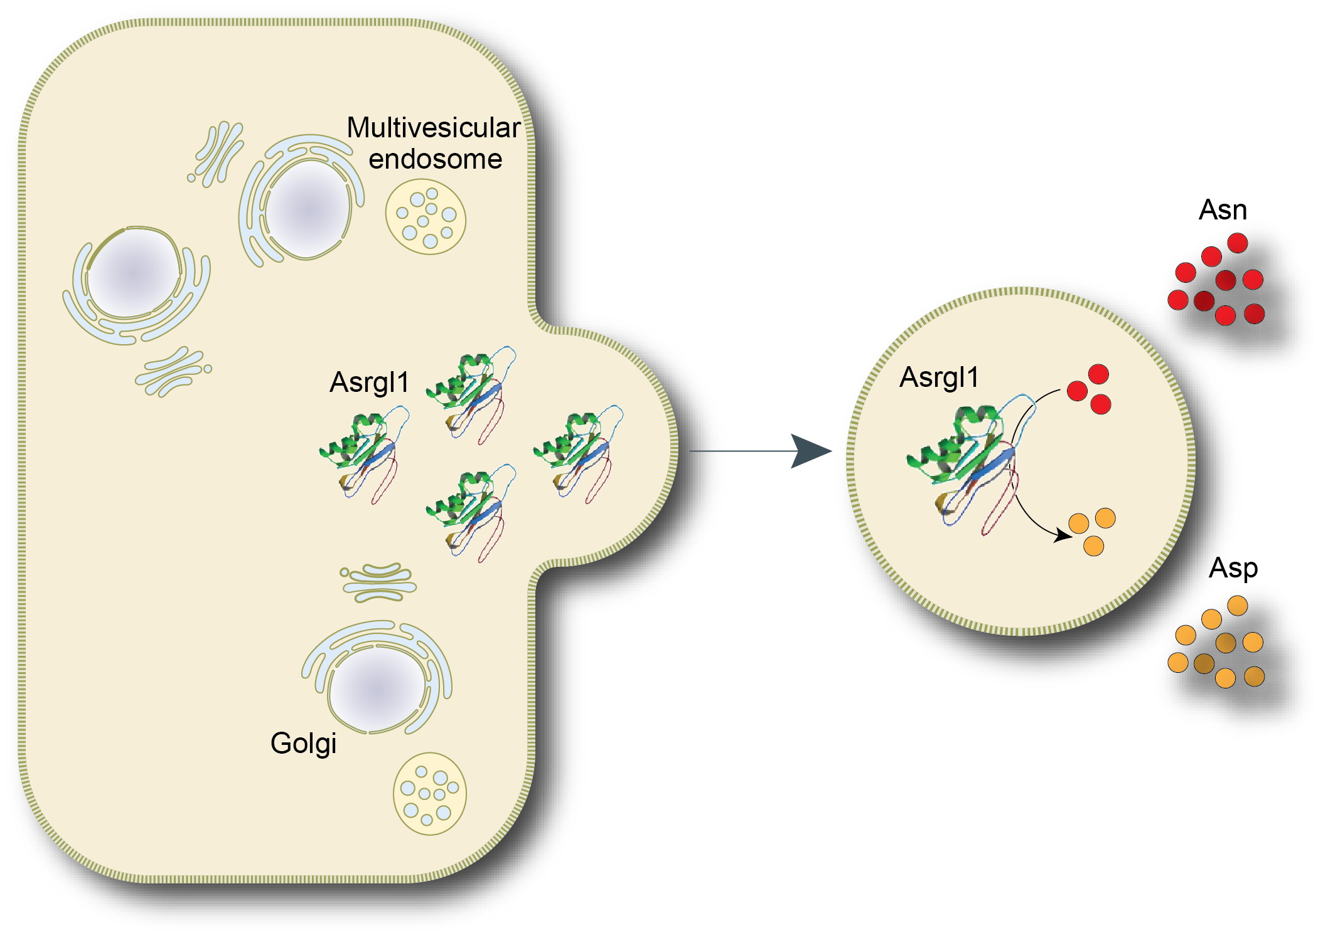
3rd July 2017. A team of scientists based at the University of Cambridge have discovered new insights into cellular signalling processes that may lead to advanced treatments for cancers types that depend on specific metabolic pathways to survive. Targeting those pathways has great potential for developing better and more selective drugs.

Stefano Pluchino from the Wellcome Trust – Medical Research Council (MRC) Cambridge Stem Cell Institute and Christian Frezza from the MRC Cancer Unit, used neural stem cells to study the extracellular vesicles (exosomes) that these cells release to communicate with the surrounding microenvironment.
By isolating stem cell exosomes, the scientists were able to measure their enzymatic activity and to discover that the most active enzyme was Asparaginase-like 1 (Asrgl-1), an isoform of the enzyme L-asparaginase that is currently used to treat acute lymphoblastic leukemia (ALL), a blood cancer often diagnosed in children and young adults. This discovery significantly extends our understanding of cell signalling biology and highlights potential clinical applications.
L-Asparaginase therapy for cancers such as ALL works by depleting Asparagine, an amino acid that cancer cells need to survive. However, the approved drug also depletes another amino acid, Glutamine, which healthy cells need to function normally, while producing Glutamate that is toxic for the liver. Many patients also develop hypersensitivity to the bacteria-derived L-Asparaginases currently used in the clinic.
Critically, the team of scientists at Cambridge found that the Asrgl-1 isolated in exosomes acts specifically on Asparagine, while leaving Glutamine untouched.

The team lead by Pluchino will look to advance this work from the bench to the bedside with the help of Cambridge Innovation Technologies Consulting Limited (CITC Ltd), a Cambridge (UK) based biotechnology firm with vast expertise in drug development and neural stem cell based-therapeutics.
“The current treatment of acute lymphoblastic leukaemia presents a difficult balancing act: removing enough asparagine so that cancer cells cannot survive, but leaving enough glutamine to ensure normal cells in the body can thrive”, explains Pluchino, University Reader in Regenerative Neuroimmunology at Cambridge University and Chief Scientific Officer (CSO) at CITC Ltd. “The discovery that the Asparaginase-like 1 in stem cell exosomes depletes Asparagine but does not affect Glutamine could provide an alternative anti-cancer therapy that may limit side effects that can occur when Glutamine is transformed into Glutamate”.
This novel research, which appeared today as an Advanced Online Publication (AOP) in the journal Nature Chemical Biology (http://www.nature.com/nchembio), has the potential to improve the treatment of ALL and other cancers for which asparaginase is undergoing clinical trials, such as acute myeloid leukemia (AML), pancreatic cancers, and non-Hodgkin lymphoma (NHL).
Together, CITC Ltd and the partnering Cambridge consortium of physician-scientists hope to advance this novel/selective cancer therapy for patients and families in need.

About Stefano Pluchino
Stefano Pluchino is University Reader in Regenerative Neuroimmunology and Honorary Consultant in Neurology at the University of Cambridge. He is also a 2010 European Research Council (ERC) Starting Independent Researcher, member of the Department of Clinical Neurosciences and CSO at CITC Ltd. The major contribution of his studies has been the demonstration of the [constitutive vs inducible] immune modulatory functions of somatic neural stem/precursor cells (NSCs). This seminal observation has inspired the very first in men studies in progressive multiple sclerosis with allogeneic somatic NSCs injected trough biological routes. His major recent focus has been the exploitation of the cellular and molecular mechanisms regulating the therapeutic plasticity of NSCs in inflammatory CNS diseases such as multiple sclerosis, ischemic stroke, and spinal cord injury. Current research in his laboratory (www.pluchinolab.org) is also exploring the novel mechanism of intercellular communication that works through the cell-to-cell transfer of exosomes.

About CITC Ltd
CITC Ltd is a high-tech start-up based in Cambridge (UK) specialised in high-tech fields/high-growth sectors requiring multi-disciplinary approaches and know-how: from bio-electronics, smart sensors and systems to advanced solutions for nano-medicine, cell-therapies, and drug delivery. CITC Ltd has filed a patent application entitled “Human asparaginase lacking glutaminase activity” (European patent application No. 16189525.5).

CITC Ltd works with a strong team of scientists, engineers and medical experts to innovate within both the health care and medical fields and to improve people’s quality of life and costs of care (www.citc-ltd.co.uk).

To read the full story click here (http://www.stemcells.cam.ac.uk/news/cambridge-scientists-could-improve-the-201cbalancing-act201d-in-cancer-therapy).

