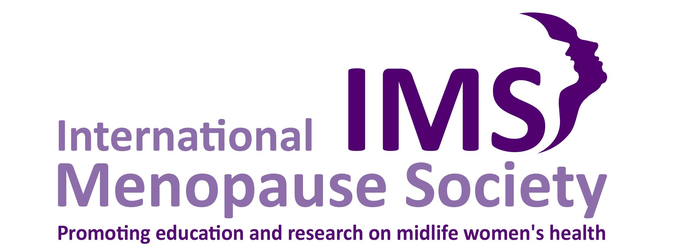

International consensus on testosterone treatment for women.

Agreement among leading experts about the benefits and risks of testosterone therapy for postmenopausal women.

The first Global Position Statement on the use of testosterone in the treatment of women, led by the International Menopause Society (IMS), was published in four leading international medical journals today. The statement has been authored by a diverse team of leading experts based around the world and has been endorsed by internationally-esteemed medical societies.

It follows years of debate regarding testosterone therapy for women and, for the first time, provides agreement among experts and medical societies about how testosterone could be prescribed for women.

An international task force of experts from leading medical societies, brought together by the IMS, produced the Global Position Statement to provide clear guidance regarding the prescribing and measurement of testosterone for female testosterone therapy as well as advice on testosterone prescribing practices that have the potential to be ineffectual or cause harm.

They concluded that testosterone can be effective at improving sexual wellbeing for postmenopausal women with Hypoactive Sexual Desire Dysfunction (HSDD). Recognised benefits included improved sexual desire, arousal, orgasm and pleasure, together with reduced concerns and distress about sex.

HSDD is thought to affect around 32% of women at midlife; and, while it's common for women to lose interest in sex around the time of the menopause and after, the use of testosterone as a treatment offers women an approach that may significantly improve their sexual and related emotional wellbeing.

Professor Susan Davis, President of the International Menopause Society said:

“This position statement has far reaching global consequences. It not only reassures clinicians that a trial of testosterone therapy is appropriate for women with HSDD, but very emphatically states that, at present, the available evidence does not support the use of testosterone for any other symptoms or medical condition.

“It also clearly advises that when testosterone therapy is given, the resultant blood levels should not be above those seen in healthy young women. We hope this will allow women who may benefit to be offered treatment, and simultaneously protect women from receiving inappropriate testosterone therapy.

“I am very proud that the IMS has led on the development of this crucial medical guidance”.

Dr. Sharon Parish, Professor of Clinical Medicine and Professor of Medicine in Clinical Psychiatry at Weill Cornell Medical College added:

“The Global Position Statement has been developed, approved, and endorsed by a broad group of experts from international women's health, sexual medicine, endocrine, gynecological and menopause societies across the world.

“The key messages for clinicians and researchers who care for and study postmenopausal women across a wide array of clinical and research disciplines are that testosterone clearly has positive benefits on sexual function and minimal side effects and low risk profiles, and is a very important and critical treatment option for postmenopausal women with HSDD.”

The international panel is calling on industry, researchers,and funding organisations to recognise the need for further research into testosterone therapy for women of all ages and the development and licensing of products formulated specifically for women.

The statement was developed by a multinational, multidisciplinary task force, the members of which were delegates from leading medical societies, and was peer reviewed by expert committees of endorsing societies from across the world. It has been translated into 13 languages and aims to improve the sexual wellbeing of women on a global scale.

About the International Menopause Society

A Charitable Incorporated Organisation based in the UK, The International
Menopause Society (IMS) brings together the world’s leading experts to
collaboratively study and share knowledge about all aspects of aging in women.
The IMS advocates evidence-based treatment options that optimise mid-life
women’s health and promotes best practice in women’s health care to healthcare
professionals and women across the globe.

IMS activities include:

- building communities of practice through its membership and Council of
Affiliated Societies;
- publishing original research, reviews, statements and recommendations;
- holding events to disseminate information including the bi-annual World
Congress on Menopause, symposia and workshops
- offering online practitioner training resources
- the annual World Menopause Day awareness raising campaign
- www.imsociety.org

About the Global Position Statement on testosterone treatment for women

- The Global Position Statement was developed to inform health care professionals of the known benefits and potential risks of testosterone therapy for women. The aims were to provide clear guidance as to which women might benefit from testosterone therapy; identify symptoms, signs, and conditions for which evidence does not support the prescribing of testosterone; explore areas of uncertainty; and to identify any prescribing practices that have the potential to cause harm.

The panel concluded that:

- a testosterone blood level should not be used to diagnose HSDD. HSDD should be diagnosed following a careful medical assessment that elicits lowered sexual desire with associated personal distress and no other treatable cause.
- there is only evidence for beneficial effects of testosterone therapy in postmenopausal women, and specifically those suffering with HSDD
- there is insufficient data to support the use of testosterone for the treatment of any other symptom or clinical condition or for disease prevention
- testosterone treatment should only be with formulations that achieve blood concentrations of testosterone that approximate what is normal for premenopausal women
- although treatment of postmenopausal women with doses that result in blood levels seen in premenopausal women was associated with mild increases in acne and body/facial hair in some women, it was not associated with scalp hair loss or voice change
- as no approved testosterone for women is presently approved by any national regulatory body, male formulations can be used judiciously in small doses with blood testosterone concentrations monitored regularly
- compounded testosterone should not be used if a regulatory approved product is available
- larger studies are needed to inform clinical recommendations regarding the use of testosterone for HSDD in premenopausal women
- studies must be undertaken to establish the longer-term cardiometabolic and breast safety of testosterone therapy for women.

- The advice was developed by nine leading medical organisations including The International Menopause Society, The International Society for Sexual Medicine, The Federacion Latinoamericana de Sociedades de Climaterio y Menopausia, The American College of Obstetricians and Gynecologists, The North American Menopause Society, The European Menopause and Andropause Society, The International Society for the Study of Women’s Sexual Health, The Royal College of Obstetricians and Gynaecologists, and The Endocrine Society, and endorsed by several additional Societies.
- It was published on 2 September 2019 in four leading international medical journals: Climacteric, Maturitas, The Journal of Sexual Medicine, and The Journal of Clinical Endocrinology and Metabolism.
- The Global Position Statement is based on the world wide published literature in this field, including a recent systematic review and meta-analysis of clinical trials of testosterone therapy in women published in the Lancet Diabetes and Endocrinology on 25th July 2019, and where data were not available, on expert opinion of international leaders in this field.
- There are no clearly established indications for testosterone therapy for women prior to the publication of the consensus statement.
- There was no external funding for this process which was entirely supported by grants from the participating societies.
- Translated versions of the Global Position Statement are available on the International Menopause Society website: https://www.imsociety.org/position_papers_and_consensus_statements.php
- Visit www.imsociety.org to find out more.

Worsley R et al J Sex Med 2017;14:675-686

