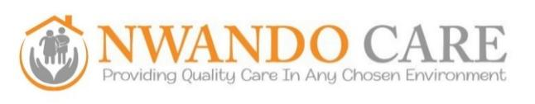

Quality Assurance Officer
This role requires a background in social care partnering combined with a focus on operational tasks to ensure the highest standards of service delivery. The ideal candidate will possess a deep understanding of CQC (Care Quality Commission) regulations, safeguarding, and compliance frameworks. We are looking for an individual with experience in auditing and policy development who is passionate about expanding a premium, private-led care business.

Key Responsibilities

- You will serve as the lead advisor and auditor, providing expert guidance on adult safeguarding, the Mental Capacity Act 2005, Liberty Protection Safeguards (LPS), and broader quality matters while promoting a culture of accountability and person-centred care. You will take full responsibility for CQC compliance by leading audits and incident management to maintain and improve our ratings.

- Your role includes developing training programs on safeguarding and professional standards, supporting staff through mentoring and reflective practice. You will analyse audits, complaints, and safeguarding incidents to identify risks, subsequently delivering workshops to bridge practice gaps and promote inclusive, non-discriminatory care.

- Furthermore, you will lead the complaints process, ensuring thorough investigations and reporting trends to senior management for organisational improvement. You will be responsible for cascading these findings across all levels of the organisation and representing Nwando Care in multi-agency collaborations to ensure consistent, high-standard practice.

To apply for the role of Quality Assurance Officer at Nwando Care, please submit your ‘CV and cover letter’ attached as a word document to hr@nwandocare.co.uk, outlining your relevant experience and why you believe you are suitable for the position.

Please note that the advertisement for the above position may close early if we receive a sufficient number of suitable candidates.

Shortlisted candidates will then be invited to attend an interview at a date to be confirmed.

Closes: 28th February 2026

