**MULTIPROFESSIONAL PRIMARY CARE APPRAISAL TOOLKIT**

**Version 2.0**

**August 2025**



**ACKNOWLEDGEMENTS**

This toolkit was prepared by a working group made up of members from Training Hubs across Kent, Surrey and Sussex. We would like to thank Kerry Myall and Jo Powell for the design of the appraisal forms which were adapted for this toolkit.

**The toolkit has been ratified and approved by the Kent, Surrey and Sussex Primary Care School within the Workforce, Transformation and Education Directorate (South East) within NHS England.**

**Initial Working group members**

Harriet Hewitt Practice Education Lead, Sussex Training Hub

Sharon Lee Senior Programme Lead, Kent and Medway Primary Care Training Hub

Terri Lovis GP Tutor, Surrey Training Hub

Caroline McBride Primary Care Workforce Lead, Kent Training Hub

Jenny Shorey Primary Care Workforce Tutor, Sussex Training Hub

**Reviewed August 2025 by**

Julie Ginman Practice Development Facilitator, Sussex Training Hub

Steve Rowley Workforce Development Lead, Sussex Training Hub

Suzi Arnold Clinical Lead, Surrey Training Hub

Philly Adams Primary Care Workforce Lead, Kent and Medway Primary Care Training Hub

Ann Humphreys Primary Care Workforce Lead, Kent and Medway Primary Care Training Hub

Sara-Jane Kray Primary Care Workforce Lead, Kent & Medway Primary Care Training Hub

Danny Bartlett Clinical Lead, Primary Care School Kent Surrey and Sussex, NHSE

**About this toolkit** Appraisal is an annual requirement for NHS staff. However, currently there is no standardised appraisal guidance for staff in general practice other than GPs and there is wide variation in how appraisals are implemented. The purpose of this document is to provide some guidance and structure for the appraisal process which can be adapted by individuals and practices to meet their specific needs.

This toolkit is intended as a resource which will be used as and when appropriate, with users referring to the specific sections they need at that time.

The toolkit can be used by individuals from any professional group and also by administrative and clerical staff.

**Why do appraisals?** Appraisal provides the opportunity for an individual and appraiser to consider the individual’s professional development over the past year and to look at their developmental needs in conjunction with the practice’s strategic plan. The NHS 10-Year Health Plan states that every single member of NHS staff has their own personalised career coaching and development plan, to help them acquire new skills and practice at the top of their professional capability



The appraisal process should be seen as a positive approach to development. It is not about creating unrealistic expectations or rewards; for evaluating or increasing pay entitlements or to be used in place of any disciplinary procedures.

**Key activities contributing to successful appraisals**

1. Identifying your appraiser
2. Communication and training
3. Implementing an appraisal cycle
4. Obtaining feedback from others
5. Setting objectives
6. Regular supervision
7. Portfolios and supporting evidence



1. **Identifying your appraiser**

In many circumstances your appraiser will be a Practice Manager, a GP Partner or lead practitioner from your professional group such as a Lead Nurse. However, you may need to consider who directs the majority of your work; whether the appraiser understands the professional obligations set out by regulatory bodies such as the GPhC, HCPC, NMC, etc. and whether the appraiser has suitable skills and training for the context in which the appraisal is taking place. It may be appropriate to identify more than one appraiser or an external appraiser to ensure that there is both a professional component, and a discussion within the practice, to agree the coming years work objectives aligned to the organisational objectives and to sign off the personal development plan.

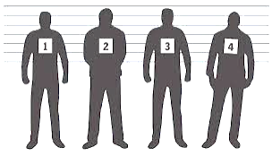**An appraiser should understand**:

* the appraisee’s full scope of work;
* the professional obligations placed on the appraisee by the relevant professional body;
* the importance of appraisal for supporting accountability, professional development and patient care;
* the purpose of appraisal in the revalidation process

1. **Communication and training**

It is important to ensure that the whole practice or primary care network (PCN) team understand appraisal and the appraisal process.

**Communicating the appraisal process** to all staff is important. Start the annual appraisal cycle by reminding all staff about the timetable, the value and role of appraisals and what they should cover. Also share any relevant templates, support and guidance for appraisers and staff.

Ensure all appraisers and appraisees have undertaken some **appraisal training**. E-Learning for Health (e-LfH) provides online training around [having confident appraisal conversations](https://portal.e-lfh.org.uk/Component/Details/840785) for NHS staff as well as [supervision for Multi-Professional Teams - eLearning for healthcare](https://www.e-lfh.org.uk/programmes/supervision-for-multi-professional-teams/) . Your local training hub will also signpost local face to face and online training resources and opportunities.

**A note on confidentiality:** it is very important that everyone involved has trust in the confidentiality of the appraisal interview and the documentation surrounding it. This will encourage both appraisee and appraiser to be as open and honest as possible. An exception to this is if issues emerge which indicate that the appraisee is in breach of the code of conduct relevant to their profession, or that might compromise patient safety. Confidentiality also applies to information contained in the appraisee’s portfolio or supporting evidence.

1. **Implementing an appraisal cycle**

**Setting a date for the appraisal** in accordance with the annual appraisal timetable for your organisation will ensure that individual staff are reviewing their work and setting new objectives at a similar time. This will improve planning and allow individuals and managers to look at developmental needs in conjunction with the practice or PCNs strategic plan.

**Preparation:** once a date for the annual meeting has been agreed, both the appraiser and appraisee need to prepare for the meeting and employers should allow some protected time for this. Preparation would usually involve looking at information about the job and required skills and knowledge against individual performance, behaviours, development and achievements over the last year, and consider objectives for the following year.

**Gathering feedback** from others gives individuals information about their skills, performance, and working relationships and contributes to the traditional appraisal arrangements that are based online managers’ assessment alone. This should be done in advance of the appraisal meeting.

**Reviewing previous year’s objectives** against what individuals have achieved during the year should be done in advance of the appraisal meeting by both the appraisee and appraiser.

**Maintaining a record of supporting evidence** should be an ongoing, year-round activity**.** Reviewing and updating supervision records and / or logs of development or training, action learning and critical appraisal activities should be done by the appraisee in advance of the appraisal meeting.

**Guidance on setting objectives**; obtaining feedback from others; on supervision; and on keeping professional portfolios and maintaining records that can be used for supporting evidence is provided in the following sections of this toolkit. Other resources are also available that support these activities, such as e-portfolios and online tools for multi-source feedback as well from most professional bodies.

**At the appraisal meeting**, the line manager and staff member has the opportunity to review performance and development for the previous year, before agreeing objectives and personal development for the next year. During the appraisal meeting, dates should be set for interim or mid-year reviews.

**Doing the appraisal follow-up is** important and must not be overlooked.Finalising and agreeing the appraisal forms usually involves agreeing and signing off the content by both the appraiser and appraisee. A copy of the form will need to be kept on file by the employer. Providing a copy to the appraisee is also good practice.

**Interim/mid-year reviews** should be planned at the end of the appraisal meeting. Interim meetings are for reviewing progress on objectives and any agreed training or personal development that has been agreed for the year. Any significant change to the employing organisations objectives, or other events or activities that have, or will impact, upon an individual’s annual objectives should be discussed at these meetings. Discussion at the interim meeting(s) should be documented on the appraisal form and kept on file by the employer.

1. **Obtaining feedback from others (patients, peers, supervisors)**

360-degree feedback (also known as multi-source feedback, or multi source assessment) are a method of performance appraisal which gather feedback from a number of sources, including peers, direct reports, senior colleagues, patients or service users, as well as self-evaluations by the appraisees themselves. This variety of feedback can offer line managers a wide-ranging perspective and help to make appraisal a more objective and fair process.

360**-**degreefeedback offers individuals valuable insights into their skills, performance, and working relationships. Unlike traditional appraisals based solely on a manager’s view, it draws input from a range of sources — creating a fuller, more balanced picture.

The person seeking feedback (the appraisee) completes a self-assessment and invites 6–10 others (respondents) to complete the same questionnaire. Respondents are grouped by their relationship to the appraisee — such as senior, peer, junior, or patient — giving a true “360-degree” view of performance.

This method works especially well in environments where the appraisee works across multiple teams or independently, making it hard for line managers to observe their full impact.

To be effective, 360-degree feedback must be handled with care. The appraisee should stay in control of the process, with proper planning and support provided throughout. Feedback should be constructive, confidential, and delivered by someone trained in giving feedback.

1. **Setting objectives (PCN/ Neighbourhood Teams, Practice, Professional, Personal)**

When setting objectives, consider not only personal objectives for the future but also what is needed by the employer and the local integrated care system. In the Primary Care context, consider both the practice and the PCN/ Neighbourhood Teams objectives.

**PCN/Neighbourhood Teams objectives** may be linked to the network contract as well as to any goals or mission statements for the network. These objectives should be set by the clinical director and agreed at the beginning of the financial year. These should be reviewed quarterly and communicated via a cascade system to the practices in the network. Objectives should define the plans and outcomes for the services using specific deliverables and targets.

**Practice objectives** should flow from the PCN/ Neighbourhood Teams objectives with specific key performance indicators to be achieved at a local level. Objectives at this level should indicate what specifically that particular practice needs to do to meet its responsibilities, performance improvements and targets.

**Professional objectives** should include development activities that are linked to professional competency that may contribute directly or indirectly to practice or PCN /Neighbourhood objectives.

**Personal objectives** should flow from the team objectives and should be set at a level suitable for the role of the person. They should be SMART objectives that can be monitored and measured leading to clear outcomes. This is so that both parties can evidence the success, progress towards or failure to achieve them. When in doubt measurable objectives should include a numerical component e.g. Monitoring of fridge temperature should occur on X occasions and measurements should be recorded and filed in X location within X minutes of taking the reading.

When agreeing your objectives, please consider all pillars of practice, and not just your direct clinical or patient facing responsibilities. All staff have valuable contributions to make to educating others, growing as leaders and involvement in service improvement.

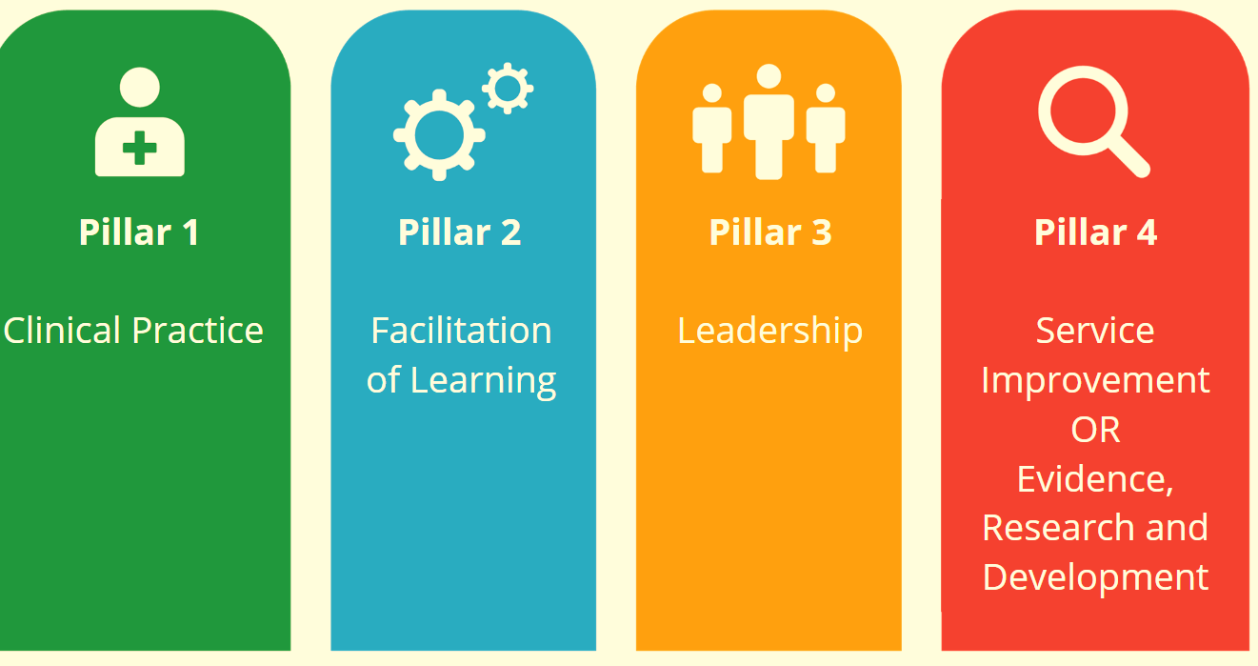

**SMART objectives are:**

**Specific**

The action, behaviour or outcome must be linked to a rate, number, percentage or frequency. ‘Answer the telephone quickly’ is not specific and allows for a subjective judgement to be made about whether the outcome has been achieved. In contrast, ‘reduce waiting time on the telephone to 1 minute’, is specific.

**Measurable**

You must be able to measure the extent to which an objective has been achieved. If you’ve successfully created a specific objective linked to a rate, number, percentage or frequency, this will be easier.

**Attainable**

Put simply, an objective is achievable if, with a reasonable amount of effort and application, it can be achieved. Deciding what constitutes a realistic amount of effort and application calls for a subjective judgement to be made, which is one reason why objectives should be mutually agreed, and not ‘set’.

**Relevant**

This means that the outcome sought must be something the individual can actually impact upon. The key questions here are: Does the individual have the necessary knowledge, skill and authority to complete this objective?

**Time-based**

This means a timeframe within which the objective should be undertaken. For example, make the necessary changes to practice to reduce waiting time on the telephone to 1 minute, by a specific date. If there is no timeframe, the objective is not SMART.

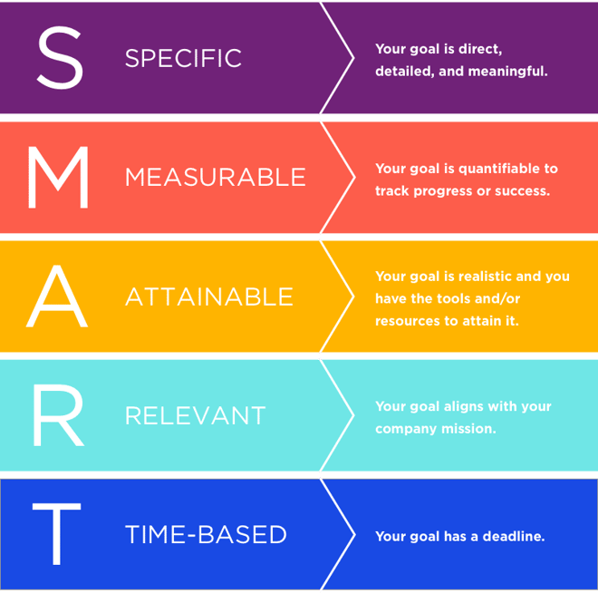

1. **Supervision**

**One to one meetings** are a form of managerial supervision which should take place regularly, the frequency set at a level suitable for the role. Individual performance and development should form part of regular one to one discussions.

**Clinical supervision** is complementary to but separate from managerial supervision which is about monitoring and appraising the performance of staff. The purpose of clinical supervision or action learning is to provide a safe, confidential and non-judgemental environment for staff to reflect on and discuss their work and their personal and professional responses to their work.

Clinical supervision is often aimed at registered professionals (for example, nurses, doctors, clinical pharmacists and allied health professionals) but non-clinical staff would equally benefit. The focus is on supporting all staff throughout their career, regardless of their qualifications, in their personal and professional development through reflection and feedback.

Clinical supervision has been linked to good clinical governance, by helping to support quality improvement, managing risks, and by increasing accountability. [Regulation 18: Staffing - Care Quality Commission](https://www.cqc.org.uk/guidance-regulation/providers/regulations-service-providers-and-managers/health-social-care-act/regulation-18)

Particular groups of staff may also be able to access or contribute to **action learning sets**. Your local Training Hub/ PCN Educator Teams may be able to signpost you to these.

Clinical supervision and/or action learning sets should also take place regularly. It can take place within the practice team but is often successful when done outside of the team or practice. The frequency and duration of clinical supervision should be adequate to ensure safe and competent care for people who use services.

**What models of clinical supervision are there?**

**One-to-one supervision** takes place between a supervisor and supervisee.

**Group supervision/action learning sets** in which two or more practitioners discuss their work with a supervisor.

**Peer or co-supervision**

where practitioners discuss work with each other, with the role of supervisor being shared or with no individual member of staff acting as a formal supervisor.

Please find the KSS Guide to Supervision [here](https://kss.hee.nhs.uk/wp-content/uploads/sites/15/2024/10/A-guide-to-supervision-in-KSS-primary-care-V2.1-Oct-24.pdf) for further guidance on supervision of multiprofessionals in practice as well as a helpful page from [NHS England » Supervision guidance for primary care network multidisciplinary teams](https://www.england.nhs.uk/long-read/supervision-guidance-for-primary-care-network-multidisciplinary-teams/)

1. **Professional portfolios and supporting evidence**

Clinical professionals will be familiar with keeping a professional portfolio, but this record is useful for all staff. A portfolio should contain evidence of practice, continuous professional development (CPD) and reflective activities to support professional registration and to prepare for revalidation

**Supporting evidence should include:**

**A record of CPD activities** including any formal learning or updates.

**A record of your practice**. Professional bodies have specific requirements for recording practice hours for registered professionals. Non-registered staff should be encouraged to keep a record of work undertaken; especially work that contributes to objectives set during appraisals.

**Reflective accounts** that explain what has been learnt from CPD activity and/or feedback and/or an event or experience in practice and how this changed or improved your work as a result

**A record of clinical supervision** or any reflective discussions that took place during meetings with line managers or peers.

Confidentiality applies to information contained in the portfolio or supporting evidence. Patient identifiable information e.g. names or dates of birth should be removed from forms or other information that are included in them.

**Online tools and e-portfolios**

A number of online tools and resources are available, that support appraisals or aspects of the appraisal process such as multi-source feedback and portfolios or supporting evidence.

Individuals or practices may choose to use a subscription e-portfolio service to support them but there are a number of free resources available too.

**Example Appraisal form template**

**Please find below an example appraisal template that can be used for various multiprofessional roles. Please note these are meant as guides and may need to be adapted to the organisation carrying out the appraisal.**

**Staff Appraisal Form**

The appraisal form has three sections. Some parts **you need to complete in preparation before you meet your appraiser,** other parts you will **complete together**:

**1a.** Personal reflections

**Section 1**Review and rate the past year

**1b.** Review performance against objectives

**1c.** Review of personal development plan

**1d.** Discuss your rating

**Section 2**Plan for the year ahead

**2**. Set and agree your performance objectives

**Section 3**Summarise and confirm appraisal

**3.** Complete the Summary and confirmation of appraisal section

Appendix- Follow up one to one if requested by Appraisee/Appraiser

**Appraisal Process**

**Appraisee prepares section 1 of appraisal form including:**

1a Personal Review  
1b Review of performance against objectives and development action plan  
1c Review of health and well-being / work-life balance  
1d Consideration of assessment of performance rating

A copy of the completed appraisal form is sent to the appraise and line manager within 1-2 weeks of the appraisal interview or negotiated timescale

**Appraiser and appraisee**Complete and sign off all forms summarised and signed off by appraiser and appraisee

Appraisal takes place

**Appraiser**

Reads material, specifically section 1d, and prepares for appraisal **1-2** **weeks** before the appraisal or within the negotiated timescale

Completes assessment of performance form

**Appraisee**

Sends prepared forms to appraiser before the appraisal or within the negotiated timescale

Identify and agree an appraiser and set the appraisal date

|  |  |  |  |  |  |  |  |  |  |  |  |  |  |  |  |  |  |
| --- | --- | --- | --- | --- | --- | --- | --- | --- | --- | --- | --- | --- | --- | --- | --- | --- | --- |
|  | | | | | | | | | | | | | | | | | |
| **Personal Details**  A copy of the completed appraisal form is sent to the appraise and line manager within 1-2 weeks of the appraisal interview or negotiated timescale | | | | | | | | | | | | | | | | | |
| Employee Name: | | | | | |  | | | Employers Name: | | | | | | |  | |
| Job Title: | | | | | |  | | | Profession (if applicable) | | | | | | |  | |
| Date of this annual appraisal: | | | | | |  | | | Date of follow up one to one is agreed: | | | | | | |  | |
| **Professional Registration Details (if applicable)** | | | | | | | | | | | | | | | | | |
| Professional body: | | | | | |  | | | Expiry Date: | | | | | | |  | |
| Registration Number: | | | | | |  | | | Revalidation Date: | | | | | | |  | |
| **Section 1a – Personal review of the past 12 months** | | | | | | | | | | | | | | | | | |
| Wellbeing   * How have you been feeling at work recently? * Are there any factors affecting your wellbeing that you’d like to talk about? * What helps you feel supported and motivated in your role? | | | | | | | | | | | | | | | | | |
|  | | | | | | | | | | | | | | | | | |
| Appraisee Personal Reflections   * What has gone well? * What hasn’t gone so well? If not, why hasn’t it? * What could your employer have done differently to support you? | | | | | | | | | | | | | | | | | |
|  | | | | | | | | | | | | | | | | | |
| **Review of Previous Years Training and Development** | | | | | | | | | | | | | | | | | |
| **Description of training and development** | | | | | | | **Date completed** | | | | | | **Comments/Reflections** | | | | |
|  | | | | | | |  | | | | | |  | | | | |
|  | | | | | | |  | | | | | |  | | | | |
|  | | | | | | |  | | | | | |  | | | | |
|  | | | | | | |  | | | | | |  | | | | |
|  | | | | | | |  | | | | | |  | | | | |
|  | | | | | | |  | | | | | |  | | | | |
|  | | | | | | |  | | | | | |  | | | | |
|  | | | | | | |  | | | | | |  | | | | |
|  | | | | | | |  | | | | | |  | | | | |
|  | | | | | | |  | | | | | |  | | | | |
| Section 1b- Review of your performance against objectives and Personal development plan | | | | | | | | | | | | | | | | | |
|  | **Objective Do not rewrite previously agreed objectives – just the key words** | | | | | | **Achieved/Partially Achieved/Not Achieved** | | | | **Your comments** | | | | | | **Manager comments** |
|  | 100% compliant with Statutory & Mandatory requirements | | | | | |  | | | |  | | | | | |  |
|  | Supporting Learners in Practice (include students / apprentices/ new starters etc) | | | | | |  | | | |  | | | | | |  |
|  | Service objectives (detail) | | | | | |  | | | |  | | | | | |  |
|  |  | | | | | |  | | | |  | | | | | |  |
|  |  | | | | | |  | | | |  | | | | | |  |
|  |  | | | | | |  | | | |  | | | | | |  |
|  | Personal objectives (detail) | | | | | |  | | | |  | | | | | |  |
|  |  | | | | | |  | | | |  | | | | | |  |
|  |  | | | | | |  | | | |  | | | | | |  |
|  |  | | | | | |  | | | |  | | | | | |  |
|  | Professional objectives (link to level of practice / Roadmap documents and revalidation as required) | | | | | |  | | | |  | | | | | |  |
|  |  | | | | | |  | | | |  | | | | | |  |
|  |  | | | | | |  | | | |  | | | | | |  |
|  |  | | | | | |  | | | |  | | | | | |  |
|  |  | | | | | |  | | | |  | | | | | |  |
|  |  | | | | | |  | | | |  | | | | | |  |
|  |  | | | | | |  | | | |  | | | | | |  |
|  |  | | | | | |  | | | |  | | | | | |  |
|  |  | | | | | |  | | | |  | | | | | |  |
|  |  | | | | | |  | | | |  | | | | | |  |
|  |  | | | | | |  | | | |  | | | | | |  |
|  |  | | | | | |  | | | |  | | | | | |  |
|  |  | | | | | |  | | | |  | | | | | |  |
|  |  | | | | | |  | | | |  | | | | | |  |
|  |  | | | | | |  | | | |  | | | | | |  |
|  |  | | | | | |  | | | |  | | | | | |  |
| **Section 1c- Assessment of performance** - ***To be completed jointly at time of appraisal*** | | | | | | | | | | | | | | | | | |
|  | | | **Comments** | | | **A**  **Well above standard** | | **B**  **Satisfactory, meets required standard** | | | **C**  **Less than satisfactory**  **requires slight improvement** | | | | | | **D**  **Unsatisfactory**  **below the standard reasonably expected** |
| **Volume of work**  How does the amount of work done compare with the job requirements? | | |  | | | o  Exceptionally high output | | o  Output is usually above average | | | o  Output is occasionally unsatisfactory | | | | | | o  Insufficient improvement needed |
| **Job Knowledge**  Does the employee have the knowledge to do the job properly? | | |  | | | o  Exceptionally thorough knowledge of own and related work | | o  Good knowledge of own job and related work aspect | | | o  Lack of job knowledge sometimes hinders progress | | | | | | o  Inadequate knowledge of own work |
| **Safety Awareness**  Consider in regard to safe working practices | | |  | | | o  Highly motivated towards safety. Always insists on safe working practices | | o  A good attitude to safety and encourages others likewise | | | o  Sometimes has to be reminded of safety precautions at work | | | | | | o  Disregards basic safety precautions |
| **Dependability**  How well does the employee follow procedures | | |  | | | o  Always thoroughly reliable | | o  Little supervision required | | | o  Requires more frequent checks than normal | | | | | | o  Requires constant supervision |
| **Teamwork**  How well does the employee work with others to accomplish the goals of the job | | |  | | | o  Works extremely well with others and responds enthusiastically to new challenges | | o  Cooperative and flexible | | | o  Usually gets along reasonably well but occasionally unhelpful | | | | | | o  Uncooperative, resists change |
| **Attendance and Punctuality**  What is the employee’s pattern of absence and punctuality | | |  | | | o  Exceptionally punctual. Rarely absent | | o  Attendance levels are acceptable and is rarely late | | | o  Absence and/or lateness levels are higher than average | | | | | | o  Frequently late and/or absent |
| **Work Planning**  Consider employee’s success in planning own work | | |  | | | o  Displays excellent planning ability | | o  Organises work well | | | o  Needs to improve some aspects of work planning | | | | | | o  Does not plan effectively |
| **Communication**  How effective is the employee at verbal and written communication | | |  | | | o  Exceptionally effective in all written and verbal communication | | o  Usually a good communicator | | | o  Some difficulties with written and/or verbal communication | | | | | | o  Does not communicate effectively |
| **Overall Marking** | | |  | | | o  Well ahead of standard performance | | o  More than satisfactory – slightly above job requirements | | | o  Less than satisfactory – needs slight improvement | | | | | | o  Unsatisfactory – below the standard reasonably expected |
| **Additional Comments** | | |  | | | | | | | | | | | | | | |
| **Section 2- Objectives/PDP for the coming year** | | | | | | | | | | **Dates From _________To____________** | | | | | | | |
| **Set SMART**  **(Specific, Measurable, Achievable, Realistic, Time bound) objectives in line with practice/PCN objectives Including mandatory, essential to role and career development** | | | | | | | | | | | | | | | | | |
|  | | **Objective List objectives for coming year’s Appraisal** | | | | **How** | | **By when** | | | **Expected outcomes / measure of achievement** | | | | | | **Support / action required from manager or others** |
|  | | 100% compliant with Statutory & Mandatory at all times | | | |  | |  | | |  | | | | | |  |
|  | | Supporting Learners in Practice (include students / apprentices/ new starters etc) | | | |  | |  | | |  | | | | | |  |
|  | | Service objectives (detail) | | | |  | |  | | |  | | | | | |  |
|  | |  | | | |  | |  | | |  | | | | | |  |
|  | |  | | | |  | |  | | |  | | | | | |  |
|  | |  | | | |  | |  | | |  | | | | | |  |
|  | | Personal objectives (detail) | | | |  | |  | | |  | | | | | |  |
|  | |  | | | |  | |  | | |  | | | | | |  |
|  | |  | | | |  | |  | | |  | | | | | |  |
|  | | Professional objectives (link to level of practice / Roadmap documents and revalidation as required) | | | |  | |  | | |  | | | | | |  |
|  | |  | | | |  | |  | | |  | | | | | |  |
|  | |  | | | |  | |  | | |  | | | | | |  |
|  | |  | | | |  | |  | | |  | | | | | |  |
| **Section 3- Summary and confirmation of appraisal**  **This section confirms the outcomes of the Appraisal and the reporting process. It is recommended that you complete this at the time of appraisal, whilst you are both together.** | | | | | | | | | | | | | | | | | |
| **3.1: Summary of performance and development** | | | | | | | | | | | | | | | | | |
| **Staff member/Appraisee’s summary comments on performance and development, including demonstration of behaviours,** **over past year.** | | | | | | | | | | | | | | | | | |
|  | | | | | | | | | | | | | | | | | |
| **Manager/Appraiser’s summary comments on performance and development, including demonstration of behaviours,** **over past year.** | | | | | | | | | | | | | | | | | |
|  | | | | | | | | | | | | | | | | | |
| **3.2 Character check** | | | | | | | | | | | | | | | | | |
| **Have you any criminal charges, convictions or cautions that have not been declared since your last DBS check?** | | | | | | | | | | | | Yes | | | | | No |
| **Note for managers:** If the answer is Yes then, a separate meeting should be held to discuss the matter, together with employer within 7 days. NMC to be informed by registrant in keeping with the Code. | | | | | | | | | | | | | | | | | |
| **3.3 Signatures:** | | | | | | | | | | | | | | | | | |
| Appraisee Name: | | | |  | | | | | | Appraiser Name: | | | | |  | | |
| Email Address: | | | |  | | | | | | Email Address: | | | | |  | | |
| Signature: | | | |  | | | | | | Signature: | | | | |  | | |
| Date: | | | |  | | | | | | Date: | | | | |  | | |
| **Follow up One to One** | | | | | | | | | | | | | | | | | |
| **Date** | | | | |  | | | | | | | | | | | | |
|  | | | | |  | | | | | | | | | | | | |
| Appraisee’s Update: | | | | |  | | | | | | | | | | | | |
| Appraiser’s Update: | | | | |  | | | | | | | | | | | | |
| Agreed outcome/plan: | | | | |  | | | | | | | | | | | | |
| Appraisee Signature: | | | | |  | | | | Appraisers Signature: | | | | |  | | | |
| Date: | | | | |  | | | | Date: | | | | |  | | | |