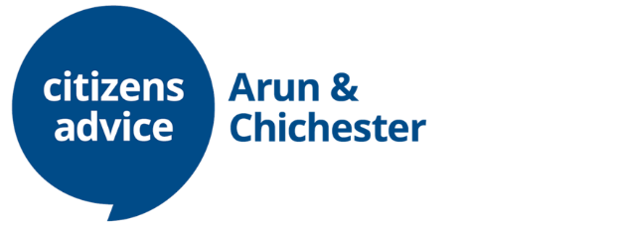

Energy Adviser

Key Duties/Accountabilities
- To interview clients over the phone or online, providing appropriate advice and information, exploring options and implications to help clients set priorities and make decisions.
- To undertake a holistic approach to the client and deal with related issues as well as the presenting issues.
- To undertake casework on clients’ behalf, write letters and negotiate with third parties.
- To maintain clear and accurate case records that meets the quality standards of the Membership Scheme.
- To maintain records as required for continuity of casework, information retrieval, statistical monitoring, accountability and report preparation.
- To seek support as necessary to ensure quality of advice, good practice and that the degree of casework taken on is appropriate.
- To utilise an internal referral system between the advice centres in ACCA.

TRAINING
- Keep informed of new and changing legislation relevant to the post and of issues and policies in all advice areas.
- Complete the City & Guilds L3 Energy Awareness qualification if they do not already hold this.
- Keep up to date with all the regular Citizens Advice circulars and information items.
- Attend regular training to develop knowledge, skills and expertise.
- Participate constructively in team meetings.
- The post holder must be willing to undergo training in Information & Communication Technology and case management software and apply it as needed to carry out the tasks of the post.

SOCIAL POLICY
- Recognise the root causes of problems and contribute social policy evidence in line with the twin aims of the Citizens Advice service, highlighting issues of particular concern to disadvantaged groups and clients in general.
- Participate in local and regional social policy initiatives developed by ACCA, its projects and partner organisations.

ADMINISTRATION
- Ensure that the information sources in use are up to date.
- Maintain statistics and analysis of work in accordance with ACCA procedures and funding conditions.
- Be responsible for own file management and letter writing and implement administrative procedures as directed by Line Manager.
- Record outcomes on the database throughout the case management process.
- Contribute to reports for Line Manager giving update of project, including all financial outcomes and a sample of case studies.
- Liaise with the administration team for tasks such as appointment booking, sending letters or processing fuel vouchers.

POLICIES OF CITIZENS ADVICE
- The post holder must understand and be committed to the aims, principles and policies of Citizens Advice and the ACCA service.
- The post holder must have due regard in the planning and execution of their duties and at all times to the aims, principles and policies of ACCA and Citizens Advice

ESSENTIAL
- Able to work unsupervised
- Good IT skills
- Commitment to continuous development
- Experience working with vulnerable clients in a non-judgemental way
- Energy Advisory background

DESIREABLE
- C&G L3 Energy Awareness

Person specification
- Ability to collect, analyse and present project data.
- Ability use systems to collect, collate and share information about project achievements and outcomes.
- Understanding of and commitment to the aims and principles of the Citizens Advice service and its equal opportunities policies.
- A willingness to learn and develop and reflect on practice.
- Excellent interpersonal skills, including the ability to relate and work with a large variety of different people.
- Ability to monitor and maintain own standards.
- Numerate and literate to the level required by the tasks.
- Effective written and oral communication skills.
- Ability to use IT applications to record statistics and produce documents of the data collated.
- Knowledge and understanding of the problems people face in our local community.

