
Individual Health Care Plan (IHCP)
Offer to Schools
IHCPs should be drawn up in partnership between the school, parents, pupils (whenever appropriate) and a relevant healthcare professional, e.g. specialist or children’s community nurse, general practitioner, paediatrician, or school nurse; the relevant healthcare professional is the person who can best advice on the particular needs and interventions for the child. Partners should agree who will take the lead in writing the plan, but responsibility for ensuring it is finalised and implemented rests with the school. (Supporting pupils at school with medical conditions 2015, updated 2017).

CYPHWS Offer

The service can help with:
- Information and advice: about a child or young person's health needs and how schools can best support them where medical evidence has been obtained (e.g. prescription, hospital letter). If medical evidence does not correspond with information available or no medical evidence is provided, as a public health service, we are unable to provide specific clinical advice.
- Professional liaison: where schools are unable to obtain the appropriate medical evidence, the school health service can support the school and/or parents/carers by liaising with lead clinicians responsible for the child’s care (e.g. GP, paediatrician, specialist nurse) to obtain the required information, for example this could mean sending a letter/email to the GP requesting medical evidence is sent to the school and parents/carers, or connecting the school with the specialist nurse. The service cannot access and share third party health information from other clinical systems; we can only support the development of IHCPs with information provided by the relevant professional.
- Formulation: public health nursing can support formulation of a plan based on the diagnosis, treatment and medical opinions of the treating team which may include aspects such as identifying school support needs, emergency planning, medication safety.

Implementation of IHCPs
The service can help with:

- Policy development: supporting schools to develop their policy and procedures in line with changes in legislation or requirements around managing medical conditions in schools.
- Training: Delivering a rolling programme of tiered training for school staff giving them the knowledge and confidence to support children and young people with a range of medical conditions.

Management of IHCPs
The service can help with:

- IHCP Reviews: school health do not routinely contribute to IHCP reviews however if required, support can be provided as above.
- Transitions: supporting handover arrangements of IHCPs, early years to primary, primary-to-secondary school, special-to-mainstream.

Request for Support (Rfs)

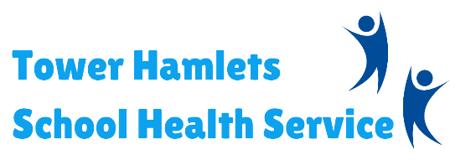
Support with a child’s IHCP can be requested by submitting a Request for Support (RfS). Please note RfS will only be accepted if the conditions below have been met (please include this information in the RfS):

- Medical information has been obtained
- Reasonable attempts have been made to obtain medical information from healthcare professional and parent/carer

Please note: RfS for IHCPs should be made at least six weeks in advance of the IHCP expiry to allow sufficient time for support to be provided.


Resources and guidance on the development of IHCPs in schools can also be found on our website.

Delivered in partnership…

