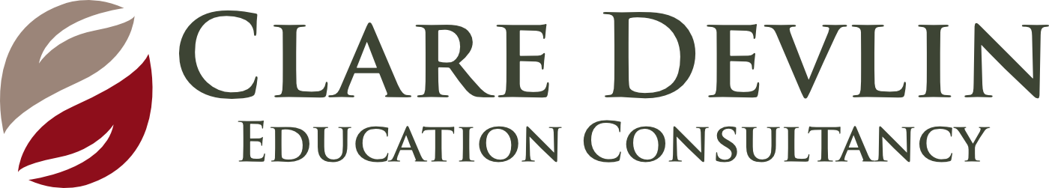 Observation, Assessment & Planning (Pre School)
Name of Child: Maeve (3:11) Date of Assessment: 25.11.20

WHAT? (Observation)  Describe what you observe the child doing as he/she moves through the session | SO WHAT? (Learning)  What are these observations telling you about the child’s development across the 6 key areas?  What are the child’s understandings and misunderstandings? | NOW WHAT? (Planning)  What is the next level of intended learning and development for the child? (Link to planning with child’s initials)
When you have completed the So What section – simply staple your observations on top of this box.  You do not need to write anything in this box!  Signpost here to any photos or video footage you have stored electronically that supports your assessment – you do not need to print photos. | Personal, Social & Emotional Development  Confident to speak to adult. Knows routines and is comfortable with the environment. Brave and understanding. Can make choices. Uses social communication appropriately. Uses equipment appropriately. Engages well with adults and children. Good levels of concentration.  Physical Development & Movement  Not yet applying appropriate pressure when mark making. Pincer control and hand muscles are developing.  Language Development  Has clear verbal communication and a good range of vocabulary. Can listen well and attend to stories.  Know that marks convey meaning  Early Mathematical Experiences  Aware of time and happenings in the future. Confident to express ideas through model making.  The Arts  Demonstrates good imagination  The World Around Us  Aware of family relationships and events. Aware of and can describe weather conditions appropriately. | - Offer M small leadership roles to foster responsibility.  - Create situations where she can act as a “buddy” to support other children  - Develop deep sensory system and hand muscle through:  - lifting, carrying, pushing, pulling heavy items  - pressing down firmly on objects, e.g. hole puncher, stapler, potato prints …  - clay work, spray bottles, stretching elastic bands over objects …  - Extend vocabulary by introducing rich storybooks  - Support early writing by providing spaces for mark making, drawing and creating books  - Add wedding items to role play to encourage conversation and extended play
Involvement Level – High/Medium/Low
Well Being –
High/Medium/Low
We Wonder: Collect more observations on Maeve outdoors. Tune in to her understanding of maths and use of mathematical language. Focus on Art processes
Additional Information/Queries:

