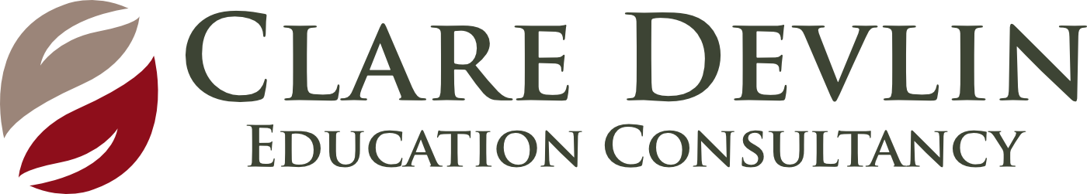 Observation, Assessment & Planning (Pre School)
Name of Child: Date:

WHAT? (Observation)  Describe what you observe the child doing as he/she moves through the session | SO WHAT? (Learning)  What are these observations telling you about the child’s development across the 6 key areas?  What are the child’s understandings and misunderstandings? | NOW WHAT? (Planning)  What is the next level of intended learning and development for the child? (Link to planning with child’s initials)
When you have completed the So What section – simply staple your observations on top of this box.  You do not need to write anything in this box!  See IPAD for additional observations and evidence | Personal, Social & Emotional Development  Physical Development & Movement  Language Development  Early Mathematical Experiences  The Arts  The World Around Us
Involvement Level – High/Medium/Low

Well Being – High/Medium/Low

Additional Information/Queries:
We Wonder

