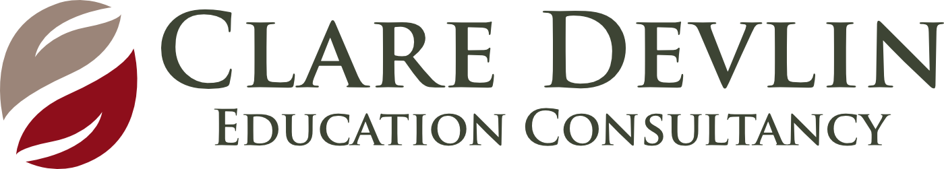 Observation (Under 3s)
Name of Child: Date:

WHAT?  Observation:  Describe what you observe the child doing as he/she moves through the session | SO WHAT?  Learning:  What are these observations telling you about the child’s development across the 4 key areas?  What are the child’s understandings and misunderstandings? | NOW WHAT?  Planning:  What is the next level of intended learning and development for the child? (Link to planning with child’s initials)
Physical Development

Personal, Social & Emotional Development

Language & Communication

Exploring & Thinking

Involvement Level – High/Medium/Low

Well Being – High/Medium/Low

We wonder ….

