
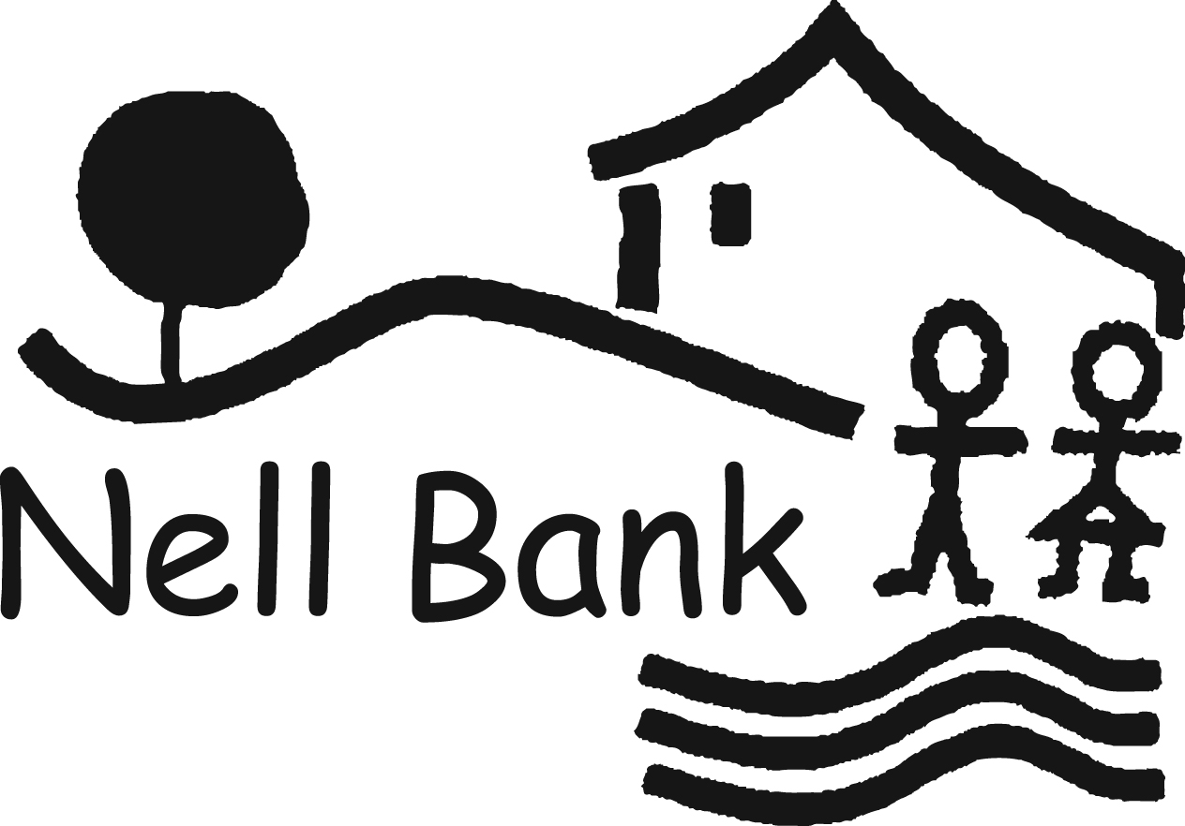

Ilkla Moor baht’at,
giants and
national curriculum Yorkshire english
2014

Group leader guidance, ideas and resources for the classroom.
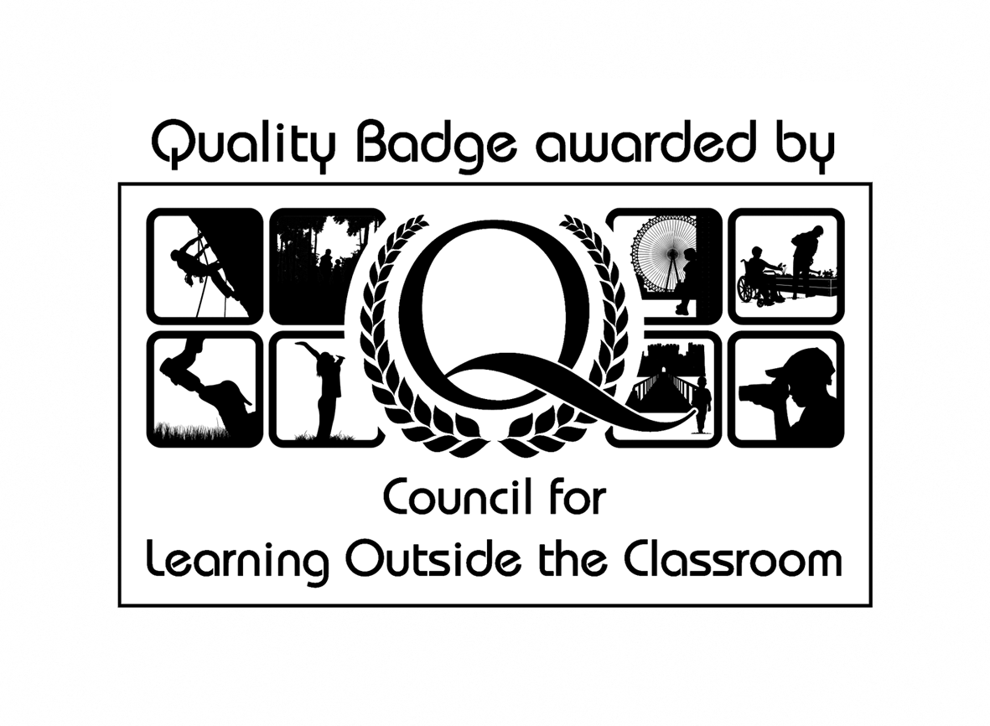

English at Nell Bank
Our English programme is a key element of all primary visits to Nell Bank and our new creative writing days are becoming a popular addition to our activity list. Each programme helps pupils explore and develop skills of language which are essential to participating fully as a member of society. At Nell Bank we help teachers promote high standards of language and literacy by building confidence in pupils’ command of the spoken and written word… good comprehension draws from linguistic knowledge and on knowledge and experience of the world.

Pre-visit preparation for adults
Before your visit to Nell Bank please make all other adults on the trip aware of their responsibilities during the visit:

All adults can support their pupils by:
- Remaining with the group to which they have been assigned
- Quietly assisting pupils who need help following instructions
- Being an active participant in the activities their group is presented with
- Filling out and returning a Nell Bank evaluation form.
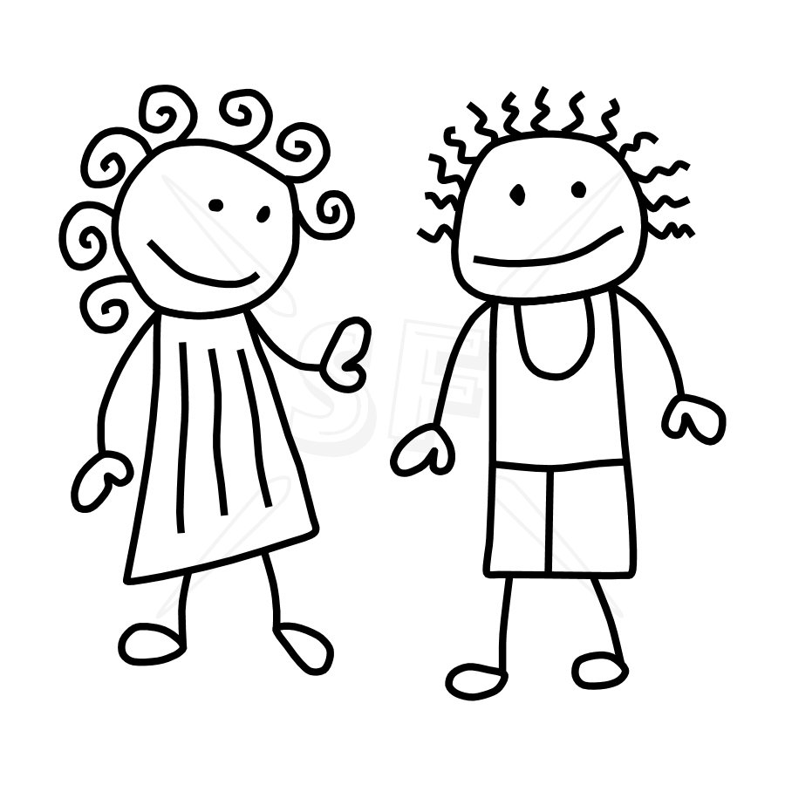

Pre-visit preparation for pupils
Prior to the visit it is helpful if your pupils are given an opportunity to explore the focus of the visit. Work done in preparation in the classroom enables pupils to access new experiences, language and the environments more readily. By following the lesson plans on the following pages you will give your pupils the knowledge they need to get the most from their day at Nell Bank.

How Nell Bank can help you teach the statutory requirements for english
As part of a visit to Nell Bank we offer pupils the chance to explore and develop their confidence in spoken language, which underpins the development of reading and writing, through first hand experiences of story settings and characters. These first hand experiences help pupils prepare their ideas before they write assisting with making thinking clear and building secure foundations through discussion. Drama and role play gives pupils the opportunity to improvise, devise and script for a range of audiences as well as rehearse, refine, share and respond thoughtfully to drama.
For example:
Nell Bank in Year 1 asks pupils:
To retell the familiar story, ‘We’re going on a bear hunt’.
Using firsthand experience of a journey around Nell Bank the children improvise and add to the basic story.
Nell Bank in Year 4 asks pupils to:
To retell the Nell Bank story, ‘How the giants fingers came to be’.
Pupils have the opportunity to rewrite sections of the story, creating characters and using their firsthand experience to write in detail about the story setting and the characters involved.

The following pages contain lesson plans and work sheet ideas to get the most from your visit and the statutory requirements our activities cover.
Nell Bank Pre-visit lesson plan
Date: | Class: KS1 | Topic for lesson: Owl Babies
Lesson objectives:
- Saying out loud what they are going to write about
- Sequencing sentences to form short narratives

Resource list: Owl Babies by Martin Waddell, strips of paper, A class of enthusiastic children
Risk assessment: N/A classroom based
Starter  Read the book owl babies with the class  How do you think the babies Sarah, Percy and Bill felt when they woke up to find their mother gone?  (List words pupils come up with on the board add a few extra) |  |  | Vocabulary  Nocturnal  Sad  Scared  Worried  Wobbly  unhappy  etc
Main

In pairs can pupils come up with a sentence to describe how each of the 3 owl babies felt using the words on the board. E.g. Sarah was very quiet and scared. Percy was so worried he felt like crying. Bill was so sad he couldn’t speak.

When they have a good one, read to an adult if it gets the thumbs up... write it on a strip of paper (to collect on the board).

Intervention/Extension/Enrichment

Ask children to choose one of their sentences and act/behave like that owl baby.

Ask more able to look at their sentences and think of the opposites e.g. happy/sad etc to change the meaning.

Plenary

Children read or act out their favourite owl baby sentence to the class.

Write a narrative sequence using the children’s ideas to describe each of the owl babies felt.

Whole class act out how the owl babies felt when their Mother returned.

Main Outcomes

- Children show their understanding and creativity by saying out loud what they know they will write about
- Teacher demonstrates the sequencing sentences to form short narratives which could be the starting point for the next lesson.

Nell Bank Follow up lesson plan
Date: | Class: KS2 | Topic for lesson:  Myths and legends
Lesson objectives:
- In narratives, creating settings, characters and plot.
- Assessing effectiveness of their own and others’ writing and suggesting improvements

Resource list: Giant Rombald story, Character profile grid, Giants word bank
Risk assessment: N/A Class based
Starter:  What is a giant? Discuss with your partner.  Whole class contributes to giant word bank sheet (see attached) on board  Name some famous giants... e.g. Little John, Jack and the beanstalk, goliath, the incredible hulk....BFG |  |  | Vocabulary  Giant  Massive  Enormous  Voluminous  Gigantic  Vast  Huge  Gargantuan  Colossal  Leviathan  Big
Main:

Using the character profile grid (see attached) to guide your thoughts create a giant with your partner that you would use in a story. (10 minutes)

Find a space in the classroom/hall/playground and ask the children to their partner how the giant could walk/talk/stand/sound like. (10 minutes)

In pairs, in the centre of a large piece of paper, write between 2 and 5 sentences describing the giant they have created.

Intervention/Extension/Enrichment

Explain that they are going to pass their work on to other pairs and they are going to add any improvements they can see in the spaces round the sentences.

Plenary

Join with another pair to act out/read out their giant character, can classmates think of any improvements.

Ask pairs who have been improving written sentences to nominate a pair who produced a really good one and used any improvement they suggested.

Main Outcomes

- Pupils develop the main character for a legend.
- Pupils given the opportunity to assess the effectiveness of their own and others’ writing and suggest improvements

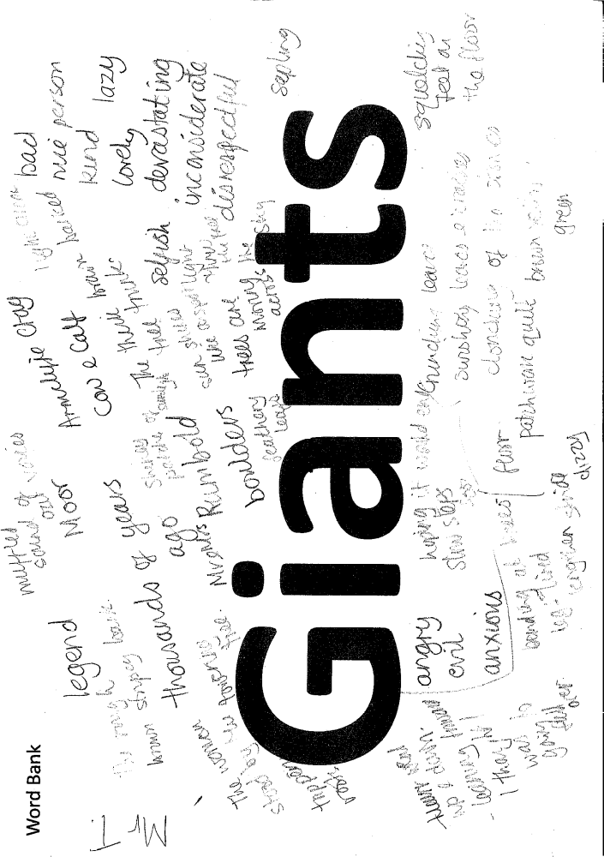

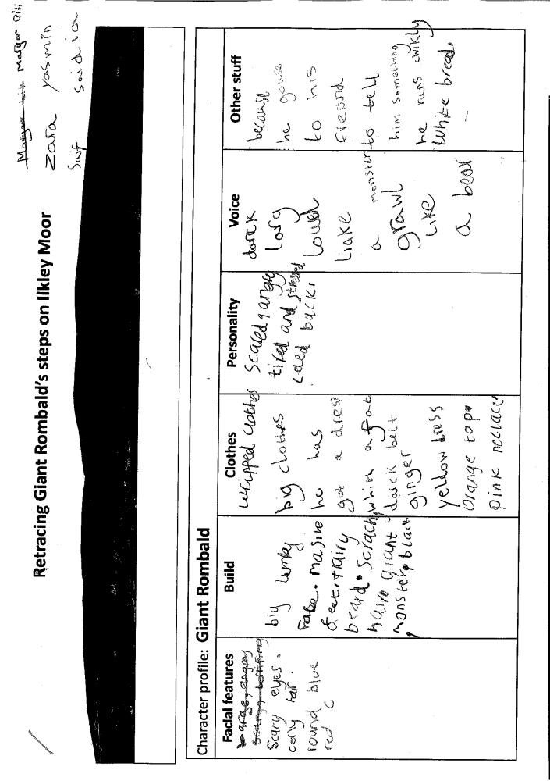
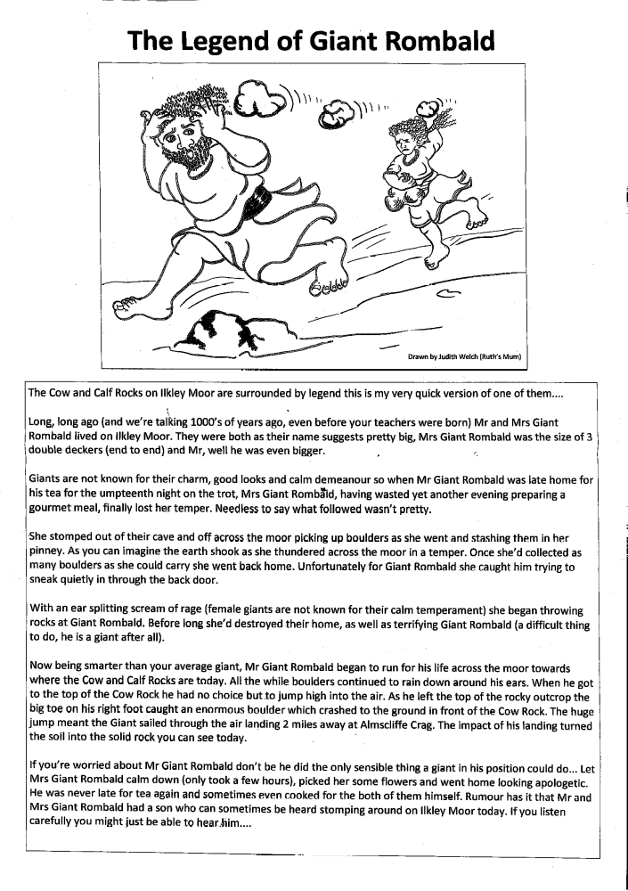

Other post-visit activity ideas

PHSCE
Blue Chameleon by Emily Gravett ISBN978-0-33051875-8
A picture/word book all about friends and feelings great to use with any primary age group.

Literacy
KS1
Poems based on ‘The Gruffalo’ Julia Donaldson ISBN 978-0-33-71093-7
If I invited the Gruffalo to tea
Would he be scared of me?
And what about Fox, Owl and snake
Would they too quiver and quake?
Hmmm...The only one left is....
Little Brown Mouse wouldn’t be afraid
When he saw the cake and lemonade.

Songs based on ‘We’re going on a bear hunt’ Michael Rosen ISBN0-7445-2323-0
We’re going on a bear hunt
We’re going to catch a big one
What a beautiful day
We’re not scared!
Uh oh!
(Crisps – crunch...jelly–wibble wobble...tuna sandwiches–munch...orange juice–slurp... etc)

KS2 other writing ideas…
‘Diary of a friendly giant...’ based on the ‘BFG’ by Roald Dahl
‘Diary of a wimpy giant...’ based on ‘Diary of a wimpy kid’

Statutory Framework for the Early Years Foundation Stage
The following table illustrates how our activity programmes at Nell Bank can help you satisfy the standards for learning, development and care for children from birth to five.

Early Years and Foundation Stage
Prime areas of learning and development | Nell Bank activity programmes
Prime areas of learning and development | Animal Senses and adaptations | Bear Hunt | Gruffalo | Owl babies | Woods walk
Communication and language development involves giving children opportunities to experience a rich language environment; to develop their confidence and skills in expressing themselves; and to speak and listen in a range of situations. | ☺ | ☺ | ☺ | ☺ | ☺
Physical development involves providing opportunities for young children to be active and interactive; and to develop their coordination, control and movement. Children must also be helped to understand the importance of physical activity, and to make healthy choices in relation to food. | ☺ | ☺ | ☺ | ☺ | ☺
Personal, social and emotional development involves helping children to develop a positive sense of themselves, and others; to form positive relationships and develop respect for others; to develop social skills and learn how to manage their feelings; to understand appropriate behaviour in groups; and to have confidence in their own abilities. | ☺ | ☺ | ☺ | ☺ | ☺
Specific areas of learning and development | Nell Bank activity programmes
Specific areas of learning and development | Animal Senses and adaptations | Bear Hunt | Gruffalo | Owl babies | Woods walk
Literacy development involves encouraging children to link sounds and letters and to begin to read and write. Children must be given access to a wide range of reading materials to ignite their interest. | ☺ | ☺ | ☺ | ☺ | ☺
Mathematics involves providing children with opportunities to develop and improve their skills in counting, understanding and using numbers, calculating simple addition and subtraction problems; and to describe shapes, spaces and measures. | ☺ | ☺ | ☺ | ☺ | ☺
Understanding the world involves guiding children to make sense of their physical worlds and their community through opportunities to explore, observe and find out about people, places, technology and environment. | ☺ | ☺ | ☺ | ☺ | ☺
Expressive arts and design involves enabling children to explore and play with a wide range of media and materials, as well as providing opportunities and encouragement for sharing their thoughts, ideas and feelings through a variety of activities in art, music, movement, dance, role play and design and technology. | ☺ | ☺ | ☺ | ☺ | ☺

National Curriculum - english programmes of study: key stages 1 and 2
The following table illustrates how our activity programmes at Nell Bank can help you satisfy the statutory requirements of the english National Curriculum.

Key stage one and two programmes of study - english
Spoken language | Nell Bank activity programmes
Spoken language | Animal Senses and adaptations | Bear Hunt | Giants | Gruffalo | Owl babies | River studies | Woods/  moors walk
Listen and respond appropriately to adults and their peers |  |  |  |  |  |  | 
Ask relevant questions to extend their understanding and knowledge |  |  |  |  |  |  | 
Use relevant strategies to build their vocabulary |  |  |  |  |  |  | 
Articulate and justify answers, arguments and opinions |  |  |  |  |  |  | 
Give well-structured descriptions, explanations and narratives for different purposes, including for expressing feelings |  |  |  |  |  |  | 
Maintain attention and participate actively in collaborative conversations, staying on topic and initiating and responding to comments. |  |  |  |  |  |  | 
Use spoken language to develop understanding through speculating, hypothesising, imagining and exploring ideas. |  |  |  |  |  |  | 
Speak audibly and fluently with an increasing command of Standard English |  |  |  |  |  |  | 
Participate in discussions, presentations, performances, role play, improvisations and debates. |  |  |  |  |  |  | 
Gain, maintain and monitor the interest of the listener(s) |  |  |  |  |  |  | 
Consider and evaluate different viewpoints, attending to and building on the contributions of others |  |  |  |  |  |  | 
Select and use appropriate registers for effective communication |  |  |  |  |  |  | 
Writing – composition  Write sentences by: | Nell Bank activity programmes
Writing – composition  Write sentences by: | Animal Senses and adaptations | Bear Hunt | Giants | Gruffalo | Owl babies | River studies | Woods/  moors walk
Saying out loud what they are going to write about |  |  |  |  |  |  | 
Composing a sentence orally before writing it |  |  |  |  |  |  | 
Sequencing sentences to form short narratives |  |  |  |  |  |  | 
Re-reading what they have written to check that it makes sense |  |  |  |  |  |  | 
Discuss what they have written with the teacher or other pupils |  |  |  |  |  |  | 
Read aloud their writing clearly enough to be heard by their peers and the teacher |  |  |  |  |  |  | 

Key stage two programmes of study - english
LKS2 Writing –  vocabulary, grammar and punctuation | Nell Bank activity programmes
LKS2 Writing –  vocabulary, grammar and punctuation | Giants | Moors walk | River studies | Three bridges | Woods walk
Extending the range of sentences with more than one clause by using a wider range of conjunctions, including when, if, because, although |  |  |  |  | 
Choosing nouns or pronouns appropriately for clarity and cohesion and to avoid repetition |  |  |  |  | 
Using conjunctions, adverbs and prepositions to express time and cause |  |  |  |  | 
Using fronted adverbials |  |  |  |  | 
Using and punctuating direct speech |  |  |  |  | 
LKS2 Writing - composition | Nell Bank activity programmes
LKS2 Writing - composition | Giants | Moors walk | River studies | Three bridges | Woods walk
Plan their writing by:  Discussing writing similar to that which they are planning to write in order to understand and learn from its structure, vocabulary and grammar |  |  |  |  | 
Discussing and recording |  |  |  |  | 
Draft and write by:  Composing and rehearsing sentences orally (including dialogue), progressively building a varied and rich vocabulary and an increasing range of sentence structures |  |  |  |  | 
Organising paragraphs around a theme |  |  |  |  | 
In narratives, creating settings, characters and plot |  |  |  |  | 
Evaluate and edit by:  Assessing the effectiveness of their own and others’ writing and suggesting improvements |  |  |  |  | 
Proposing changes to grammar and vocabulary to improve consistency, including the accurate use of pronouns in sentences |  |  |  |  | 
Read aloud their own writing, to a group or the whole class, using appropriate intonation and controlling the tone and volume so that meaning is clear |  |  |  |  | 
UKS2 Writing - composition | Nell Bank activity programmes
UKS2 Writing - composition | Giants | Moors walk | River studies | Three bridges | Woods walk
Plan their writing by:  Identifying the audience for and the purpose of the writing, selecting the appropriate form and using other similar writing as models for their own |  |  |  |  | 
Noting and developing initial ideas, drawing on reading and research where necessary |  |  |  |  | 
In writing narratives, considering how authors have developed characters and settings in what pupils have read, listened to or seen performed |  |  |  |  | 
Draft and write by:  Selecting appropriate grammar and vocabulary, understanding how such choices can change and enhance meaning |  |  |  |  | 
In narratives, describing settings, characters and atmosphere and integrating dialogue to convey character and advance the action |  |  |  |  | 
Evaluate and edit by:  Assessing the effectiveness of their own and others’ writing |  |  |  |  | 
Proposing changes to vocabulary, grammar and punctuation to enhance effects and clarify meaning |  |  |  |  | 
Perform their own compositions, using intonation, volume and movement so that the meaning is clear |  |  |  |  | 

Activities offered aim to be inclusive and are enjoyed by all ages and abilities. We also pride ourselves on the flexibility of our offer and our willingness to respond to customers evolving demands...

 | Age Group |  |  |  |  |  | Offered as part of a… |  | Is this activity inclusive?
Activity | EYFS | KS1 | LKS2 | UKS2 | KS3+ | Adults | day visit | residential | Is this activity inclusive?
Bear Hunt |  |  |  |  |  |  |  |  | 
Bear Homes |  |  |  |  |  |  |  |  | 
Gruffalo |  |  |  |  |  |  |  |  | 
Gruffalo Crumble |  |  |  |  |  |  |  |  | 
Little Brown Mouse House |  |  |  |  |  |  |  |  | 
Pond dipping |  |  |  |  |  |  |  |  | 
Meet the Chickens |  |  |  |  |  |  |  |  | 
Minibeasting |  |  |  |  |  |  |  |  | 
Water play |  |  |  |  |  |  |  |  | 
Animal Senses and Adaptations Programme
Squirrel Run |  |  |  |  |  |  |  |  | 
Badger Sniff |  |  |  |  |  |  |  |  | 
Mole Walk |  |  |  |  |  |  |  |  | 
Mouse Maze |  |  |  |  |  |  |  |  | 
Rabbit Run |  |  |  |  |  |  |  |  | 
Habitat Trail |  |  |  |  |  |  |  |  | 
Woods Walk |  |  |  |  |  |  |  |  | 
Schools Linking Network Programme
Circle Games |  |  |  |  |  |  |  |  | 
Scavenger Hunt |  |  |  |  |  |  |  |  | 
Woods Walk |  |  |  |  |  |  |  |  | 
Parachute Games |  |  |  |  |  |  |  |  | 
Exploring Habitats Programme
Habitat Trail |  |  |  |  |  |  |  |  | 
KS2 Pond dipping |  |  |  |  |  |  |  |  | 
KS2 Woods Walk |  |  |  |  |  |  |  |  | 
KS2 Minibeasting |  |  |  |  |  |  |  |  | 
Adventure play |  |  |  |  |  |  |  |  | 
Orienteering onsite |  |  |  |  |  |  |  |  | 
Orienteering woods |  |  |  |  |  |  |  |  | 
River Studies |  |  |  |  |  |  |  |  | 
Teambuilding Programme
Trust Trail |  |  |  |  |  |  |  |  | 
Duck Rescue |  |  |  |  |  |  |  |  | 
Custard Crossing |  |  |  |  |  |  |  |  | 
Save the Species |  |  |  |  |  |  |  |  | 
Magic Carpet |  |  |  |  |  |  |  |  | 
Prisoner |  |  |  |  |  |  |  |  | 
Circle in a circle |  |  |  |  |  |  |  |  | 
Initiative course |  |  |  |  |  |  |  |  | 
 | Age Group |  |  |  |  |  | Offered as part of a… |  | Is this activity inclusive?
Activity | EYFS | KS1 | LKS2 | UKS2 | KS3+ | Adults | day visit | residential | Is this activity inclusive?
Early Peoples’ Settlement Programme
Archaeological dig |  |  |  |  |  |  |  |  | 
Den building |  |  |  |  |  |  |  |  | 
Experimental Archaeology |  |  |  |  |  |  |  |  | 
Dustbin Game |  |  |  |  |  |  |  |  | 
Ecology Fieldwork Programme
Freshwater sampling - ponds |  |  |  |  |  |  |  |  | 
Freshwater sampling - rivers |  |  |  |  |  |  |  |  | 
Woodland ecology |  |  |  |  |  |  |  |  | 
Residential Activities
Mud Trail |  |  |  |  |  |  |  |  | 
Ilkley Moor walk |  |  |  |  |  |  |  |  | 
Three Bridges walk |  |  |  |  |  |  |  |  | 
Manor House |  |  |  |  |  |  |  |  | 
Other Activities offered
Work Related Learning |  |  |  |  |  |  |  |  | N/A
Work placements * |  |  |  |  |  |  |  |  | 
D of E camp ground |  |  |  |  |  |  |  |  | 
D of E Ambassador Award Scheme |  |  |  |  |  |  |  |  | 
CPD training – teachers |  |  |  |  |  |  |  |  | 
ITT Training – QTS, PGCE students |  |  |  |  |  |  |  |  | 
Community support Volunteers |  |  |  |  |  |  |  |  | 
Voluntary work |  |  |  |  |  |  |  |  | 
Trainee Tutor – 3 fulltime training positions per year |  |  |  |  |  |  |  |  | 
Aiming High |  |  |  |  |  |  |  |  | 
Meeting Room |  |  |  |  |  |  |  |  | 
Residential Short Breaks for families |  |  |  |  |  |  |  |  | 
Other Regular Events
Outdoor Classroom e.g. Marshfield |  |  |  |  |  |  |  |  | 
Specific Education Training courses |  |  |  |  |  |  |  |  | 
Outdoor Odyssey (Summer Hols) |  |  |  |  |  |  |  |  | 
Nell Bank Family Fun Day |  |  |  |  |  |  |  |  | 
Disability Rocks |  |  |  |  |  |  |  |  | 
Wharfedale Schools x-country events |  |  |  |  |  |  |  |  | N/A
Ilkley and District Riding |  |  |  |  |  |  |  |  | N/A
Musical theatre workshop |  |  |  |  |  |  |  |  | 
Play in a day e.g. Foxhill Primary |  |  |  |  |  |  |  |  | 
Big Challenge |  |  |  |  |  |  |  |  | 
CISV |  |  |  |  |  |  |  |  | 
Race for Life |  |  |  |  |  |  |  |  | N/A
2012/2013 - 33 Students ranging from Year 10 to Trainee Teachers have attended a 2+ week work placement at Nell Bank

