Owl Babies
The day is focussed on the retelling of the Owl Babies story. Children look for Mother Owl, Sarah, Percy and Bill hiding in the ivy near their nest. Science concepts of habitats, adaptations, predator/prey relationships and nocturnal feature during the interactive retelling of the story by Martin Waddell.
Activities can be weather dependent so the day will include some or all of the following...
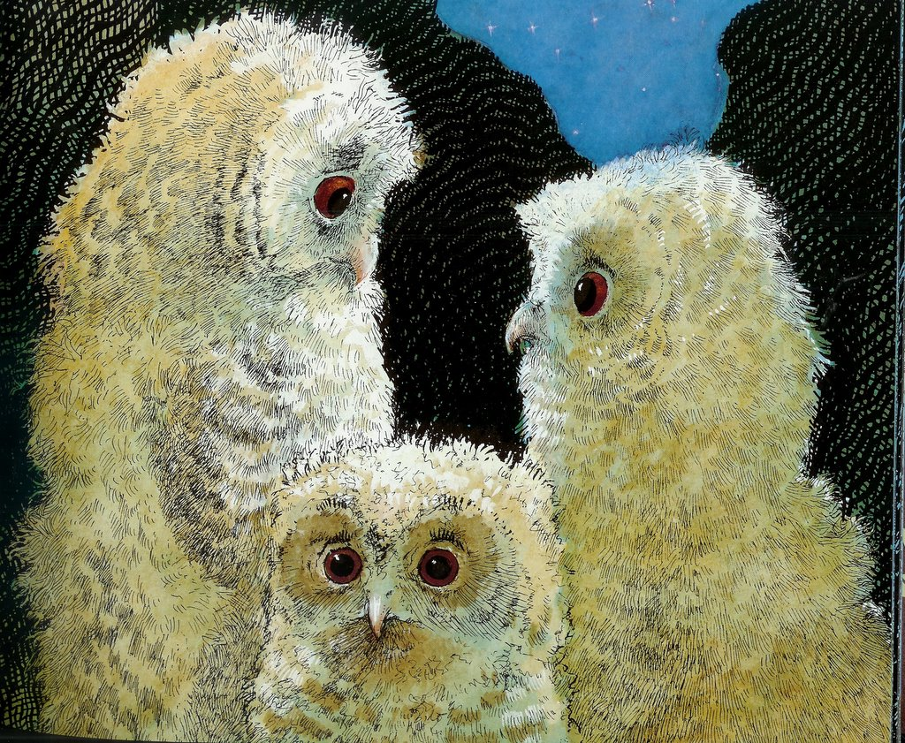
Activity | Description
Owl Babies Story & Finding Mother Owl & Babies | Pupils listen to the story and discuss the emotional and environmental aspects of the story. Using the ideas they have discussed, they set off to try and find Mother Owl and her babies who are hidden in the natural environment.
Animal Orchestra | Basically animal snap! Children are given cards and asked to make the noise of the animal pictured, then find peers making the same noise. Finish with an orchestral manoeuvre in the dark conducted by a virtuoso Nell Bank tutor.
Baby Owl Nests | A walk in the woods to find a new safe place for the baby owls to nest. In groups helped by an adult children make a really cosy nest for the babies to snuggle up in while they wait for Owl Mother.
Baby Owl Balance | Through play children discover just how good your balance needs to be if you are an owl on a branch and how very useful adaptations like claws are for holding on when you’re up high in a tree.
Habitat Trail | Who lives where at Nell Bank? This activity gives children the chance to use prior learning about habitats and the freedom to explore the natural environment with minimal adult help.
Minibeasting | There’s more to the woodland floor than you think…find out just how mini the beasties are in the woods as well as the occasional hibernating frog, toad or sleepy newt. Through careful observation of the creatures caught pupils are introduced to basic classification.
Adventure Play  (if time allows) | Pupils have the opportunity to explore the adventure playground, slither down the tube slide, climb the bouldering wall, crawl along the tunnels and swing from the monkey rings. A brilliant way for groups to experience the freedom and physical challenge of adventurous play.
Parachute Games  (cold weather option) | An exciting and fun way to get children working together on a wet, chilly day... Bear football is always a good giggle and guaranteed to get everyone warmed up.
Water Play  (warm weather option) | Put simply children are encouraged to play both independently and collaboratively with water, squirty things, rubber ducks and buckets. Slightly soggy Nell Bank fun guaranteed even on the sunniest day!

